Project Team FM22
39th Meeting of FM22  Copenhagen, 16 – 19 April 2013 | FM22(13)08rev1

Date issued: 09 April 2013

Source: Lithuania

Subject: Criteria to protect fixed radio monitoring stations from harmful emissions
N
Password protection required? (Y/N) *

Summary

This document presents the procedures applied in Lithuania for the protection of fixed radio monitoring stations of the Communications Regulatory Authority (hereinafter referred to as ‘the Authority’) from harmful interference radiated from nearby radio stations. The modified methodology for calculation of maximum permissible field strength that is generated by one source is also presented in this document.

Proposal
The material in this document may be useful for a Draft Revision of Recommendation ITU-R SM.575.

Background

Introduction
Interference arising from unwanted strong radio signals makes it difficult to measure weak radio signals in radio monitoring stations. And intermodulation products from interaction of several strong signals in the input circuits of radio monitoring receiver especially impede the search of illegal transmitters.
- Procedures applied for the protection of fixed radio monitoring stations from harmful radio interference
In Lithuania, as well as in many other countries, fixed radio monitoring stations of the Authority are mainly located in the cities. On the other hand, the density of public mobile communication base stations of GSM, UMTS and LTE networks in urban areas is higher than in rural. Therefore, public mobile communication base stations with their generated fields are the main obstacle for proper operation of fixed radio monitoring stations. This obstacle occurs as intermodulation products are generated when several strong downlink signals interact in input circuits of radio monitoring receivers because of the nonlinearity of their transmission characteristics.
At present, Authority uses 5 fixed radio monitoring stations. Procedures applied for the protection of these stations from strong electromagnetic fields are set down in regulations. One of the main provisions’ of the regulations is that it is not allowed to install radio stations for any purpose near the fixed radio monitoring stations if their field strength exceeds limit values presented in Recommendation ITU-R SM.575.
In Lithuania, all the coordinates of fixed radio monitoring stations of the Authority and their antennas’ heights are publicly available on the Internet. An operator intending to install a base station near monitoring station begins with evaluation of field strength produced by his station to the fixed station. If the determined field strength does not exceed limit value presented in Recommendation ITU-R SM.575, he applies to the Authority regarding registration of his base station. After verification of the results, operator installs the station and the Authority registers it. In the second phase, after opening the station, radio monitoring station personnel measures field strength. Very often the permitted rate is exceeded. Therefore, inclination of base station antenna‘s angle is changed or, less often, power of transmitter output is decreased, until the field strength in monitoring station is reduced to maximum permitted value.
There are three operators in Lithuania using their own public mobile communication networks. Each of them has deployed 3 and more GSM-900, GSM-1800 and UMTS base stations near every monitoring station of the Authority. As follows from earlier explanation, field strengths in radio monitoring stations are close to limit values presented in Recommendation ITU-R SM.575.
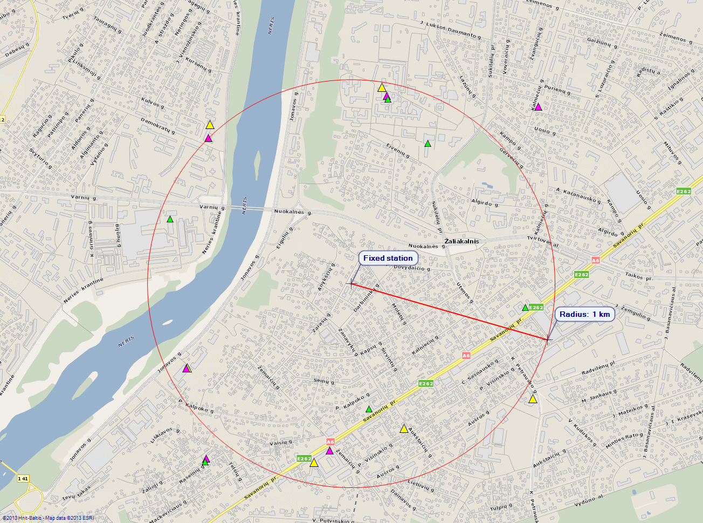
Figure 1. Location of the base stations in the area of fixed radio monitoring station in Kaunas city. Stations of different operators’ networks are presented in different colors.

Fig. 1 shows location of the base stations in the area of fixed radio monitoring station in Kaunas. Similar deployment of base stations is around the rest 4 fixed radio monitoring stations of the Authority. It can be seen in the Fig. 1 that there are 12 base stations near the radio monitoring station (in radius of 1 km). Each base station actually consists of 3 stations: GSM-900, GSM-1800 and 3G. Because of such large number of bases stations it becomes very possible that the input of radio monitoring receiver can get more than 2 strong signals of similar level.

Features of Recommendation ITU-R SM.575
This Recommendation provides two maximum permissible values of field strength generated by one signal: 10 mV/m (80 dBμV/m) for signals in the frequency band from 9 kHz to 174 MHz and 50 mV/m (94 dBμV/m) for signals in the frequency band from 174 kHz to 960 MHz. This is one of shortcomings of Recommendation ITU-R SM.575 because the limit values of field strength estimated to interfering (intrusive) signals are not related to bandwidth of these signals. Naturally, if the power of intermodulation products is the same, then less interfering are those IM products that are of wider spectrum. Wider spectrum intermodulation products occur from interaction of wider bandwidth signals, therefore, higher limit values of field strength should be established to signals of wider bandwidth.
Besides, maximum permissible value is not estimated for those signals whose frequency is higher than 960 MHz. Regulation of the Authority applies 50 mV/m value even to those signals whose frequencies are higher than 960 MHz.

- Calculation of the maximum permissible field strength

Basic parameters
For evaluation of maximum permissible field strength of signal are important:
- Signal frequency and bandwidth
- Immunity of a receiver to third order intermodulation products
- Receiver noise
- Antenna gain

Third order intermodulation products
The most dangerous are the third-order intermodulation products whose frequencies are close to incoming signals’ frequencies. When two incoming signals of f_{g} and f_{h} frequencies interact, only two intermodulation products of IM3(2,1) type are possible. Frequencies of these products f_{IMP} are equal to:
$f_{\text{IMP}}=2f_{g}−f_{h}$ (1)
Each index g and h accepts one of two values 1 or 2 under the condition:
$g+h=3$ (2)
In case of three signals with f_{k} , f_{l} and f_{m} frequencies, intermodulation products of IM3(2,1) and IM3(1,1,1) type are possible. IM3(1,1,1) product frequencies f_{IMP} are equal:
$f_{\text{IMP}}=f_{k}+f_{l}−f_{m}$ (3)
Each index k, l and m accepts one of three values 1, 2 or 3 under the condition:
$k+l+m=6$ (4)
If power of all incoming signals is equal, power of intermodulation product IM3(2,1) can be calculated according to well-known formula:
$P_{\text{IM}3−1}=3P_{S}−2P_{\text{IP}3}$ (5)
with:
P_{IM3-1} – power of the 3rd order intermodulation product IM3(2,1) in dBm;
P_{S} – input power of incoming signal into the monitoring receiver in dBm;
P_{IP3} – 3rd order intercept point (IP3) of the receiver in dBm.
Power of intermodulation product IM3(1,1,1) is 6 dB higher, than IM3(2,1) and is equal to:
$P_{\text{IM}3−2}=(P_{k}+P_{l}+P_{m})−2P_{\text{IP}3}+6$ (6)
with:
P_{IM3-2} – power of the 3rd order intermodulation product IM3(1,1,1) in dBm,
P_{k,} P_{l}, P_{m} – input power of incoming signals into the monitoring receiver in dBm.
If P_{k,} = P_{l} = P_{m} = P_{s}, equation (6) becomes a well-known formula:
$P_{\text{IM}3−2}=3P_{S}−2P_{\text{IP}3}+6$. (7)
It should be noted that formulas from (5) to (7) are valid even when there are more than 3 interacting signals.
Speaking of harmful influence of intermodulation product, it is not enough to know its power, but it is important to know its spectrum. It is not easy to determine the band width of intermodulation product when real signals interact (e.g. DVB-T or LTE). Usually these spectrums have no significant minimums and maximums. Thus, it is possible to presume, without making great error, that spectrum of intermodulation product is rectangular.

Internal noise of the receiver
It is well-known that the average square value (r.m.s.) of internal noises of the receiver calculated for receiver’s input is given by:
$p_{R}=(f−1){\text{kt}}_{0}B_{n}=(f−1)p_{n}B_{n}$, (8)
where:
f : noise factor of the receiver
k : Boltzmann‘s constant
$t_{0}$ : reference temperature taken as 290 K
B_{n} : noise bandwidth of the receiver
$p_{n}={\text{kt}}_{0}$ : available thermal noise power in 1 Hz bandwidth.
Usually sensitivity of the receiver in specification sheet is characterized with noise figure F. Then equation (8) can be written:
$p_{R}=({\text{10}}^{\frac{\text{NF}}{\text{10}}}−1)p_{n}B_{n}$ (9)
where:
NF=10logf : noise figure of the receiver in dB.
Usually receiver’s internal noises are presented in dBm:
$P_{R}(\text{dBm})=\text{10}\text{log}(\text{1000}p_{R})=\text{10}\text{log}({\text{10}}^{\frac{\text{NF}}{\text{10}}}−1)+\text{10}\text{log}B_{n}−\text{174}(\text{dBm})$ (10)
where:
$−\text{174}(\text{dBm})=\text{10}\text{log}(\text{1000}p_{n})$.
Technical specifications of the receivers give the values of measurement bandwidth but not of noise bandwidth. Usually measurement bandwidth of the receiver is approximately only 10-20 % larger than noise bandwidth. Therefore, for calculation of internal noises of the receivers it will be no great error to put measurement bandwidth of the receiver in equations (8)-(10) instead of noise bandwidth. Besides, equation (10) becomes less complex if noise figure is larger than 10 dB:
$P_{R}(\text{dBm})=\text{NF}+\text{10}\text{log}B−\text{174}\text{dBm}$ (11)
where:
B : measurement bandwidth of the receiver in Hz.
In such case, when NF=10 dB of the receiver, the result of calculation according to the formula (11) only 0,5 dB is higher than the result of calculation according to the formula (10). But when NF = 1 dB, calculation results differ in 6,9 dB.

Calculation of maximum permissible field strength
We’ll calculate maximum permissible field strength of one signal in three cases. The first case is when a signal in receiver input circuits interacts with no less than two equal signals of equal power and bandwidth. The second case is when a signal interacts with no less than two signals of equal power but less bandwidth. The situations of three signals interacting are most probable when signals are radiated constantly. The sources of such signals are public mobile communication base stations. If a radio station radiates in short intervals, then most likely we will have the third case when two signals interact. In this case we will presume that their power and bandwidth are the same. In all three cases we will presume that:
- internal noise of the receiver significantly exceed radio noise;
- spectrum of intermodulation products is rectangular;
- losses of antenna feeder are uncounted.
1) As follows from formula (3), in case of interaction of equal signals, the bandwidth of intermodulation product IM3(1,1,1) three times exceeds the bandwidth of a single signal .
Using formula (7), we can get IM3(1,1,1) products power ∆P_{IM3} registered in the receiver band B:
${ΔP}_{\text{IM}3}(\text{dBm})=P_{\text{IM}3}+\text{10}\text{log}\left(\frac{B}{3B_{S}}\right)=3P_{S}−2P_{\text{IP}3}+6+\text{10}\text{log}(B)−\text{10}\text{log}3B_{S}$ (12)
where:
B_{s}: bandwidth of incoming signals.

Interference due to IM products begin to be visible when the level ∆P_{IM3} exceeds the receiver noise floor:
${ΔP}_{\text{IM}3}≥P_{R}$. (13)
The “critical” point where this situation occurs can be calculated using formulas (11) and (12) as follows:
$3P_{S}−2P_{\text{IP}3}+6+\text{10}\text{log}B−\text{10}\text{log}(3B_{S})=\text{NF}+\text{10}\text{log}(B)−\text{174}\text{dBm}$ (14)
$P_{S}=\frac{2P_{\text{IP}3}+\text{NF}+\text{10}\text{log}(B_{S})}{3}−\frac{\text{174}+6−\text{10}\text{log}3}{3}$. (15)
As it is well known, field strength E and electric power in the antenna output (and receiver input) P are connected according to formula:
$E({\text{dBµV}}/m)=P(\text{dBm})+\text{20}\text{log}f(\text{MHz})−G_{i}(\text{dB})+\text{77}\text{dB}$ (16)
where:
f : frequency MHz
G_{i} : antenna gain in the direction to signal source dB_{i} .
In combination of formulas (15) and (16) final expression for maximum permissible field strength is received:
$E_{\text{max}}({\text{dBµV}}/m)=\frac{2P_{\text{IP}3}(\text{dBm})+\text{NF}(\text{dB})+\text{10}\text{log}B_{S}(\text{Hz})}{3}+\text{20}\text{log}f(\text{MHz})−G_{i}(\text{dB})+\text{18},6\text{dB}$ (17)
As can be seen from this expression, the value of maximum permissible field strength depends not on receiver measurement bandwidth but on bandwidth of the signal generating this field.
2) In this case it is logical to accept that these are top levels of two narrow-band signals and can be expressed by formula (15). In such case power P_{IM 3-2} intermodulation product IM3(1,1,1) is:
$P_{\text{IM}3−2}^{'}=(P_{S}^{'}+2P_{S})−2P_{\text{IP}3}+6$ (18)
with:
$P_{S}^{'}$ – input power of broadband signal in dBm;
P_{S} – input power of narrow-band signal in dBm.
As bandwidth of intermodulation product in this case is equal to width $B_{S}^{'}$of broadband signal $P_{S}^{'}$, thus registered power ${ΔP}_{\text{IM}3−2}^{'}$ in receiver band B is equal to:
${ΔP}_{\text{IM}3}^{'}(\text{dBm})=P_{\text{IM}3}+\text{10}\text{log}\left(\frac{B}{B_{S}^{'}}\right)=P_{S}^{'}+2P_{S}−2P_{\text{IP}3}+6+\text{10}\text{log}B−\text{10}\text{log}B_{S}^{'}$ (19)
As before, combining equations (11) and (19) we get:
$P_{S}^{'}+2P_{S}−2P_{\text{IP}3}+6+\text{10}\text{log}B−\text{10}\text{log}B_{S}^{'}=\text{NF}+\text{10}\text{log}B−\text{174}$ (20)
When combining this equation and (15) we get:
$P_{S}^{'}(\text{dBm})=\frac{2P_{\text{IP}3}+\text{NF}+\text{10}\text{log}B_{S}^{'}}{3}+\frac{2}{3}(\text{10}\text{log}\frac{B_{S}^{'}}{B_{S}})−\frac{\text{174}+6+2∗\text{10}\text{log}3}{3}$ (21)
When combining formulas (16) and (21), we receive final expression for maximum permissible field strength:
$E_{\text{max}}^{'}({\text{dBµV}}/m)=\frac{2P_{\text{IP}3}(\text{dBm})+\text{NF}(\text{dB})+\text{10}\text{log}B_{S}^{'}(\text{Hz})}{3}+\frac{2}{3}(\text{10}\text{log}\frac{B_{S}^{'}}{B_{S}})+\text{20}\text{log}f(\text{MHz})−G_{i}(\text{dB})+\text{13},8\text{dB}$(22)
As can be seen from this expression, in this case the value of maximum permissible field strength depends on bandwidth of the signal generating this field and on its relation to bandwidths of other two incoming signals.
3) As follows from formula (1), in case of interaction of equal signals, the bandwidth of intermodulation product IM3(2,1) three times exceeds the bandwidth of a single signal.
Using formula (5), we can get IM3(2,1) products power ∆P_{IM3} registered in the receiver band B:
${ΔP}_{\text{IM}3}(\text{dBm})=P_{\text{IM}3}+\text{10}\text{log}\left(\frac{B}{3B_{S}}\right)=3P_{S}−2P_{\text{IP}3}+\text{10}\text{log}(B)−\text{10}\text{log}3B_{S}$ (23)
Then after analogical actions as in case 1), we may receive final expression for maximum permissible field strength:
$E_{\text{max}}({\text{dBµV}}/m)=\frac{2P_{\text{IP}3}(\text{dBm})+\text{NF}(\text{dB})+\text{10}\text{log}B_{S}(\text{Hz})}{3}+\text{20}\text{log}f(\text{MHz})−G_{i}(\text{dB})+\text{20},6\text{dB}$ (24)
The results of calculation show that permissible field strength is only 2 dB higher when 2 signals interact comparing to the case when 3 equal signals interact.

Calculation of maximum permissible field strength of typical signals
In most cases calculations according to the formula (22) give 2-5 dB larger values of permissible field strength than calculations according to the formula (17). Therefore, our calculations will be based on formula (17). As in document FM22(12)42 Annex 6, we’ll take such typical values for receiver’s and antenna’s parameters:
- 3rd order intercept point of the receiver P_{IP3}=+15 dBm
- noise figure of the receiver NF=10 dB
- antenna gain G_{i}=2,15 dB.
After putting these typical values into equation (17) and expressing signal bandwidth in kHz, we will get:
$E_{\text{max}}^{'}({\text{dBµV}}/m)=\frac{\text{10}}{3}\text{log}B_{S}(\text{kHz})+\text{20}\text{log}f(\text{MHz})+\text{29},\text{78}\text{dB}$ (23)
With this equation maximum permissible field strength values for several typical signals have been calculated. Summary of the results is presented in Table 1 and Fig. 2.

Table 1
Maximum permissible field strengths of typical signals
Type of signal | Bandwidth | Frequency band  (downlink) | Maximum permissible field strength
Narrowband FM | 12,5 kHz | (118 – 890) MHz | (74,54 – 92,42) dBµV/m
GSM | 200 kHz | (390,2 – 1990) MHz | (89,27 – 103,42) dBµV/m
UMTS | 5 MHz | (728 – 2690) MHz | (99,35 – 110,7) dBµV/m
LTE | 1,4 MHz  5 MHz  20 MHz | (728 – 2690) MHz | (97,51 – 108,86) dBµV/m  (99,35 – 110,7) dBµV/m  (101,36 – 112,71) dBµV/m

Figure 2
Maximum permissible field strengths of typical signals
