Project Team FM22
41st Meeting of FM22  Vilnius, 01 – 04 April 2014 | FM22(14)05rev1

Date issued: 19 March 2014

Source: Lithuania

Subject: Measuring the maximum frequency deviation of FM broadcast emissions at monitoring stations
N
Password protection required? (Y/N) *

Summary

The improvements to the method of measuring the maximum frequency deviation of FM broadcast emissions at monitoring stations are introduced in this document which is applied in Lithuania. This document enlarges the current Recommendation ITU-R SM.1268-2 (in force).

Proposal
The material in this document may be useful for a Draft Revision of Recommendation ITU-R SM.1268-2. The enlargement may take place in an Annex 1 and Annex 2. FM22 delegates are invited to develop this proposal for a Draft Revision of Recommendation ITU-R SM.1268-2.

Background

Introduction
Most European countries control frequency deviation of FM radio broadcasting stations more or less. Most often the maximum permissible frequency deviation relative overshooting time τ_{max} (hereinafter – maximum time τ_{max}), when frequency deviation may exceed maximum permitted value f_{max} (often 75 or 77 kHz), and maximum permissible modulation power P_{max} are determined. It is not easy to determine compliance of the mentioned deviation parameters to the requirements, as they vary randomly during a time. For this reason the questions of how these parameters shall be measured properly and how the measurements results shall be evaluated arise.
- Frequency deviation limits

Usually relative overshooting time τ, when deviation exceeds maximum permitted value (hereinafter – overshooting time τ or time τ), is estimated according to accumulated distribution plot of deviation F. Time τ is equal to the value of function F at frequency f_{max}. Frequency f_{max} of 75 kHz can be taken, as specified in Recommendation ITU-R BS.412-7, but because of frequency deviation measuring error, depending on measuring equipment, frequency f_{max} should not be 75 kHz.

Value of frequency f_{max} depends on the purpose of measurement. For example, if Regulator writes a notification on violation to an Operator, he must be sure that the measured time τ exceeds the maximum permitted value. As function F is descending, in this case it would be logical to estimate time τ with frequency$f_{\text{max}}^{+}$:

$$f_{\text{max}}^{+}=\text{75}\text{kHz}+\left|δ_{D}\right| ,$$

where δ_{D} – deviation measuring error.

If broadcast operator tests deviation compliance with the set conditions, he must be sure that the measured time τ does not exceed the maximum permitted value. Therefore, it would be logical to estimate time τ with frequency$f_{\text{max}}^{−}$:

$$f_{\text{max}}^{−}=\text{75}\text{kHz}−\left|δ_{D}\right| \text{.}$$

It is obvious, that in order to estimate time τ properly, accumulated distribution plot of deviation F shall be measured accurately.

Formation features of accumulated distribution plot of deviation

Most equipment used for deviation measuring in radio monitoring (e. g. Audemat FM-MC4) determines deviation value according to the quantity of composite signal in the output of frequency detector. As the spectrum of composite signal reaches 90 kHz, the speed of its samples (discretization frequency) shall be significantly higher than 90 kHz. Recommendation ITU-R SM.1268-2 suggests to use no less than 200 kHz discretization frequency. In the equipment FM-MC4, discretization frequency is equal to 256 kHz and instantaneous values of frequency deviation are taken every 3.9 µsec. During 15 minutes of measuring time (recommended in Recommendation ITU-R SM.1268-2) this equipment collects about 2.2*10⁸ deviation measurement samples. As time τ is equal to relation of the measurement samples exceeding frequency f_{max ,} with total number of the measurement samples, thus it is possible to measure very short times τ because of such big realization (FIGURE 1).

FIGURE 1

Accumulated distribution plot of deviation

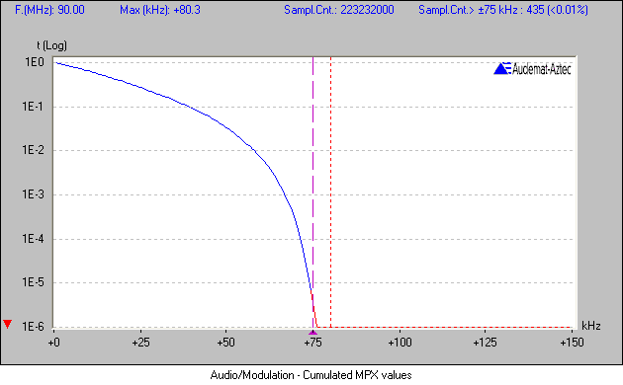

On the other hand, part 5.2 of the Annex 2 of Recommendation ITU-R SM.1268-2 defines how accumulated distribution plot of deviation is preferably to be obtained. Basing on this method, accumulated distribution plot of deviation is obtained not from all the collected deviation measurement samples, but just from peak values which are observed at 50 ms measuring intervals. In this case not more than 1.8*10⁴ deviation measurement samples are collected during 15 minutes of measuring time (device FM-MC4 in this regime collects about 2.25*10⁴ deviation values). Having such small series, it is not possible to measure values of time τ lower than 0.01%. Meanwhile the abovementioned Recommendation suggests that 10^{–4}% of the measurement samples (τ =10⁻⁶) exceeding 77 kHz deviation may be considered as a practical value. To eliminate this contradiction, method presented in part 5.2 of the Annex 2 shall be put aside. Besides, distribution of deviation values collected according this method is distorted and this leads to an error when specifying time τ (this is mentioned in the Recommendation also).

3.1 Time of measurement

Measurements of frequency deviation are aimed at controlling that deviation does not exceed maximum permitted value. Thus it would be logical to measure with such programme material when deviation is the highest. Practice shows that in many cases there is no obvious relation between the type of programme material (music, speech and etc.) and the frequency deviation value. Therefore, the requirement that the measurement should represent typical modulation of the programme material of the broadcasting station is excessive and can be rejected. Besides, measuring procedure becomes simpler without this requirement. Then a period of 15 minutes is enough to fulfil deviation measuring of one station.

Overshooting time as random variable

As mentioned above, Recommendation ITU-R SM.1268-2 introduces 10⁻⁶ as an allowable maximum time τ_{max}. Administrations of the countries, where frequency resource is sufficient and intervals between FM broadcasting stations wide enough, use higher value of τ_{max}. For example, Regulation of frequency deviation measurement in Lithuania specifies that time τ_{max} is equal to 1%.
It is obvious that, because of random origin of FM station frequency deviation, values of time τ captured in different measurements will not repeat. E.g., results of time τ measurements of one station in Vilnius during the 4 hours period are presented in FIGURE 2 (time τ was estimated according to deviation measurements during the interval of 15 minutes). As we see, it is impossible to make any conclusion on compliance with deviation requirements from one measurement because the results of some measurements exceed the permitted limit of 1%, and does not exceed of others. If it would be possible to conclude from one measurement with a certain probability about compliance of frequency deviation with the requirements, we should know the distribution type of time τ and its standard deviation (for this purpose, statistical features of time τ measurement results were analyzed).

FIGURE 2
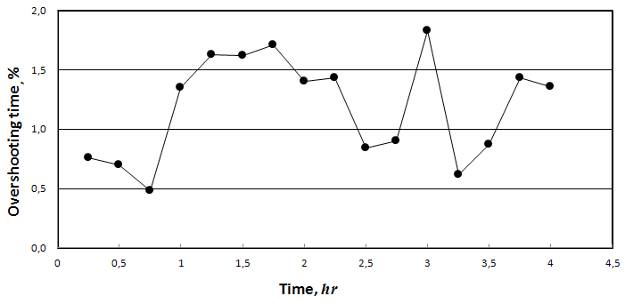

4.1 Measurement procedure
During the tests, the relative overshooting time τ of 21 FM station was measured. At different stations sample mean m of measured time τ values varied from about 10^{–4}% to 10%. Frequency deviation of the stations whose sample mean was less than 0.1% was measured by specialists of Latvian administration with the equipment Audemat FM-MC4. Stations whose sample mean was higher were measured by Lithuanian representatives with equipment Deva DB3000. This equipment has lower resolution than Audemat FM-MC4 and it is equal to 0.1% (see FIGURE 3).

FIGURE 3

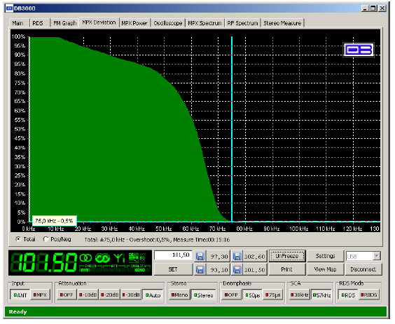

It took about 900 minutes to measure every station, and values of time τ were estimated every 15 minutes. Thus series of 16 measurement values for every station were collected.

4.2 Measurement result

Sample mean m and sample standard deviation s were calculated for each time τ series. As sample mean m varies in very wide limits, relation between sample mean m and sample standard deviation s of every measurement series is better expressed by dependence of normalized sample standard deviation $s_{n}=\frac{s}{m}$ on sample mean m. Such dependence is shown in FIGURE 4.

FIGURE 4 shows that if m is higher than 1%, then normalized standard deviation do not change significantly and its value is close to 0.4.

FIGURE 4

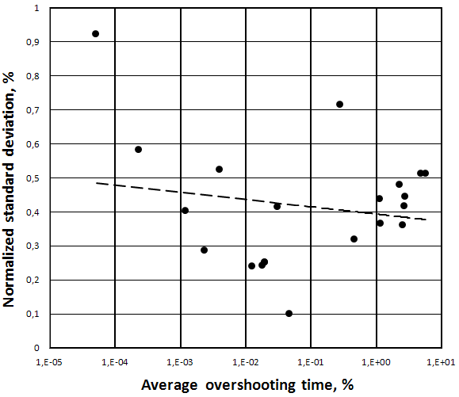

In order to estimate the distribution type of time τ, measurements of two FM stations (A and B) were made within several days. During the measurements a series of 131 time τ values (samples) for station A were collected and of 134 values for station B. Time variation of the time τ for station A is presented in FIGURE 5. Analysis of these series showed that histograms of time τ of both stations are close to normal (Gaussian) distribution. Histogram of station A is presented in FIGURE 6 (width of columns in the histogram is constant and is equal to 0.4s).

FIGURE 5

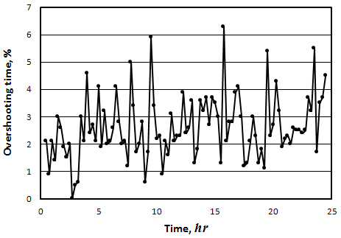

FIGURE 6

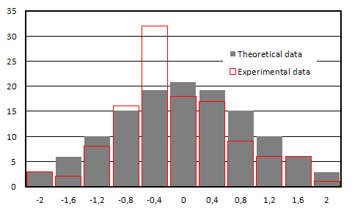

It should be noted that values of normalized sample standard deviations s_{n} of mentioned long series were equal to 0.419 and 0.367, which is quite close to 0.4.
4.4 Evaluation of measurement results of deviation overshooting time
The aim of measuring the deviation overshooting time of FM stations with the aid of radio monitoring stations is to identify if it does not exceed the maximum permissible value τ_{max}. As time τ is a random variable, measurement results only allow establishing that time τ exceeds value τ_{max} with a certain probability.
As presented above, time τ is a random variable with distribution close to normal and its standard deviation s is directly related with the sample mean m:
$s=k⋅m \text{.}$ (1)
In order to apply mathematical apparatus, we shall consider that distribution of time τ is exactly normal to the expected value (mean) µ and the standard deviation σ and there is a direct relation between these parameters:
$σ=k⋅μ \text{.}$ (2)
So we have the probability density function:
$p(τ)=\frac{1}{k⋅μ\sqrt{2π}}\text{exp}\left[−\frac{1}{2}⋅{\left(\frac{τ−μ}{k⋅μ}\right)}^{2}\right] ,$ (3)
By standardizing, we get a random variable z with a standard normal distribution:
$z=\frac{τ−μ}{k⋅μ} \text{.}$ (4)
When substituted equation (4) to equation (3), we will have the standard normal distribution (independent of the parameters µ and σ ) with the probability density function
$p(z)=\frac{1}{\sqrt{2π}}\text{exp}\left(−\frac{z^{2}}{2}\right)$ (5)
and cumulative normal distribution function P(z):
$P(z)=\frac{1}{\sqrt{2π}}\int{\text{exp}}\left(−\frac{ξ^{2}}{2}\right) dξ \text{.}$ (6)
Adopted the number of z corresponding to the given probability P (z) = 1-α, shall be marked with the letter z_{α:}
$P(z_{α})=\frac{1}{\sqrt{2π}}\int{p(z)\text{dz}}=P \text{rob}[z≤z_{α}]=1−α \text{.}$ (7)
It follows from equation (7) that the probability for random variable z to exceed a particular level z_{α} is:
$P \text{rob}[z>z_{α}]=\frac{1}{\sqrt{2π}}\int{p(z)\text{dz}}=1−P(z_{α})=α \text{.}$ (8)
Integral (6) cannot be evaluated analytically. Note that there are many ways (table of the standard normal distribution, usually called as Z table; normal calculator, etc.), as for the given probability P(z_{α}) to determine the corresponding value z_{α} or the opposite: for the given z_{α} to determine the corresponding probability P(z_{α}).
It is now possible to calculate the probability that the time τ will exceed the threshold τ_{max} and how this probability depends on the known mean µ. The expression for normalized mean follows from equation (2):
(9)
where numbers z_{α} are determined by the corresponding values of α.
Calculated in this way, the probability [Prob (τ> τ_{max})] dependence on the normalized mean is shown in FIGURE 7, where the value k=0.4 has been used.

FIGURE 7
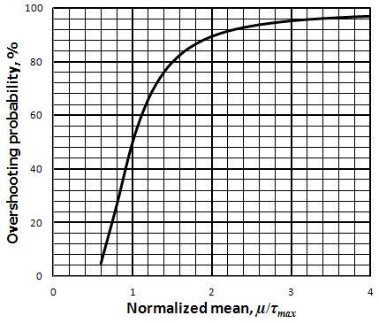
So to determine if time τ exceeds τ_{max} with a certain probability, we should know the “true” mean µ. In general it is not known, but if N measurement results of time τ were collected, we are able to determine the sample mean m. If the time τ distribution is normal, then the sample mean distribution is also normal. Therefore, the standard deviation of the sampling distribution of the sample mean is:
(10)
As before, by standardizing, we get a random variable z:
(11)
It is now possible to calculate the lower endpoint μ_{β}, which is exceeded by mean μ with confidence level β. As mentioned above, the confidence level β corresponds to the number z_{β}. Therefore, it follows from equation (11) that:
$z_{β}=\frac{(m−μ_{β})\sqrt{N}}{k⋅m} \text{.}$ (12)
From the equation (12) we obtain the relationship between the normalized parameter μ_{β}/τ_{max} and value m/τ_{max}:
$\frac{m}{τ_{m}}=\frac{μ_{β}}{τ_{\text{max}}}⋅\frac{\sqrt{N}}{\sqrt{N}−z_{β}⋅k} \text{.}$ (13)
In combination of formulas (9) and (13), we obtain:
$\frac{m}{τ_{m}}=\frac{1}{1+k⋅z_{α}}⋅\frac{\sqrt{N}}{\sqrt{N}−z_{β}⋅k} \text{.}$ (14)
This equation allows to calculate the probability [Prob (τ>τ_{max})] dependence on the normalized sample mean to a few fixed confidence levels. Calculation results when sample mean is determined from one measurement of the time τ (therefore m=τ) are shown in FIGURE 8, where the value k=0.4 has been used.

FIGURE 8
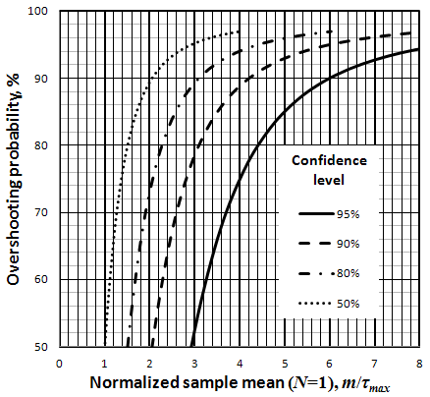
The curves presented in FIGURE 8 allow evaluating the deviation measurements’ results. For example, let us assume that we have done single measurement of time τ (therefore m=τ) and the measurement result is τ/τ_{max}=3. In this case, we can say that with 90% confidence level the probability of time τ to overshoot the value τ_{max} is equal to 79%. At 80% confidence level this probability is greater and equal to 94%.
If the measured value τ exceeds the 3τ_{max} , in this case with a high confidence level the probability of time τ to overshoot the value τ_{max} is close to one. That allows us to conclude that the value 3τ_{max} can be considered as an enforcement threshold.
If the measured time τ value lies between τ_{max} and 3τ_{max}, it is suggested to increase the number of measurements N to three. Calculation results, when sample mean is determined by measuring the value of time τ for three times (sample size N = 3), are shown in FIGURE 9, where the value k=0.4 has been used.
FIGURE 9
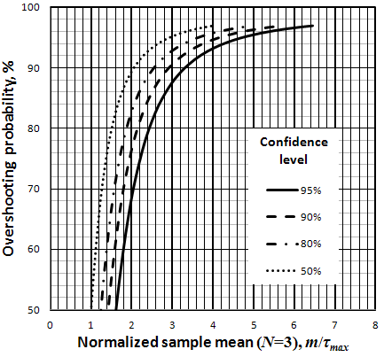

As follows from calculation results, in this case the conclusion if time τ to overshoots the value τ_{max} can be done by significantly smaller sample means.
It is clear that increasing the sample size N, the sample mean m converges to the “true” mean μ. Therefore, all the curves that correspond to N = 10, practically merge with the curve corresponding to 50% confidence level. Note, that the curve corresponding to 50% confidence level is nothing else but the probability for random variable τ to overshoot limit value τ_{max}, as shown in FIGURE 7.
In order to test the enforcement threshold efficiency, measurements of one FM station were made within several days. FIGURE 10 presents the measuring results of time τ (in total 97 sample values). The sample mean m of this series has been calculated. As the series length is quite long, it can be considered that it practically coincides with the true mean µ. The situation was modelled where the true mean µ coincides with the enforcement threshold 3τ_{max}. The enforcement threshold and overshooting time limit τ_{max} are presented in red lines in FIGURE 10. It was mentioned above (FIGURE 7) that in such situation 5% of measurements’ values shall be less than τ_{max}, and the rest 95% of values – higher than τ_{max}. 5% of 97 values of time τ is equal to 4.85. As seen in the FIGURE 10, 4 values are below τ_{max} level. Such a favourable coincidence confirms once more that distribution of time τ is close to normal.

FIGURE 10
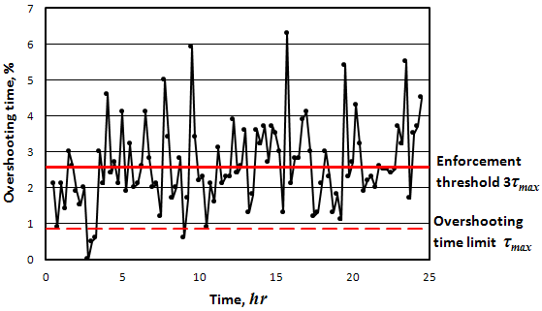

It is clear, that enforcement threshold 3τ_{max} is useful for Regulator. When Regulator writes a notification on violation to an Operator, he must be sure that the measured time τ exceeds the indicated value.

If broadcast operator tests deviation compliance with the set conditions, he must be sure that the measured time τ does not exceed the indicated value. In this case, it will be logical to introduce guard threshold. The calculation procedure could be an analogous to the enforcement threshold calculation procedure.

Statistics of measurement results of MPX power

Because of random origin of frequency deviation of FM station, not only time τ but also maximum values of MPX power (P_{m)} measurements do not repeat as well. For example, FIGURE 11 presents the measurement results of P_{m} of one FM station in Vilnius in the period of 4 hours (one P_{m} value was determined from MPX power measuring in the interval of 15 minutes).

FIGURE 11
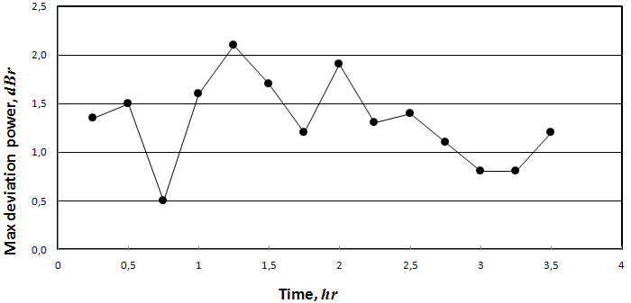

The same as in the case of time τ measuring, we often cannot make any conclusion from one P_{m} value about the compliance of MPX power to the requirements. Therefore we will try to establish a relation between P_{m} mean and the standard deviation.

5.1 Measurement procedure

During the tests, P_{m} values of 12 FM stations were measured, whose sample means were in the interval from about -1 dBr to +7 dBr. The measurements were carried out using Deva DB3000 FM modulation analyzer. Accuracy of the equipment is 0.2 dBr, and resolution – 0.1 dBr.

Measurement of every station took 900 minutes, and P_{m} values were estimated every 15 minutes. Thus series of 16 sample values for every station were collected.

5.2 Measurement result

Sample mean m and standard deviation s was calculated for every series. No obvious relation between these parameters was found (FIGURE 12).

FIGURE 12
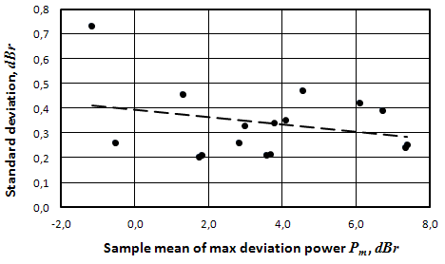

In order to determine distribution type of P_{m}, one FM station was measured within several days. During this time the series of 100 P_{m} values was collected.

To find out if separate P_{m} values from the collected series are independent statistically, test of series was applied. It showed that values from the series are independent statistically and there is no trend.

Histogram of the series is presented in FIGURE 13 (width of columns in the histogram is hold constant and is equal to 0.4 s). It is seen, that histogram has two explicit peaks and is absolutely different from normal distribution or any other known distribution.

FIGURE 13

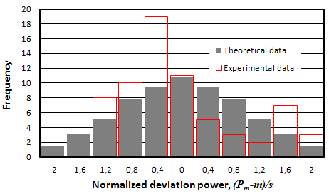
5.3 Evaluation of measurements results
P_{m} distribution was not identified. Therefore, in order to assess the P_{m} deviation from the mean μ we may use the well-known Chebyshev’s inequality:
(17)
As follows from equation (17), upper endpoint of prediction interval is:
$P_{m}^{+}=μ+s c ,$ (18)
and lower endpoint:
$P_{m}^{−}=μ−s c \text{.}$ (19)
Note that Chebyshev's inequality is universal and fits any type of distribution. Therefore, confidence intervals calculated by this inequality were usually wider than those which were calculated for a particular type of distribution.
Regulator must be sure that the majority of the measured P_{m} values exceed the P_{max} (0 dBr as limit value is recommended in the Recommendation ITU-R SM.1268-2). We shall evaluate the mean µ_{enf} when the upper endpoint of prediction interval is equal to 0 dBr. We shall consider that P_{m} does not overpass the endpoints of prediction interval with 10% probability (1/c²=0.1). Standard deviation (as can be seen on FIGURE 12), usually is close to 0.4 dBr. With the aid of equation (19), it follows that the mean µ is given by:
$μ_{\text{enf}}=\text{sc}=0\text{.}4\sqrt{\frac{1}{0\text{.}1}}=1,\text{26} (\text{dBr}) \text{.}$ (20)
As follows from the abovementioned, if the MPX power mean μ exceeds 1.26 dBr, then in 90% of the cases the measured P_{m} values exceed 0 dBr. The theoretical μ_{enf} value can be used as the enforcement threshold. But the experiment has shown that it is too high. The measurement results have shown that in any sample series the difference between the maximum and minimum P_{m} values did not exceed 1.8 dBr. Therefore, the practical enforcement threshold could be 0.9 dBr. 1 dBr may be considered as a practical value of enforcement threshold.
If state administration establishes maximum allowed P_{max}=3 dBr, it shall apply the enforcement threshold of 4 dBr.

Conclusions
A sample time τ, when deviation exceeds the maximum permissible value τ_{max}, is a random variable. Generally, it is impossible to calculate the standard deviation from one random measured value, and, therefore, it is impossible to forecast the change of a random variable. After processing of long series of deviation measurement results of FM stations, it was estimated that standard deviation of time τ is proportionate to the sample mean and distribution is close to normal. This allowed calculating of enforcement threshold value which can be used for measuring. Enforcement threshold of the time τ_{max}, which is equal to 1% and more, is 3 τ_{max}. Measurement result which exceeds enforcement threshold indicates that time τ exceeds τ_{max} with high probability. In those cases, when measured value of τ_{m} is in the interval between permissible overshooting time τ_{max} and enforcement threshold, it is better to execute more measurements.
Maximum value of MPX power which is observed during the fixed measurement time is also a random variable. Its enforcement threshold value was also calculated. This value exceeds the maximum allowed MPX power in 1 dB.

References
Julius S. Bendat and Allan G. Piersol (1986) Random data (Analysis and Measurements Procedures).A Wiley-Interscience Publication, New York, Chichester, Brisbane, Toronto and Singapore.

RECOMMENDATION ITU-R SM.1268-2*
Method of measuring the maximum frequency deviation
of FM broadcast emissions at monitoring stations

(1997-1999-2011)

Scope
This Recommendation describes methods to measure deviation and multiplex power of FM broadcasting stations during normal programme operation and verify compliance with the conditions assumed by broadcast network planning procedures.
The ITU Radiocommunication Assembly,
considering
a) that planning parameters of FM broadcasting networks are provided in Recommendation ITU-R BS.412;
b) that protection ratios for the planning of broadcasting transmitter frequencies are based on a maximum frequency deviation of ±75 kHz (or ± 50 kHz) and a maximum power of the modulation signal which does not exceed the power of a sinusoidal tone which causes a ±19 kHz frequency deviation;
c) that various broadcast transmissions exceed the maximum frequency deviation and/or modulation power owing to different types of programmes, additional components of the composite signal (e.g. radio data system (RDS)) and audio compression;
d) that limitation of peak frequency deviation and modulation power is required owing to mutual protection of broadcast planning and the aeronautical radionavigation service in the frequency band above 108 MHz;
e) that monitoring of broadcast emissions is necessary to prevent transmissions from exceeding a maximum frequency deviation and a maximum modulation power;
f) that common measurement procedures are necessary in order to achieve mutual acceptance of measurement results by the parties concerned, e.g. frequency managers, monitoring services and broadcasters;
g) that the number of broadcasting stations using additional signals as RDS and high speed data signals is increasing and these systems are highly sensitive to interference from adjacent channels,
recognizing
a) that the method described in Annex 1 is a simple “go-no go” test based on a spectrum mask which cannot replace precise measurements of the frequency deviation;
b) that the method described in Annex 1 cannot be applied on transmissions with 50 kHz peak deviation due to the fact that no appropriate spectrum mask is available;
c) that the method described in Annex 2 is also applicable on transmissions with 50 kHz peak deviation,
recommends
1 that the method described in Annex 1 may be used as a verification to indicate whether the frequency deviation of an FM broadcasting station exceeds the limits;
2 that the method described in Annex 2 should be used when the values of the deviation and modulation power are required.

Annex 1
Simple spectrum mask based method to indicate the exceeding
of frequency deviation limits

Requirements
For this measurement any spectrum analyzer and test receiver with analyzer capabilities can be used.

Connection transmitter and spectrum analyzer
With the aid of a measurement antenna.

Measurement conditions
– the measurement time should be at least 5 min during three measurements of 5 min each, the transmitter to be judged should be modulated with a representative programme material for that particular transmitter. Additional measurements may be carried out to ensure that the programme material is truly representative;
– impulse interferences should not occur (for example interference from an ignition source);
– signal/(interference + noise) should be ≥ 50 dB.

Adjustments of the spectrum analyzer
The spectrum analyzer should be adjusted as follows:
– center frequency (CF) = f0 (carrier frequency of the transmitter);
– RBW 10 kHz (IF filter);
– VBW 10 kHz (video filter);
– span: 340 kHz;
– sweep time: 340 ms (1 ms/kHz);
– max hold mode;
– input attenuation is dependent on input level.
Settings for digital signal processor (DSP) analyzers will be different but should provide equivalent results.

Measurement instruction
a) Record the transmitter signal over a 5 min period.
b) Observation of the analyzer and acoustic controls at the receiver should be used as a means to ensure that no measurement results are evaluated which have been distorted by impulse interference. For the same reason the measurement is repeated twice.
c) Overlay the graphical measurement with the mask as described in § 7.
d) The center of the x-axis of the mask shall correspond with the center frequency (f0).
e) Adjust the reference level so that the maximum amplitude of the measurement corresponds to 0 dB.
f) Determine whether the measurement is within the limits of the mask.

Limits
If any of the measured spectra exceeds the mask, the transmitter deviation is assumed not to meet the requirements.

Mask construction
a) The calibration of the mask should be consistent with the analyzer settings.
b) The center of the x-axis is aligned to f₀.
c) The top of the y-axis corresponds with the 0 dB reference level.
d) Straight lines connect the coordinates:

x-axis  (kHz) | y-axis  (dB) |  | x-axis  (kHz) | y-axis  (dB)
f₀ – 74 | 0 |  | f₀ + 74 | 0
f₀ – 107.5 | –15 |  | f₀ + 107.5 | –15
f₀ – 124 | –30 |  | f₀ + 124 | –30
f₀ – 152.5 | – 40 |  | f₀ + 152.5 | – 40

The graphic display of the table is shown in Fig. 1.
FIGURE 1
Shape of the mask

Annex 2
Method of measuring the maximum frequency deviation
of FM broadcast emissions at monitoring stations

1 General

1.1 Definitions
Frequency deviation:
In the case of frequency modulation, deviation of the frequency from the frequency of the unmodulated carrier f₀.
Instantaneous deviation:
In the case of frequency modulation, the instantaneous deviation Δf(t) is the difference between the instantaneous frequency at any given time (t) and the unmodulated carrier frequency (f₀). The instantaneous frequency is:

f(t) = f₀ + Δf(t)
Peak deviation:
In the case of frequency modulation, the peak deviation Δf is the absolute maximum of the difference between the unmodulated carrier frequency (f₀) and the instantaneous frequency f(t).
Composite signal:
This signal includes all stereo information (including the pilot tone) and may also include the traffic radio signal, the RDS signal and other additional signals.
Modulation power:
The relative power averaged over 60 s of the modulation signal according to the formula:

modulation power = 10 log {(2/60 s) ∫(Δf(t)/19 kHz)² dt} dBr

0 dBr:
Is the average power of a signal equivalent to the power of a sinusoidal tone which causes a peak deviation of ±19 kHz.

1.2 Introduction
There are various reasons, such as a reduction in the time required for the measurements, which make it seem sensible to carry out frequency deviation measurements in the field and not directly at the transmitter output. Compliance by the signal to be measured with the characteristics listed below is required in addition to compliance by the measuring equipment with the requirements described in § 3 in order to avoid measurement uncertainties.

1.3 Limits
The protection ratios specified in Recommendation ITU-R BS.412 for the planning of FM sound broadcasting transmitters apply on the condition that a peak deviation of ±75 kHz is not exceeded and that the average modulation power over any interval of 60 s does not exceed that of a single sinusoidal tone which causes a peak deviation of ±19 kHz.

1.4 Observation Measurement time
The measurement should represent typical modulation of the programme material of the broadcasting station. The observation measurement time should be at least 15 min or in some cases one hour may be required to be sure to measure representative programme material.

2 Required conditions for measurements

2.1 Required wanted-to-unwanted RF signal level ratio E_{n}/E_{s} at the measurement equipment
This ratio depends on the characteristics of the equipment used for the measurements. For the required accuracy defined in §§ 3.1 and 3.2, the level of unwanted emissions has to be below the values given in Tables 1 and 2.
Measurement receivers usually have either Gaussian or channel filters. In practical environments, Gaussian filters may be less suitable for peak deviation measurements than channel filters.
a) Measurement receivers with Gaussian IF filters
TABLE 1
Frequency difference ± Δf  (kHz) | Required protection ratio  (dB)
0 | 40
X | $$\text{40}−\text{20}\text{*log}\left(e^{−\text{ln}\sqrt{2}∗(\frac{2X}{B})^{2}}\right)$$

In Table 1, “B” is the nominal 3 dB bandwidth of the measurement filter in kHz.
The following diagram illustrates the required protection ratios with three example measurement bandwidths.
FIGURE 2
Required protection ratios for receivers with Gaussian filters
b) Measurement receivers with channel filters
TABLE 2
Frequency difference ± Δf  (kHz) | Required protection ratio  (dB)
0 | 40
B/2 | 35
X (for X > B/2) | 35 – 0.2*(X – B/2)

In Table 2, “B” is the nominal 3 dB bandwidth of the measurement filter in kHz. A linear interpolation is used between discrete values. The following diagram illustrates the required protection ratios with three example measurement bandwidths.
FIGURE 3
Required protection ratios for receivers with channel filters

It is essential that the applicable protection ratios given above are observed because even a minor increase in unwanted signal levels will result in considerable measurement errors.

2.2 Multipath propagation and distortion
Delayed signals from the wanted transmitter as well as signals from other co-channel or adjacent channel transmitters shall be small enough to ensure that measurement results are not influenced by the effects of multipath propagation. In case of multipath reception only, it is considered to be sufficient if the product of delay time and amplitude ratio in percent is:

(U_{r}/U_{d}) ⋅ τ < 64% ⋅ μs (1)

where:
U_{r}: amplitude of the reflected signal
U_{d}: amplitude of the direct signal
τ: time delay (µs).
A more general way of specifying the distortion created by both multipath reception and signals from other transmitters is based on the fact that all of these components result in a certain amplitude modulation of the received signal. This resulting amplitude modulation is best defined by the maximum gradient of the dependence of RF amplitude on RF frequency and is called distortion degree. Its value is easily measurable with reflection meters. The corresponding maximum permissible gradient for stereophonic reception is:

d(U/U_{d})/df < 0.4%/kHz (2)
where:
U: the total amplitude of the received signal.
It is essential that the distortion degree does not exceed the limits above, because even minor increases will result in considerable measurement errors.

2.3 Wanted signal level at the receiver input
To ensure a sufficient AF signal-to-noise ratio, the wanted signal input level for the receiver should be at least –47 dBm.

3 Characteristics of suitable measuring equipment
To ensure that all the peaks of the frequency deviations are captured, the equipment must be able to detect the deviation caused by the highest component of the base band signal or composite signal.
For this reason must be used, if only digital measuring equipment is used, it must have a with sampling rate of 200 kHz or higher depending on the maximum composite signal frequency.

3.1 Reflection measurements
Due to a lack of directivity of the measurement antenna, it will in most cases not be possible to measure the field strengths of wanted and unwanted emissions separately and use formula (1) to calculate the degree of distortion and multipath propagation. A more practical way to measure this parameter is the use of reflection meters that actually measure the amount of amplitude modulation in the received signal and compute the degree of multipath propagation using formula (2).
Ideally the reflection meter shall have a measurement bandwidth of 150 kHz. However, most reflection meters available have a bandwidth that is considerably smaller. In this case, the maximum permissible degree of multipath propagation is less than the 0.4%/kHz stated in § 2.2. FIGURE 4 shows the corrected values for maximum indicated degree of distortion, depending on the measurement bandwidth of the reflection meter.

3.2 Frequency deviation measurements
The measuring equipment used should be able to measure deviations of 100 kHz or higher. In addition, the measuring equipment must possess such characteristics that take into account the required measurement bandwidth, filter shape factor, etc. to ensure that nonlinearity and distortion do not lead to an inaccuracy greater than specified in Table 3.
FIGURE 4

TABLE 3
Instrument accuracy for deviation measurements
Instantaneous deviation | Required accuracy
≤ 80 kHz | ± 2 kHz
> 80 kHz | ± 5%

3.3 Modulation power measurements
The modulation power (dBr) is specified in dBr according to § 1.1. The measuring equipment shall be able to measure modulation power in the range from −6 dBr to +6 dBr. The instrument accuracy shall at least meet the values specified in Table 4.

TABLE 4
Instrument accuracy for modulation power measurements
Modulation power  (dBr) | Required accuracy  (dB)
< –2 | ± 0.4
–2 to + 2 | ± 0.2
> 2 | ± 0.4

4 Result evaluation
It is considered inappropriate to regard the occurrence of single measurement samples above 75 kHz as a violation of the deviation limit, because:
a) the dynamic modulation of an FM broadcast transmitter by normal programme content may include modulation peaks that occur extremely seldom, and may not be reproducible in a second measurement;
b) even when the measurement conditions stated in § 2 are met, external interference cannot completely be avoided at all times.

For these reasons and depending on the frequency interval between stations, the maximum permissible deviation overshooting time τ_{max} may be set from 10^{–4} % to 1-10 %. Deviation overshooting time τ is a random variable. In order to make a decision if the overshooting time τ, obtained in one measurement, exceeds the maximum overshooting time τ_{max}, it is useful to introduce the enforcement threshold τ_{max} (Fig. 5). In Fig. 5. the situation is shown, when the mean value of overshooting time τ is equal to the enforcement threshold. In case the measurement result exceeds the enforcement threshold, overshooting time τ exceeds maximum overshooting time τ_{max} with a high probability. When τ_{max} is set from 10^{–4} % to 1-10 %, the enforcement threshold is equal to 3τ_{max}. For the maximum overshooting time τ_{max} =10^{–4} % the enforcement threshold τ_{Et} is equal to 5,6·10^{–4} %. When the measurement result is between the enforcement threshold τ_{Et} and overshooting time limit τ_{max} it is recommended to make several additional measurements.

FIGURE 5
Overshooting time variation
For these reasons, and considering the measurement uncertainty with an aimed confidence level of 95%, an FM broadcast transmitter can be regarded as violating the deviation limit if a certain number of measurement samples exceed ± 75 kHz (plus measurement uncertainty). 10^{–4}% of the measurement samples exceeding 77 kHz deviation may be considered as a practical value.
Overshooting time τ is a relation of the number of measurement samples exceeding ± 75 kHz (plus measurement uncertainty) with total number of measurement samples.

Since the modulation power is averaged over a period of 60 s, short peaks included in the programme content or caused by external interference are already cancelled out to a great extent. Therefore, an FM broadcast transmitter can be regarded as violating the modulation power limit if the highest measured multiplex power value exceeds 0.2 dBr.
The maximum measured multiplex power (MPX power) in a certain time period is also a random variable. In this case the use of 1 dBr enforcement threshold is also recommended.

5 Presentation of measurement results

5.1 Modulation power
The modulation power shall be presented as a function of time during the measurement interval as shown in Fig. 6. The maximum value recorded must be indicated.

5.2 Frequency deviation
Frequency deviation shall be presented as a accumulated distribution plot of deviation as shown in Fig. 7. Drawing the accumulated distribution plot, it is recommended to use a step of no more than 1 kHz. The maximum recorded value must be indicated.
To provide more information the deviation is better represented by histograms and as a function of time rather than only displaying the highest value in a “Max Hold” mode over a certain period of time. Histograms of frequency deviation are processed as follows:
a) obtain N peak hold values of the deviation each taken during a measuring time of 50 ms. The measuring time has influence on the distribution plot and hence must be standardized in order to ensure repeatability. The 50 ms ensures that the peak values of the deviation are captured even at modulating frequencies as low as 20 Hz;
b) divide the range of frequency deviation of interest (i.e. 150 kHz) into the desired resolution (for example 1 kHz) to give the number of bins (in this case 150 bins);
c) for each bin, count the number of samples which have a value within the bin. The result is a distribution plot of the deviation as shown in Fig. 5;
d) add counts in each bin from left to right and normalize by N. The result is a plot of the accumulated distribution as shown in Fig. 6 which starts with a probability of 100% from the left side and will finish with a probability of 0% at the right side;
e) additionally the N peak hold values of the frequency deviation shall be presented as a function of time during the measurement interval.

FIGURE 5
Distribution plot of deviation

FIGURE 67
Accumulated distribution plot of deviation

FIGURE 6

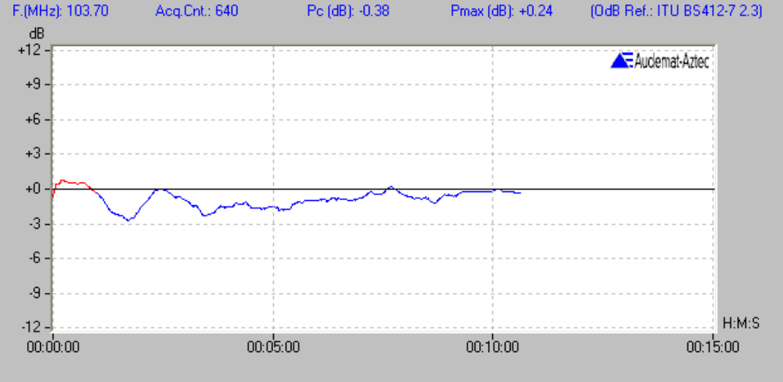

FIGURE 7
Accumulated distribution plot of deviation
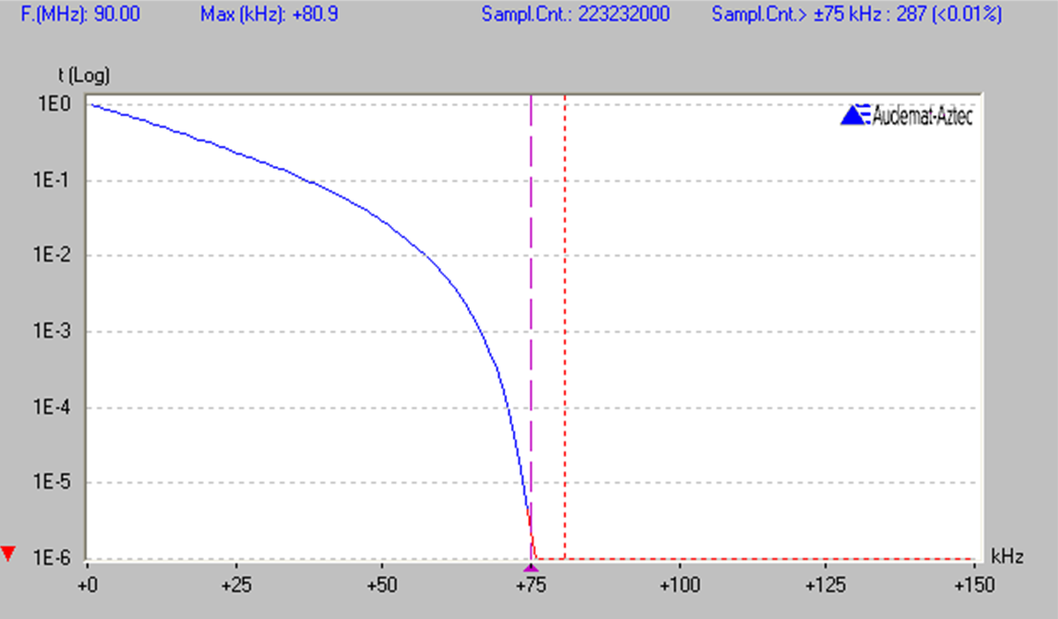

* This Recommendation should be brought to the attention of Radiocommunication Study Group 6.
This corresponds to a field strength of about 68 dB(µV/m) using an antenna as recommended in Recommendation ITU-R BS.599, Fig. 1, Curve B (12 dB front-to-back ratio).

