Project Team FM22
45st Meeting of FM22  Budapest, 12 – 15 April 2016 | FM22(16)14

Date issued: 07 April 2016

Source: Lithuania

Subject: Determination of the radiated power of radio station through field strength measurement along a route
N
Password protection required? (Y/N) *

Summary

The paper presents a method proposed to be used for determination of the radiated power of a radio station. The proposed method is based on the comparison of field strength values measured along a route with the calculated field strength values. This method is basically frequency-independent. For the purpose of verifying efficiency of the method, signal field strength of several FM broadcast radio stations was measured along selected routes. The field strength in these cases was calculated using two-ray model. The results indicated that the proposed method worked very well.

Proposal
FM22 members are invited to contribute to further development of proposed method.

Background
Performing spectrum supervision and inspections of FM radio broadcasting stations on-site, for Lithuanian spectrum administration it became actual topic on determination of the radiated power through field strength measurements in the frequency range from 87.5 MHz to 108.0 MHz. With respect to this problem, Lithuanian administration prepared methodology which allows to determine radiated power of radio station through the field strength measurements.

Introduction
Usually the radiated power of radio stations is determined indirectly through the RF power measurements at the output of a transmitter and further calculation by taking into account cable losses and antenna gain. It is sometimes impossible to use this method of measurements for inspection or radio monitoring services because there is no access to a transmitter site or there is no technical possibility to attach a power meter to the transmitter output. Reference [1] provides a measurement method to determine the radiated power from field strength measurements. This method allows excluding the influence of ground reflections because of information gained from a height scan of the field strength. Unfortunately, this measurement method loses accuracy for frequencies below 400 MHz because the height accessible by customary measurement antennas (10 m) will not be sufficient to capture both the maximum and the minimum of distribution of the main beams’ field strength. Therefore, it is difficult to apply this method for determination of the radiated power of broadcast radio stations which use the frequencies from 87.5 to 108 MHz and from 174 MHz to 230 MHz. However in paper [2] it is shown that is some cases this method can be applicable.
The main purpose of this paper is to propose another off-air method to determine the radiated power of a radio station. It is based on the comparison of the field strength values measured along a route with the calculated field strength values. Obviously, the effectiveness of the proposed method mainly depends on the radio propagation model used for the field strength calculation. For testing the proposed method, the two-ray interference model was used. This model is well-known, but only its simplified version for long distances is well-described and widely used. For the purpose of the proposed method, a fully-featured two-ray model should be used.

Two-ray fully-featured interference model for flat surface
The two-ray model is an improved version of the free space propagation model. It considers both line-of-sight (direct) and ground reflection paths and is based on geometric optics. It is reasonably accurate for predicting the large-scale field strength at a distance of several kilometres.
  - Analytical modelling
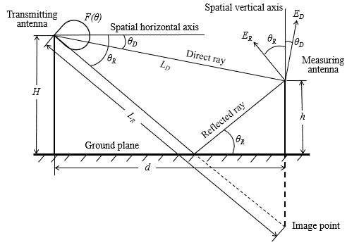
Fig. 1. Graphical representation of the two-ray model applied for a vertically polarized wave.
Following the notations in Fig. 1, the length of direct propagation path can be geometrically derived to be
$L_{D}=\sqrt{(H−h)^{2}+d^{2}} ,$ (1)
and the length of indirect due to ground reflection path derived to be
$L_{R}=\sqrt{(H+h)^{2}+d^{2}} \text{.}$ (2)
The grazing angle θ_{R} and angle θ_{D} can be derived to be
$θ_{R}=\text{arctg} (\frac{H+h}{d}) ,$ (3)
$θ_{D}=\text{arctg} (\frac{H−h}{d}) \text{.}$ (4)
Based on the lengths L_{D} and L_{R}, on the equivalent isotropically radiated power P, on directivity of the transmitting antenna in vertical plane F(θ) and on the magnitude R and phase φ(θ) of the ground reflection coefficient, the direct wave can be expressed as
$E_{D}=\frac{F(θ_{D})\sqrt{\text{60}P}}{L_{D}}\text{sin}[2πf(1−\frac{L_{D}}{c})] ,$ (5)
and the reflected wave can be expressed as
$E_{R}=\frac{R(θ_{R})F(θ_{R})\sqrt{\text{60}P}}{L_{R}}\text{sin}[2πf(1−\frac{L_{R}}{c})+ϕ (θ_{R})] ,$ (6)
where f – the transmitting frequency; c – the velocity of light in free space.
When doing field strength calculations, the type of wave polarization should be taken into account. In case of horizontal polarization, the electric vector of direct wave is horizontal to the reflecting surface. The electric vector of reflected wave also is horizontal to the reflecting surface. So, these two vectors are parallel, and the total field strength can be calculated by adding the direct and the reflected waves accounting for difference of phases. As follows from the equations (5) and (6), the phase difference is
$\text{ΔΦ}=\frac{2πf}{c}(L_{R}−L_{D})+φ (θ_{R}) \text{.}$ (7)
Therefore, for the total field strength we obtain:
$E_{H}=K_{H}\sqrt{\text{60}π P} \text{sin}(2πf),$ (8)
where
$K_{H}=\left\{{\left[\frac{F(θ_{D})}{L_{D}}\right]}^{2}+{\left[\frac{R F(θ_{R})}{L_{R}}\right]}^{2}+\right.{\left.\frac{2R}{L_{D}L_{R}}F(θ_{D})F(θ_{R})\text{cos} (\text{ΔΦ})\right\}}^{\frac{1}{2}}\text{.}$ (9)
As follows from equations (8), the r.m.s value of the total field strength is equal:
$E_{H}=K_{H}\sqrt{\text{30}π P} \text{.}$ (10)
In case of vertical polarization, the electric vectors of direct and reflected waves lay in the plane of incidence. The visualization of this situation is shown in Fig. 1. Therefore, the total field strength can be calculated by adding the direct and the reflected waves accounting for difference of directions and difference of phases.
Following the notations in Fig. 1 the vertical component of the total field strength is equal:
$E_{V}=E_{D}\text{cos}θ_{D}+E_{R}\text{cos}θ_{R} \text{.}$ (11)
The difference of phases between $E_{D}\text{cos}θ_{D}$ and $E_{R}\text{cos}θ_{R}$ is given by equation (7). Finally, in the case of vertical polarization, for r.m.s value of the total field strength we obtain the expression similar to expression (10), but with different function K_{V} :
$E_{V}=K_{V}\sqrt{\text{30}π P} ,$ (12)
$K_{V}=\begin{aligned}\left\{{\left[\frac{F(θ_{D})\text{cos}θ_{D}}{L_{D}}\right]}^{2}+{\left[\frac{\text{RF}(θ_{R})\text{cos}θ_{R}}{L_{R}}\right]}^{2}+ | \right\}\end{aligned}{\left\{\right\}}^{\frac{1}{2}} \text{.}$ (13)
When distance d is very long relatively to the height of the transmitting antenna H and receiving antenna h, the angles θ_{D} and θ_{R} are close to zero, the reflection coefficient is close to 1, and expression (10) and (12) simplifies and transforms into expression [3]:
$E=\sqrt{\text{30}π P} \frac{4π\text{Hh}f}{d^{2}c} \text{.}$ (14)
This equation is usually called the Vedenskij’s formula. The limits of Vedenskij’s formula application can be found from Figure 2. Calculations has shown that curves in this picture practically do not change when h=3 m and H varies within 50-200 m.
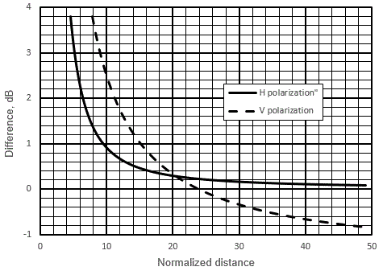
Figure 2. Dependence of the field strength difference between calculated in line with Vedenskij’s formula and equations (8) (H polarization) or equations (2) (V polarization), on normalized distance d/(Hhf/c) (h=3 m, f=100 MHz).
It is seen that at the difference of 1 dB for horizontal polarization, Vedenskij’s formula can be applied starting from normalized distance equal to 10, and for vertical polarization – starting from 15. It is easy to show, that the normalized distance equal to 10 corresponds the grazing angle of 5.3°, the normalized distance equal to 15 – 3,5°.
The equations for total field strength (10), (12) and (14) are more useful when expressed logarithmically:
$E_{H}(\text{dB}{μV}/m)=P(\text{dBW})−\text{20}\text{log}K_{H}+\text{134},\text{77} ,$ (15)
$E_{V}(\text{dB}{μV}/m)=P(\text{dBW})−\text{20}\text{log}K_{V}+\text{134},\text{77} \text{.}$ (16)
$E(\text{dB}{μV}/m)=P(\text{dBW})+\text{20}\text{log}(4{πHhf}/c)−\text{40}\text{log}d+\text{134},\text{77} \text{.}$ (17)
  - Computing of field strength
Data processing and computation were carried out with Microsoft Excel 2010. For the purpose of field strength calculations separate Excel templates were created for several types of transmitting antennas. Directivity of the transmitting antenna in vertical plane F(θ) was described using two approximating polynomials. As the main beam is symmetrical, it is enough to describe only one side of it. Usually the third order polynomial was used for its’ description. The first side lobe was described using the sixth degree polynomial. The coefficients of polynomials were determined using MS Excel.
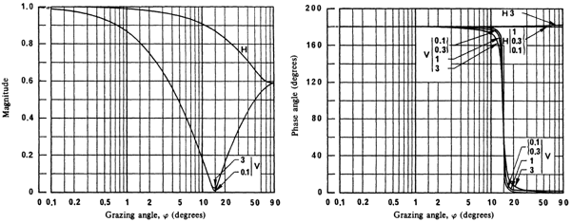
Fig. 3. Magnitude and phase of the reflection coefficient of a plane surface and medium dry ground as function of grazing angle for vertical V and horizontal H polarizations [4] (the frequencies are given in GHz).
Dependencies of magnitude and phase of the reflection coefficient on grazing angle were taken from [4] and are presented in Fig. 3. It can be seen that for horizontal polarization the magnitude of a reflection coefficient changes smoothly with the change of a grazing angle, so it was precisely described using one polynomial of the sixth degree. For vertical polarization, the magnitude of a reflection coefficient has a sharp deep minimum at a grazing angle of 15 degrees (Brewster‘s angle). For that reason, the reflection coefficient was described using two separate polynomials in the ranges from 0 to 15 degrees and from 15 to 90 degrees of grazing angle. As follows from [3], the phase of the reflection coefficient is equal to 180 degrees for horizontal polarization, and it decreases from 180 degrees to 0 degrees with the change of grazing angle from 10 to 20 degrees for vertical polarization. Because the magnitude of the reflection coefficient in this range is less than 0.2, without significant influence on calculations of the total field strength we can presume that the phase of reflection coefficient is equal to 180 degrees in the range of grazing angle from 0 degrees to 15 degrees, and it is equal to 0 in the range of grazing angle from 15 to 90 degrees.
Excel template has been created where fixed ground distance d range from 100 m to 11,000 m with step of 10 m. After entering the heights of transmitting and receiving antennas, transmitting frequency and power, the values of L_{D} and L_{R}, angles θ_{D} and θ_{R} and corresponding antenna directivity, reflection coefficient magnitude and phase values are calculated automatically for every distance value. As the final result, the values of the total field strength were calculated by formulas (15) and (16) for each fixed distance value and represented graphically.
As an example, the results of field strength calculation for a FM broadcast radio station with typical narrow beam antenna are presented in Fig. 4. In this case, beam width in vertical plane is equal to 14 degrees. For transmitting antenna with such a narrow beam width it is possible to ignore the antenna directivity only for longer distance than 2 km. It can be seen from Fig. 4 that there are significant variations between vertical and horizontal field strengths near the transmitting antenna.
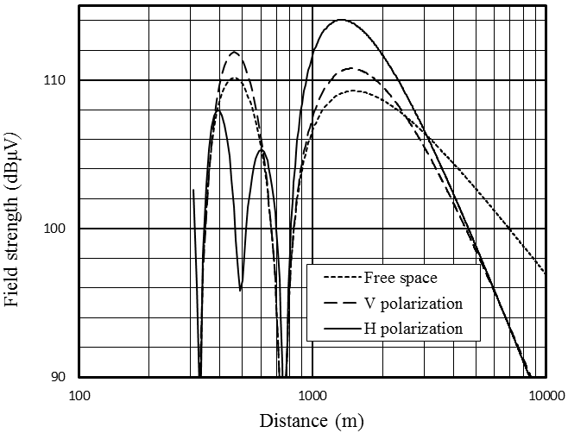
Fig. 4. Calculation result of field strength at 3.8 m for FM broadcast radio station. Station parameters: equivalent isotropically radiated power – 30 dBW; frequency – 104.1 MHz; antenna height above the ground – 200 m; antenna model – four bays of vertically stacked antenna arrays (without null fill) desired of panel antenna K5231187.
- The procedure for determination of radiated power
For the purpose to determine the radiated power from the field strength measurement, we assume that the difference between the measured and the calculated values occurs only because the incorrect radiated power value in the model is used. So this radiated power value should be adjusted in such a way, that the best fit between theoretically calculated and experimentally measured data curves is achieved. Thus, the adjusted value P_{m} is the value of radiated power, determined from the field strength measurement along the route.
For data fitting we used Root-Mean-Square Error (RMSE), which is a frequently used measure of the differences between the values calculated according to the model and the measured values. In our case the expression for RMSE is
$\text{RMSE}={\left[\frac{1}{N}\sum_{i=1}^{N}{(E_{i}^{m}−E_{i}^{c})^{2}}\right]}^{\frac{1}{2}} ,$ (18)
where N – number of points along the route; $E_{i}^{m}$ and $E_{i}^{c}$ – measured and calculated field strength values at the point i.
As mentioned above, the field strength was calculated at a ground distance from the transmitting antenna from 100 m to 11,000 m with 10 m step. The measurements were performed without accurately fixed step size with length of about 0.3 m. Therefore, in order to calculate the RMSE the route was divided into 10 meter sections and mean of field strength in each section was calculated using Microsoft Excel. These mean values were used as the values $E_{i}^{m}$ in equation (18).
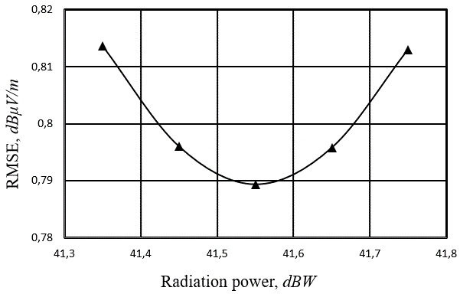
Fig. 5. Root-Mean-Square-Error dependence on the radiated power used in calculations.
As an example, RMSE dependence on the radiated power that was used in calculations for some route is shown in Fig. 5. It can be seen from the graph that the best-fit radiated power is equal to 41.55 dBW. It is interesting to note that the arithmetic mean of all measured data along the route${\bar{E}}^{m}$ is equal to arithmetic mean of all calculated data ${\bar{E}}^{c}$on the condition that the best-fit radiated power P_{bf} was used in the model. This fact allows simplifying the procedure for determining the best-fit radiated power.
Assuming the measurements carried out, we set the arithmetic mean of field strength along the route${\bar{E}}^{m}$. Then we have calculated the arithmetic mean of field strength ${\bar{E}}^{c}(P_{a})$at a freely set radiated power value P_{a} (convenient if value P_{a} is equal station’s authorized radiated power). Now we can calculate new value of radiated power:
$P_{m}(\text{dBW})=P_{a}(\text{dBW})+({\bar{E}}^{m}−{\bar{E}}^{c}) \text{dB} \text{.}$ (19)
As the field strength is linearly dependent on the radiated power, it is obvious that the calculated mean ${\bar{E}}^{c}(P_{a})$will coincide with the measured mean ${\bar{E}}^{m}$. This leads to the conclusion that P_{bf} and P_{m} values are equal. This fact allows simplifying the procedure for determination of radiated power of a radio station and performing it in three stages:
- for the selected route, an arithmetic mean ${\bar{E}}^{c}$of the field strength is calculated for a station’s authorized radiated power P_{a};
- the field strength along the route is measured and its arithmetic mean ${\bar{E}}^{m}$is calculated;
- transmitter’s radiated power P_{m} is calculated according to the expression (19).
The results obtained by using this method are listed below and then we will interpret them as the measurement results.
- Experimental validation of the method
It should be noted, that experimental validation of the method was possible because reliable data on the station’s antennas radiation patterns, the height above the ground, authorized radiated power and the transmitter’s authorized power were available.
In order to verify the efficiency of proposed method in practice, we used several FM broadcasting radio stations in rural environment. In the area of each radio station there were selected suitable routes along which the measurements of stations’ field strength was done.
The theoretical calculations of this stations field strength were performed using the actual values of the radiated power P_{a}, which was determined in this way. The transmitter’s operating power and the corresponding station’s operating radiated power are specified in the stations’ authorizations. Evidently, this station’s authorized radiated power in dBW is equal to the transmitter’s authorized power in dBW plus sum of cable losses and antenna gain in dB. During the on-site inspection the difference between the transmitter’s actual and authorized power was measured. It follows that the actual value of the radiated power is equal to the authorized radiated power plus this measured power’s difference. The results showed that the actual values of radiated power at 0.1-0.9 dB differed from the authorized values.
In most cases the surface of the measurement area was not completely flat, and it’s height does not coincide with the area where broadcast station transmitting antenna mast is built. This might be dealt with the introduction of effective transmitting antenna height H_{ef}. Using digital map with terrain heights, the height of antenna mast area above the sea level H_{A} is determined. The selected route terrain heights should be also checked, and the average route height above the sea level H_{av} should be determined. Practically we have taken the average of the highest and the lowest points of the route. Then the effective antenna height H_{ef} was calculated as follows:
$H_{\text{ef}}=H+H_{A}−H_{\text{av}} \text{.}$ (20)
Determined this way, the effective antenna heights have been used for field strength calculations.
In case the route direction did not match the exact direction of the antenna beam axis, an azimuth correction Δ_{az} was applied. Usually the deviations from the beam axis were not significant, so the correction value was calculated simply by taking from antenna’s H plane pattern the value of field strength decrease at the route’s beginning and at the end of the route and taking the average of them This correction value was added to the calculated value of P_{m} in line with equation (19).
Selection of routes, field strength measurements along these routes and techniques of measured data processing are described below.
4.1. Equipment used for field strength measurement
Field strength measurements on-the-go with geographical coordinate registration were made using the mobile monitoring station of the Communications Regulatory Authority. This station is used for general purposes and is equipped with all necessary monitoring equipment including monitoring antennas, GPS receiver and antenna, telescopic mast, generator and etc. Workplace for one operator is equipped with a computer and writing area. With the mast down, this station can operate in motion (Fig. 6).
Specifically, in this case, antenna R&S HK116 and spectrum analyzer R&S ESPI-7 were used for field strength measurement. For control of the spectrum analyzer, download of raw data and for collection of GPS information a portable computer was used.
Measurement system every 30 msec records the data of time, field strength level, direction, latitude, longitude and line-of-sight distance away from transmitting antenna mast. During the measurement the vehicle moved at 32 km/h speed so the distance between measurement points was about 0.3 m. According to [5], the distance between the measurement points must be less than 0.8 wavelengths. This requirement is completely fulfilled because the wavelength of a radio wave with a frequency of 88 MHz is 3.4 m.
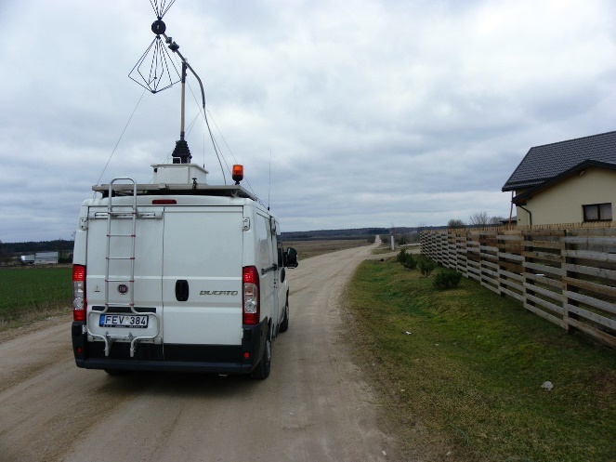
Fig. 6. The view of the mobile station with the measuring antenna in an operating position.
When performing the field strength measurements, it is essential that the measurement antenna be pointed directly to the transmitting antenna. This requirement is usually fulfilled if the mobile station moves in radial routes from or to the transmitting antenna. During the measurement the chosen height of the measuring antenna is 3.8 meters. Such antenna height is the maximum possible when vehicle is moving. Experimental measurements showed that at this antenna height the influence of a vehicle body on measurement results can be eliminated only when transmitting antenna is facing the rear of the vehicle. In case the vehicle faces the transmitting antenna, measured field strength values are about 2 dB higher. Therefore, measurements were carried when the car was moving away from the transmitting antenna mast.
The field strength measurement error basically depends on the accuracy of the measuring instruments: antenna R&S HK116 and spectrum analyzer R&S ESPI-7. According to calibration certificates, HK116 antenna factor calibration uncertainty is equal to ±1 dB and ESPI-7 level measurement uncertainty (at 100 MHz frequency) is equal to ±0.2 dB. Thus, in the worst case measurement error due to the inaccuracy of the measuring instrument does not exceed 1.2 dB.
4.2. Route selection
First of all, the route should be selected across the radial line from the transmitting antenna. There are two reasons for this. The first reason is that in such case the vehicle body has no influence on measurement results. The second reason is that it is easy to evaluate the transmitting antenna directivity in horizontal plane if needed. Needless to say that the route should coincide with antenna’s beam axis (the axis of maximum radiation, passing through the center of the main lobe).
Secondly, the route should be selected in the rural area. In this case the reflections from high buildings, big structures and etc. will be avoided. Moreover, this helps to ensure that ground electrical properties will not vary significantly along the route.
Route selection starts from selection of suitable country road in the area of inspected FM broadcast radio station, and satellite maps help with this task a lot. Only a suitable section of the road may be used for measurements along the route. It is important that the section’s length is not less than 300-400 m, and it is not closer than 1 km from the transmitting antenna mast. If possible, it should be also checked whether there are no local height variations exceeding 5-10 meters along the route.
Physical location survey was the second stage of route selection. During visual inspection of the route, any obstacles such as tall trees, hills and structures capable of causing obstruction of radio waves along the line of sight were taken into account.
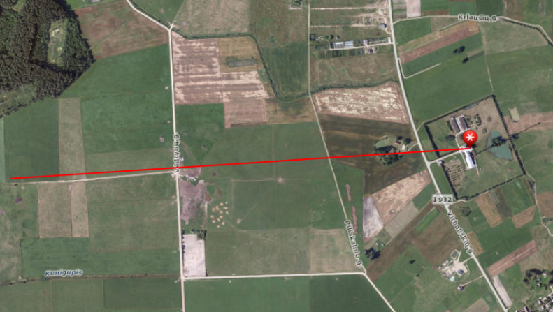
Fig. 7. Satellite map showing appropriate route in a rural area.
This way several routes were selected around every FM station. As an example, the map and the view of some route are shown in the Fig. 7 and Fig. 8 respectively. The parameters of routes and some FM broadcast radio stations are shown in the Table I. This Table also includes the parameters of transmitting antennas. All inspected FM broadcast radio stations used broadband antenna systems, consisting of one to four bays of vertically and horiziltally stacked antenna arrays.
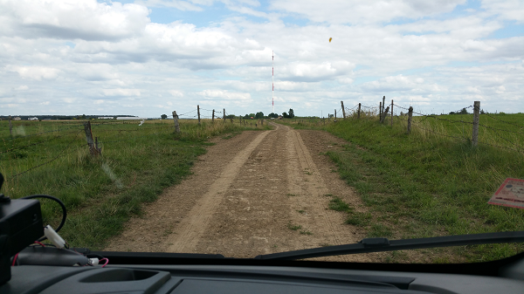
Fig. 8. View of the dirt road leading directly to the transmitting antenna mast.
The selection of suitable route does not cause any problems ir coutries with flat terrain. In Lithuania it is possible to find a suitable route almost near every FM broadcast station.
4.3. Results and analysis
This section presents the measurement results for FM broadcast stations, located in different places (Raseiniai, Rokiškis, Viešintos, Panevėžys and Juragiai). Main characteristics of the broadcast stations are presented in Table 1.
Table 1. Radio stations locations and main parameters
Locations | GPS coordinates | Antenna type | Polarization | Antenna height above ground, m | Transmitting frequency, MHz
Raseiniai | 23.13722222  55’36611111 | Aerial Oy, AV1542  1 bays, 2 sides | H | 69.4 | 90.7
Rokiškis | 25,58583333  55,94305556 | ELTI, DII/06-L  1 bays, 3 sides | H | 59 | 92.6  96.3
Viešintos | 24’98138889  55’69222222 | Kathrein, K 523187  4 bays, 4sides | H | 139 | 101.9  104.4  106.5
Panevėžys | 24.38555556  55.69611111 | Kathrein, K 523187  2 bays, 4sides | V | 97.7 | 93.7  99.1  107.5
Juragiai | 23.57583333  56.21222222 | Kathrein, K 523187  4 bays, 4sides | H | 188 | 90.3  96.2  102.1  104.1
Juragiai | 23.57583333  56.21222222 | Aerial Oy,  AV1311-95  4 bays, 1 side | V | 137 | 97.6  103.5  106.6

Only in case of Raseiniai radio station was transmitting at single frequency. In other cases, several radio stations shared a single broadband antenna system, and it was transmitting at several frequencies. Measurements were carried out at all of these frequencies and for each frequency along the route separately.
The measured and calculated field strength values were well matched for all routes. The characteristic field strength data are presented in Fig. 9. This Figure shows several fluctuations of the field strength along a route, but these fluctuations do not prevent from reaching our objective.
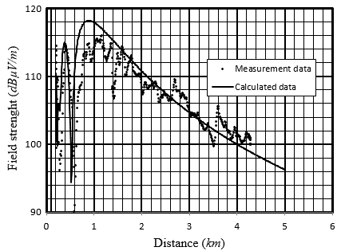
Fig. 9. The field strength level as a function of the distance between the transmitting antenna mast and the mobile station along the route.
A map with measurement routes near Raseiniai broadcast station is presented in Fig.10. All there routes were situated near the main beam axis. Antenna beam-width was very wide and the azimuth correction was only few tenths of dB.
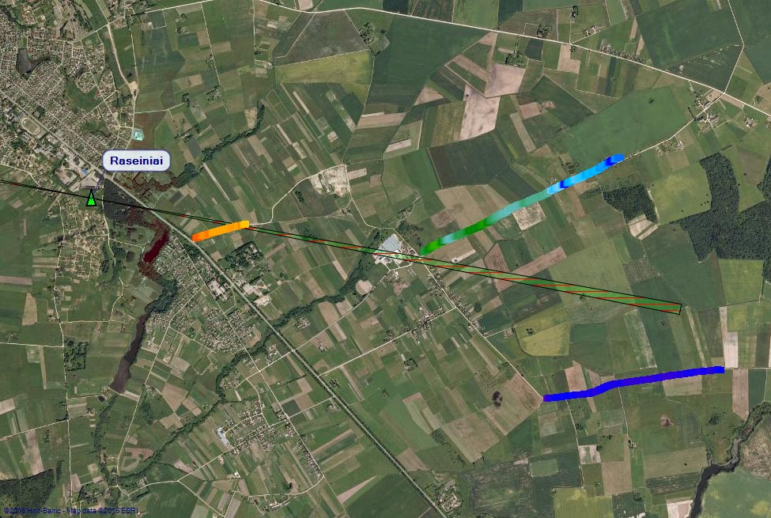

Fig. 10. Satellite map showing the measurements routes in Raseiniai.
Measurement results of Raseiniai broadcast station are presented in Table 2. Following abbreviations for this and all following tables are used:
- L_{r} — length of the route;
- d_{st} — distance from the beginning of the route to transmitting antenna mast;
- d_{st}(norm) — normalized distance to the transmitting antenna mast (values for the beginning of the route and the end of the route are presented in tables);
- Error — radiated power measurement error when field strength was calsulated in line with expression (8) or (10);
- Error (Ved) — radiated power measurement error when field strength was calculated in line with simple expression (14).
Repeated measurement for one of the routes was done. It can be seen that radiation measurement errors are less than 2 dB and for presented routes the calculations in line with the simple Vedenskij’s formula (14) are acceptable.
Table 2. Measurement results (Raseiniai)
f, MHz | L_{r}, m | d_{st}, m | d_{st}(norm) | Error, dB | Error (Ved), dB
90.7 | 390 | 940 | 9.2-13 | 1.01 | 0.21
90.7 | 390 | 940 | 9.2-13 | 1.01 | 0.22
90.7 | 950 | 2800 | 27.4-36.7 | 1.893 | 1.733
90.7 | 1630 | 2810 | 27.5-43.4 | 1.26 | 1.07
Selected measurement routes for Rokiškis broadcast station are presented in Fig.11, one for each main beam. All three routes were situated near the main beam axis. The same as in case of Raseiniai, antenna beam-width was very wide and the azimuth correction was only few tenths of dB.
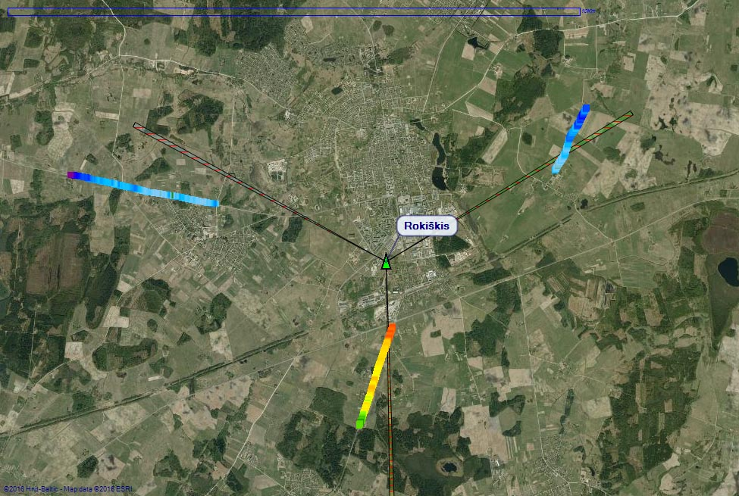
Fig. 11. Satellite map showing the measurements routes in Rokiškis.
Data presented in Table 3 show that 5 measurement results has error less than 1 dB. It is interesting, that calculations in line with simple Vedeskij’s formula (14) gave more accurate results than using more complex expression (8).
Table 3. Measurement results (Rokiškis)
f, MHz | L_{r}, m | d_{st}, m | d_{st}(norm) | Error, dB | Error (Ved), dB
92.6 | 1070 | 1780 | 14.2-37,8 | 0.66 | 0.09
92.6 | 1060 | 1800 | 14.2-38 | 0.58 | 0
92.6 | 3330 | 1080 | 63-83.2- | 1.23 | 0.86
92.6 | 3190 | 2570 | 37.2-67.1 | 0.26 | 0.05
96.3 | 3330 | 1100 | 63.3-84.1 | 0.57 | 0.53
96.3 | 3200 | 2460 | 35.9-63.4 | 0 | -0.08

A map with selected measurement routes near Viešintos broadcast station is presented in Fig.12. All routes almost coincide with the antenna’s main beam axis.

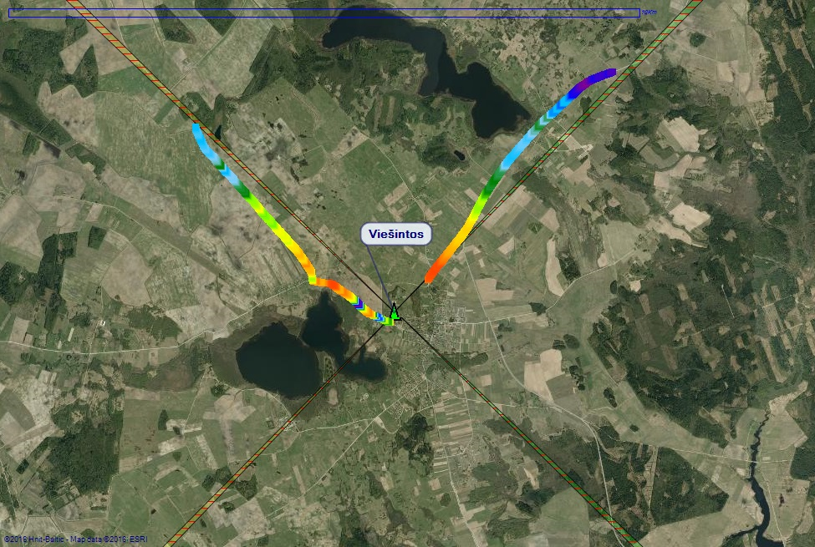

Fig. 12. Satellite map showing the measurements routes in Viešintos.

Measurement results for Viešintos broadcast station are presented in Table 4 and also show that calculations in line with simple Vedenskij’s formula (14) gave more accurate results within 1 dB.

Table 4. Measurement results (Viešintoi)
f, MHz | L_{r}, m | d_{st}, m | d_{st}(norm) | Error, dB | Error (Ved), dB
101.9 | 2000 | 2000 | 12.8-25.7 | 0.38 | -0.41
104.4 | 2000 | 2000 | 12.5-15.1 | 0.5 | -0.280
106.5 | 2000 | 2000 | 12.3-24.6 | 1.06 | 0.25
101.9 | 1000 | 2000 | 12.8-19.3 | 1.32 | -0.24
104.4 | 1000 | 2000 | 12.5-18.8 | 1.01 | 0.22
106.5 | 1000 | 2000 | 12.3-18.4 | 0.5 | -0.58

Measurement route for the Panevėžys broadcast station is presented in Fig.13. It can be seen that the route is straight, but does not coincide with main beam axis.

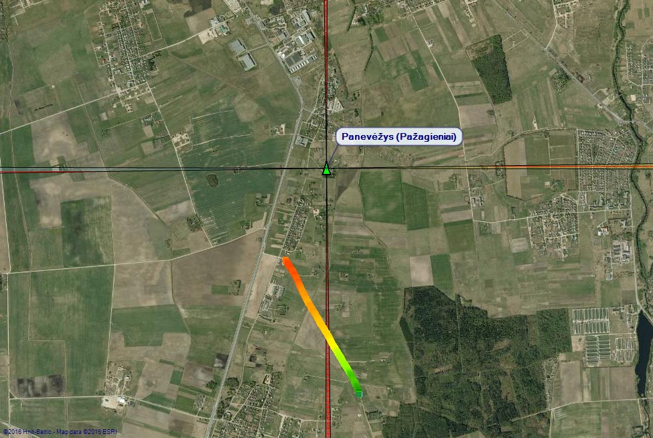
Fig. 13. Satellite map showing the measurements routes in Panevėžys.
Although the route does not coincide with the main beam axis exactly, the measurement data presented in Table 5 show that measurement error when calculations are done in line with expression (8) is less than 1 dB. It can be also seen that for this route simple Vedenskij‘s formula cannot be applied as it gave much higher measurement error. This station had vertical polarization, and Vedenskij‘s formula may be applied for measurements at normalized distances d_{st}(norm) of more than 15.

Table 5. Measurements results (Panevėžys)
f, MHz | L_{r}, m | d_{st}, m | d_{st}(norm) | Error, dB | Error (Ved), dB
93.7 | 990 | 1020 | 9.2-18.2 | -0.38 | -1.61
107.5 | 1280 | 990 | 7.8-17.2 | 0.68 | -1.1
99.1 | 1270 | 1020 | 8.7-17.9 | -0.3 | -2.17
99.1 | 1210 | 990 | 8.5-18.4 | -0.08 | -2.4

The measurement routes for Juragiai broadcast station were selected at d_{st}=1125 m (Fig. 14) and d_{st}=8185 m (Fig. 15). These routes did not coincide with the direction of main beam axis, but necessary azimuth corrections were taken into account.

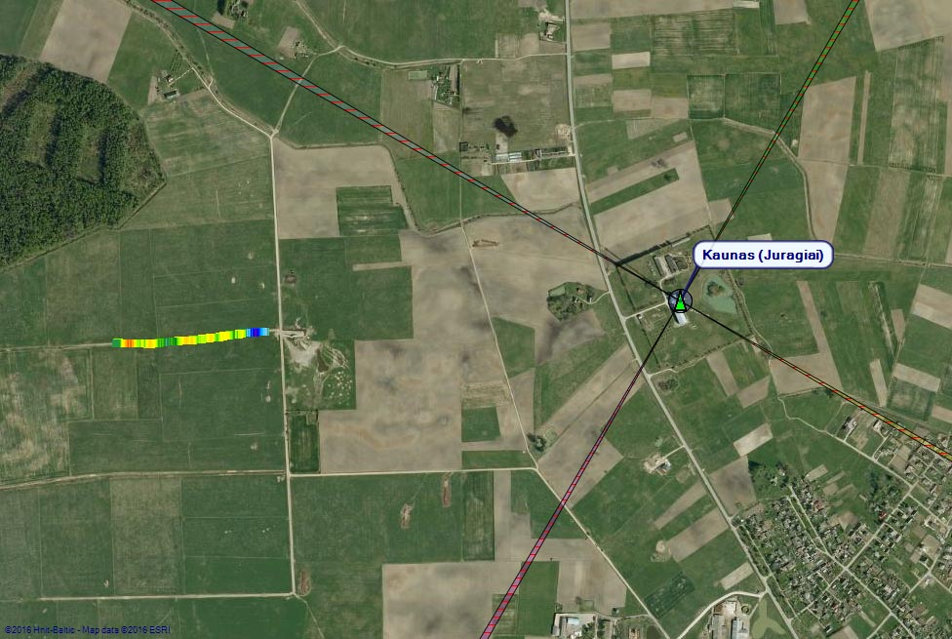
Fig. 14. Satellite map showing the measurement route in Juragiai at d_{st}=1125 m.
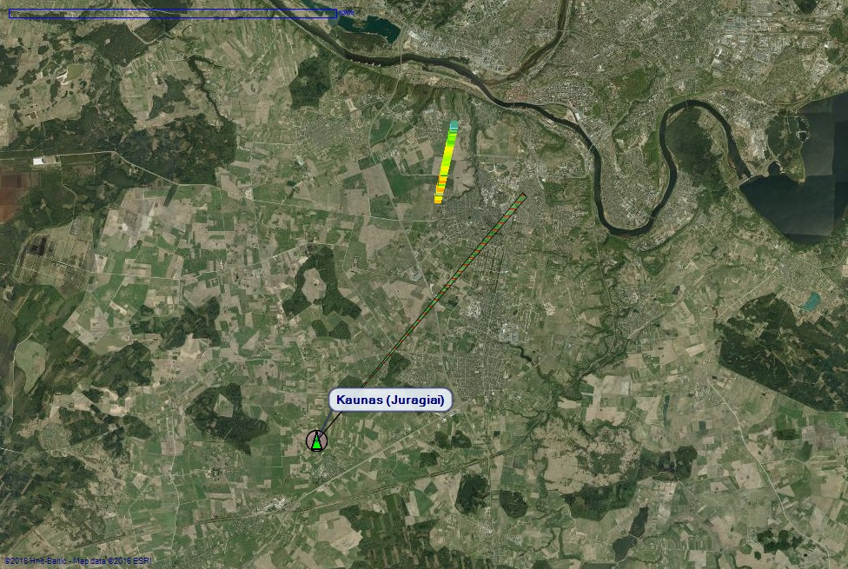
Fig. 15. Satellite map showing the measurement route in Juragiai at d_{st}=8185 m.
Measurement results of Juragiai broadcast station are presented in Table 6 also confirm that simple Vedenskij’s formula cannot be used at normalized distances d_{st}(norm) of significantly less than 15.

Table 6. Measurements results (Juragiai)
f, MHz | L_{r}, m | d_{st}, m | d_{st}(norm) | Error, dB | Error (Ved), dB
90.3 | 400 | 1125 | 5.2 | 1.91 | -5.18
96.2 | 400 | 1125 | 4.89 | 0.54 | -6.13
102.1 | 4000 | 1125 | 4.65 | 0.02 | -7.14
104.1 | 400 | 1125 | 4.55 | 0.31 | -7.18
97.6 | 1820 | 8185 | 42.1 | -1.08 | -0.35
103.5 | 1810 | 8185 | 39.8 | -1.57 | -1.28
106.6 | 1160 | 8185 | 38.5 | -2.09 | -1.8

4.4. Conclusion
From the presented measurement data following conclusions can be drawn:
- Suggested method allows to determine radiated power of broadcast FM radio stations with error less than 2 dB;
- In most cases field strength calculations may be done in line with simple Vedesnkij’s formula, and there is no need for knowing vertical antenna diagram. The results are even more accurate when normalized distance d_{st}(norm)≥15;
- It is not necessary that selected measurement route exactly coincides with the antenna’s main beam. It is only important that the route’s average azimuth coincides with attenna’s main beam axis;
- In case the horizontal antenna diagram in known, the measurement route selection becomes much easier with application of corresponding azimuth correction.

List of references
- ECC Recommendation (12)03 “Determination of the radiated power through field strength measurements in the frequency range from 400 MHz to 6000 MHz”.
- FM22(15)09, Draft New ECC recommendation on determination of the radiated power through field strength measurements in the frequency range from 87.5 MHz to 108.0 MHz.
- A. Ию Калинин, Е. Л. Чернова. Распространение радиоволн и работа радиолиний. Издательство Связь, Москва, 1971 г.A. N.
- ITU Report R-REP.P1008-1 “Reflection from surface of the Earth”.
- ITU Recommendation ITU-R SM.1708-1 “Field-strength measurements along a route with geographical coordinate registrations”.

