|  |  |
| --- | --- |
|  |  |
| **Project Team FM22** |  |
|  |  |
| **45rd Meeting of FM22**  **Budapest, 12 – 15 April 2016** | **FM22(16)15** |
| **Date issued: 07 April 2016****Source: Lithuania****Subject: Draft New ECC recommendation on determination of the radiated power through field strength measurements along a route** | |

N

Password protection required? (Y/N) *

|  |
| --- |
| **Summary** Currently is in force ECC Recommendation (12)03 on determination of the radiated power through field strength measurements in the frequency range from 400 MHz to 6000 MHz. Scope of application and limitations of this recommendation prescribes that the suggested measurement method loses accuracy for frequencies below 400 MHz. For this reason the method is not easily applicable and has certain restrictions at FM radio broadcasting band (87.5 – 108.0 MHz), what is confirmed in FM22(16)06, presented by Latvian administration.  By theoretical calculations and practical measurements in the frequency range from 87.5 MHz to 108.0 MHz a new measurement method is proposed for determination of the radiated power through field strength measurements. This measurement method relies on the comparison of field strength values measured along a route with the calculated field strength values. This method is basically frequency independent, and despite it is more technically complicated than the one described in ECC Recommendation 12(03), preliminary results in FM frequency band show greater reliability and accuracy.  Accordingly, Draft New ECC Recommendation was prepared for determination of the radiated power through field strength measurements along a route. Preparing this recommendation a part of material has been taken from ECC Recommendation (12)03. |
| **Proposal** FM22 members are invited to review the text and contribute to its further development, and if they have a possibility to make measurements of different technologies in different frequency bands. |
| **Background** Performing spectrum supervision and inspections of FM radio broadcasting stations on-site, for Lithuanian spectrum administration it became actual topic on determination of the radiated power through field strength measurements in the frequency range from 87.5 MHz to 108.0 MHz. With respect to this problem and taking into account restrictions of the method, proposed by Latvia, Lithuanian administration prepared methodology which allows determining radiated power of FM radio broadcasting station through the field strength measurements along a route.  The aim is to create corresponding ECC Recommendation on determination of the radiated power through field strength measurements in the frequency range from 87.5 MHz to X MHz which will help to perform spectrum supervision actions in the future. |

ECC Recommendation (YY)XX

Determination of the radiated power from radio stations through field strength measurements along a route

**Approved DD Month YYYY**

# introduction

The radiated power of a radio station is one of the most important parameters which characterise a transmitter and its emissions. Usually it is not possible to measure the radiated power directly. However, there are two different methods to determine the radiated power indirectly. The first method would measure the transmitter output power and calculate the radiated power by taking into account cable losses and antenna gain. The second method measures the field strength and calculates the radiated power by taking into account the measurement distance and the propagation loss.

The purpose of this Recommendation is to provide a common measurement method which will enable CEPT administrations to determine the radiated power of broadcast radio stations in the frequency range from 87.5 MHz to X MHz by field strength measurements along the route.

# ECC recommendation (YY)XX of MONTH YYYY on determination of radiated power through field strength measurements along the route

“The European Conference of Postal and Telecommunications Administrations,

*considering*

1. that radiated power is one of the parameters which is specified in a license,
2. that the verification of radio stations emissions for compliance with the license conditions is an important task of the radio monitoring or inspection services,
3. that radiated power determination through measurements at the transmitter output are often impossible due to access problems or lacking test output, and require the agreement and thus knowledge of the measurement activity by the operator
4. that these measurements can be substituted by field strength measurements under certain conditions,
5. that ECC Recommendation (12)03 describes this measurement method for frequencies above 400 MHz
6. that ITU Recommendation ITU-R SM.1708-1 describes field strength measurement along the rote

*recommends*

that the measurement method described in Annex 1 should be used to determine the radiated power of a radio stations based on field strength measurements along the route in the frequency range from 87.5 MHz to X MHz.

1. **radiated power determination based on field strength measurements along a route**
   1. introduction

Field strength measurements are one of the basic tasks of all radio monitoring services.

It is feasible for monitoring services to be able to determine the radiated power of a radio station without the need to access the transmitter output and hence without the knowledge of the operator about the measurement activity.

ECC Recommendation (12)03 describes a method to determine the radiated transmitter power through field strength measurements. Although in principle the method is applicable for all frequencies, the lower frequency limit in ECC Recommendation (12)03 is set to 400 MHz for practical reasons.

* 1. . Scope of application and limitations

The measurement method relies on the comparison of field strength values measured along a route with the calculated field strength values. This method is basically frequency independent. However application of this method in a hilly terrain can be difficult.

The accuracy of the recommended measurement method depends on the radio propagation model used for the field strength calculation. The most suitable model is the two-ray interference model. The two-ray model is an improved version of the free space propagation model. It considers both line-of-sight (direct) and ground reflection paths and is based on geometric optics. In case the field strength measurement route is far enough from the transmitting antenna, easy applicable Vedenskij’s formula can be used.

This method does not require knowing E-plane and H-plane diagrams of the transmitting antenna. However, a-priori knowledge of these diagrams may ease the selection of appropriate route.

* 1. Terms, Definitions, Abbreviations and symbols

**Table 1: Abbreviations**

| **Abbreviation** | **Explanation** |
| --- | --- |
| *c* | The velocity of light in free space, m/s |
| *d* | Horizontal distance from transmitting antenna position to the measuring antenna position |
| E | Field strength, dBμV/m |
| *F(θ)* | The directivity of the transmitting antenna in vertical plane |
| *f* | The transmitting frequency, Hz |
| *H* | Height of the transmitting antenna above the ground |
| *h* | Height of the measuring antenna above the ground |
| *P* | Equivalent isotropically radiated power |
| *R* | The magnitude of the ground reflection |
| r.m.s. | Root Mean Square |
| *s* | Second |
| *φR* | The phase of the ground reflection |
| *λ* | Wavelength, m |
| *m* | Metre |
| *dB* | Decibel |
| *dBW* | Decibel watt |
| *W* | Watt |

* 1. SHORT DESCRIPTION OF THE METHOD

Determination of radiated power is carried out in several stages:

* In the area of the transmitting station a suitable route is selected;
* In line with two-ray interference model a field strength dependence on a distance to transmitting station is calculated, taking into account that it’s radiated power *Pa* is equal to radio station’s authorized radiated power;
* for the selected route, an arithmetic mean ** of the field strength is calculated;
* the field strength along the route is measured and its arithmetic mean  is calculated;
* transmitter’s radiated power *Pm* is calculated according to the expression:

 (1)

The selection of suitable route and application of two-ray interference model are discussed below.

* 1. two-ray interference model for flat surface

Two-ray interference model is reasonably accurate for predicting the large-scale field strength at a distance of several kilometres.

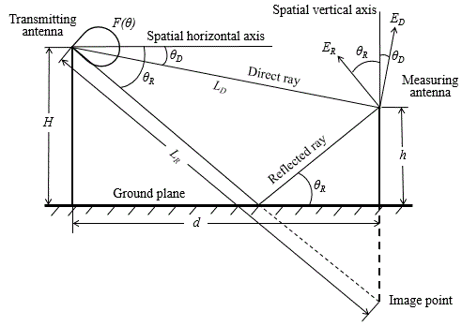

**Figure 1. Graphical representation of the two-ray model applied for a vertically polarized wave.**

When doing field strength calculations, the type of wave polarization should be taken into account. In case of horizontal polarization, the field strength (r.m.s. value) is equal:

 (2)

where

 (3)

In the case of vertical polarization, the expression for field strength is the similar to expression (2), but with different function *KV* :

 (4)

 (5)

At long distances for both polarizations we can presume, that *R*=1 and *ϕR*=180°. In this case for distances

 (6)

directivity *F(θ)* ≈ 1 and the equations (2) and (4) become simpler:

 (7)

This equation is usually called the Vedenskij’s formula.

The equations (2), (4) and (7) are more useful when expressed logarithmically:

 (8)

 (9)

 (10)

In these equations distances and heights are in meters, frequency in Hz, speed of light in m/s. The limits of Vedenskij’s formula application can be found from Figure 2. It is seen that at the difference of 1 dB for horizontal polarization, Vedenskij’s formula can be applied starting from normalized distance equal to 10, and for vertical polarization – starting from 15.

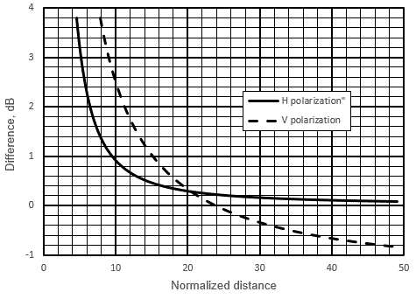

**Figure 2. Dependence of the field strength difference between calculated in line with Vedenskij’s formula and equations (8) (H polarization) or equations (2) (V polarization), on normalized distance** d/(Hhf/c) (*h*=3 m, *f*=100 MHz).

* 1. Computing of field strength

Using equation (10) calculation of field strength dependence on a distance is simple. But equations (3) and (5) contain antenna directivity, magnitude and phase of the reflection coefficient. These dependencies on grazing angle can be taken from [2] and are presented in Fig. 3. It can be seen that for horizontal polarization the magnitude of a reflection coefficient changes smoothly with the change of a grazing angle, so it can be precisely described using one polynomial. For vertical polarization, the magnitude of a reflection coefficient has a sharp deep minimum at a grazing angle of 15 degrees (Brewster‘s angle). For that reason, the reflection coefficient should be described using two separate polynomials in the ranges from 0 to 15 degrees and from 15 to 90 degrees of grazing angle. As follows from [2], the phase of the reflection coefficient is equal to 180 degrees for horizontal polarization, and it decreases from 180 degrees to 0 degrees with the change of grazing angle from 10 to 20 degrees for vertical polarization. Because the magnitude of the reflection coefficient in this range is less than 0.2, without significant influence on calculations of the total field strength it can presume that the phase of reflection coefficient is equal to 180 degrees in the range of grazing angle from 0 degrees to 15 degrees, and it is equal to 0 in the range of grazing angle from 15 to 90 degrees.

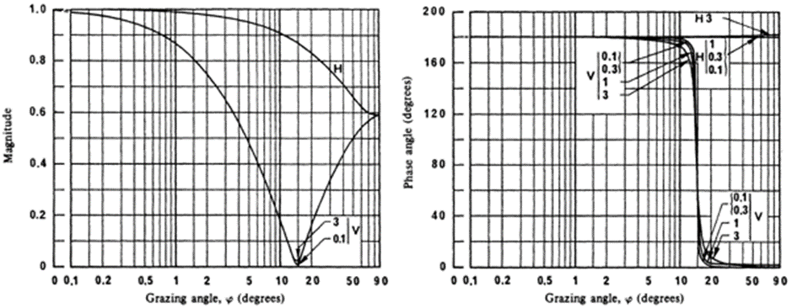

**Figure 3. Magnitude and phase of the reflection coefficient of a plane surface and medium dry ground as function of grazing angle for vertical V and horizontal H polarizations [2] (the frequencies are given in GHz).**

In case the analytical expressions of the main lob of antennas directivity in vertical plane are not available, it is possible to use graphical representation of directivity. Usually it is available in technical projects and descriptions of a broadcasting station, or publicly available in antennas catalogues. Data from graphs are transferred into Excel worksheet and approximating polynomial is calculated for vertical-plane. In order to get more precise results the main lob should be described starting from 0 degrees to the first minimum.

* 1. selection of SUITABLE route

First of all, the route should be selected about across the radial line from the transmitting antenna. It is preferable that the route is selected within the direction of the main horizontal lobe. There are two reasons for this. The first reason is that in such case the vehicle body has no influence on measurement results. The second reason is that it is easy to evaluate the transmitting antenna directivity in horizontal plane if needed.

Secondly, the route should be selected in the rural area. In this case the reflections from high buildings, big structures and etc. will be avoided. Moreover, this helps to ensure that ground electrical properties will not vary significantly along the route.

Route selection starts from selection of suitable country road in the area of inspected FM broadcast radio station, and satellite maps help with this task a lot. Only a suitable section of the road may be used for measurements along the route. It is important that the section’s length is not less than 300-400 m.

It is important to select the starting point of a route at a correct distance from the transmitting antenna. If directivity of the transmitting antenna in vertical plane is known, the selection of this distance is not critical. In this case field strength may be calculated in line with expressions (2) and (4) that assess antennas directivity in vertical plane. In sake of accuracy the distance of starting point of the route *dmin* should be selected so that antenna gain decrease in this direction is no more that 3-4 dB. The data of the transmitting antenna directivity in vertical place helps to determine this grazing angle *θm* and knowing the antenna height *H* it is possible to calculate the minimum distance:

 (11)

For grazing angles of less than 30°, the equation (11) becomes simpler:

 (12)

Usually the antenna height above the ground is specified in authorizations. Also, the height of the transmit antenna can be measured using distance/angle measurement devices.

In case the vertical antenna directivity is not known, the distance *dmin* is selected so that that the receiving antenna will be in the main vertical lobe of the transmitting antenna. In this case in order to determine *dmin* we should know the angle between horizontal line and the direction where antenna gain decreases –X db, where X – acceptable tolerance. Knowing this angle and antenna height above the ground the distance *dmin* is calculated from expressions (11) or (12). Grazing angles at which gain decreases 1 dB for most popular broadcast antennas are presented in Table 1.

**Table 1: -1 dB grazing angles for broadcast antennas**

|  |  |  |  |  |  |  |  |  |  |  |
| --- | --- | --- | --- | --- | --- | --- | --- | --- | --- | --- |
|  | **Without null fill** | | | | | **With null fill and beam tilt** | | | | |
| **Antenna bays** | **1** | **2** | **4** | **8** | **12** | **1** | **2** | **4** | **8** | **12** |
| FM antenna | 17° | 8° | 3.5° | 2° | - | - | 15° | 4.6° | 3° | - |
| Antenna 174-230 MHz  horizontal polarization | - | 5.5° | 2.5° | 1.4° | - | - | - | 3.6° | 2.2° | - |
| Antenna 174-230 MHz  vertical polarization | - | 7° | 2.5° | 1.4° | - | - | - | 3.6° | 2.2° | - |
| TV antenna 470-862 MHz  horizontal polarization | - | - | 1.8° | 1° | 0.6° | - | - | 3.2° | 2° | 1.5° |
| TV antenna 470-862 MHz  vertical polarization | - | - | 3° | 1° | 0.8° | - | - | 5° | 2.4° | 2.2° |

(10)

* 1. impact of non-ideal route evaluation

In most cases the surface of the measurement is is not completely flat, and its height does not coincide with the area where broadcast station transmitting antenna mast is built. This might be dealt with the introduction of effective transmitting antenna height *Hef.* Using digital map with terrain heights, the height of antenna mast area above the sea level *HA* is determined. The selected route terrain heights should be also checked, and the average route height above the sea level should be determined. *Hav*. Practically in most cases it is sufficient to take the average of the highest and the lowest points of the route. Then the effective antenna height *Hef* is calculated as follows:

 (13)

The effective antenna height is used for field strength calculations using expressions (8) – (10).

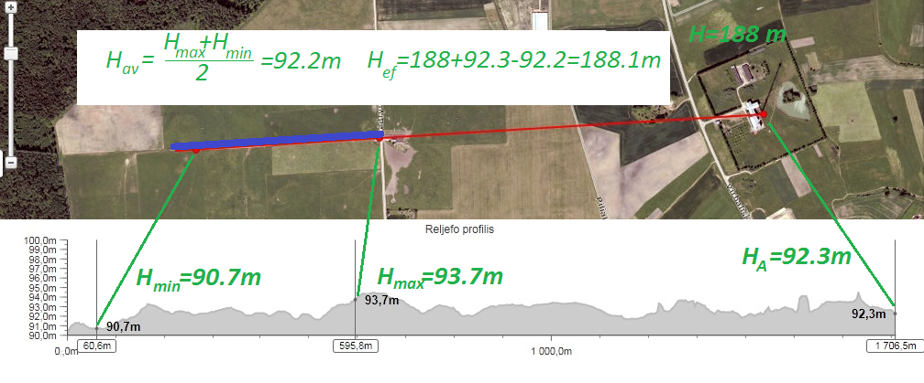

**Figure 4. Example of effective height calculation.**

* 1. Inspection of the installation (Radio station check on-site)

Transmitter frequency, antenna height above ground, polarisation, directivity, maximum or minimum emission azimuth, and transmitter location geographical coordinates have to be checked before measurements.

* 1. Measurement equipment

A laser distance measuring device, a GNSS receiver, binoculars and a compass are usable tools for the visual inspection of the transmitter and the determination of the antenna height.

For the field strength measurement a spectrum analyzer or measurement receiver with appropriate calibrated measurement antennas may be used.

* 1. Measurement UNCERTAINTY

Practical measurements of several conveniently located FM broadcasting radio transmitters with known technical parameters were done according to this recommendation. In practice, measurement results matched to theoretically calculated FM broadcasting transmitter effective radiated power within ± 2 dB interval.

Even though exists theoretical measurement uncertainty calculation methods, applicability of such methods are difficult or even impossible in context of this recommendation due to several unknown factors which affects total measurement uncertainty and cannot be objectively evaluated. Thereby uncertainty of 2 dB, which was obtained in practical measurements, has to be applied.

1. **list of references**
2. ECC Recommendation (12)03 “Determination of the radiated power through field strength measurements in the frequency range from 400 MHz to 6000 MHz”
3. ITU Recommendation ITU-R SM.1708-1 “Field-strength measurements along a route with geographical coordinate registrations”