Project Team FM22
46st Meeting of FM22  Copenhagen, 03 – 06 October 2016 | FM22(17)50

Date issued: 22 September 2016

Source: Lithuania

Subject: FM broadcast deviation measurements

N
Password protection required? (Y/N) *

Summary
The new method of measuring the maximum frequency deviation of FM broadcast emissions in line with Recommendation ITU-R SM.1268-3 gives significantly different results in comparison with the older Recommendation ITU-R SM.1268-2, which was used up until now. It should be taken into account which one of the methods is implemented in equipment, used for supervision of FM broadcast stations, and set corresponding limits for maximum allowed overshooting time.

Proposal

FM22 is invited to consider the information in this document when discussing limits of the maximum frequency deviation of FM broadcast emissions.

Background

FM22 work programme.

Comparison of overshooting time measuring methods

Frequency deviations limits
Supervision of frequency deviation of FM radio broadcasting stations is usually done through measurement of relative overshooting time τ (hereinafter – overshooting time), when frequency deviations exceed a maximum permitted limit f_{max}. Frequency f_{max} of 75 kHz can be taken, as specified in Recommendation ITU-R BS.412-9, but because of frequency deviation measuring error, depending on measuring equipment, frequency f_{max} should not be 75 kHz. According Recommendation ITU-R SM.1268-3 10⁻⁴% is a practical value of the maximum permissible frequency deviation relative overshooting time τ_{max} (hereinafter – maximum overshooting time), when frequency deviation may exceed 77 kHz.
Administrations of the countries, where frequency resources are sufficient and intervals between FM broadcasting stations are wide enough, use a higher value of maximum overshooting time. For example, regulation of frequency deviation measurement in Lithuania specifies that maximum overshooting time is equal to 1%, whereas in Switzerland it is 10%.
It should be noted that the two methods for measurement of overshooting time in line with Recommendations ITU-R SM.1268-3and ITU-R SM.1268-2 give significantly different results, so administrations should take this into account when they specify the value of maximum overshooting time

Overshooting time measuring methods
Usually overshooting time τ is estimated according to accumulated distribution plot of deviation F. Time τ is equal to the value of function F at frequency f_{max} . Part 5.2 of the Annex 2 of Recommendation ITU-R SM.1268-2 defined how accumulated distribution plot of deviation should be obtained. Based on this method, accumulated distribution plot of deviation is obtained not from all the collected deviation measurement samples, but just from peak values which are observed at 50 ms measuring intervals. It is understood that the distribution of deviation values collected according this method is distorted and this leads to an error when specifying time τ (this is mentioned in the Recommendation also). Partly because of this in new Recommendation ITU-R SM.1268-3 accumulated distribution plot of deviation is obtained from all the collected deviation measurement samples.
Some of measuring equipment, for example FM modulation analyzer DB300 (Deva Broadcast, Bulgaria), TV analyzer ETL (version till 2016 year, R&S, Germany), software Argus ((R&S, Germany) measure the overshooting time according Recommendation ITU-R SM.1268-2, TV analyzer ETL (new version since 2016 year, R&S, Germany), FM Modulation and AF Spectrum Analyzer TS9085 (Microgen Electronics, United Kingdom) - according Recommendation ITU-R SM.1268-3.

Measurement arrangement
This year the Lithuanian administrations have purchased some pieces of TV analyzer ETL (new version), which can measure the overshooting time in line with Recommendations ITU-R SM.1268-2 and ITU-R SM.1268-3. This allowed to compare these two measurement methods.
Figure 1 shows the measurement arrangement. The antenna (1) is directly connected to the input of the 2 way splitter (2) which accepts a single RF signal and splits it into two identical parts. The TV analyzers are fed with these identical RF
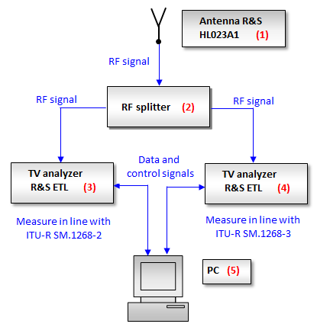
Fig.1. Measurement setup for comparison of overshooting time measurement methods.

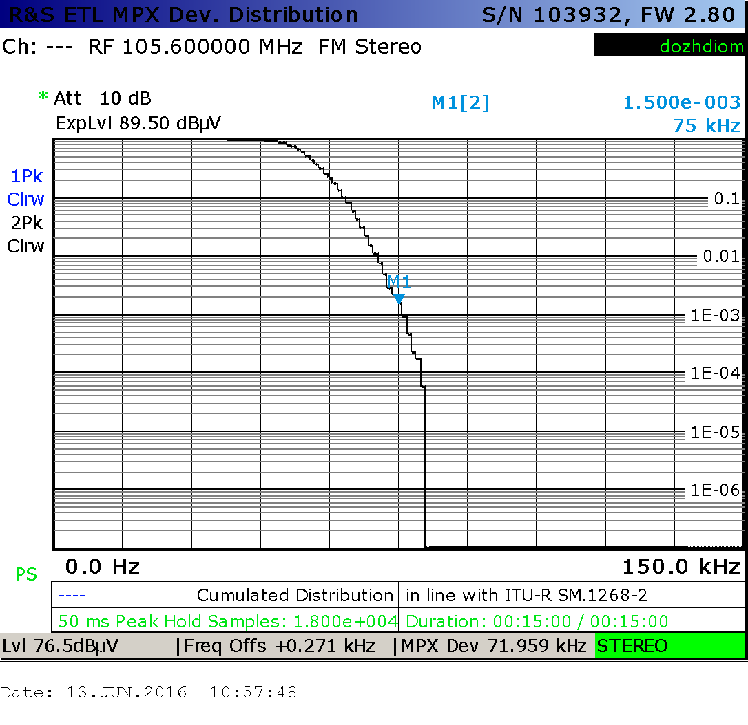
Fig.2. TV analyser ETL screen shot of a cumulative distribution of MPX deviation measurement according to Recommendation ITU-R SM.1268-2.
signals from the outputs of the splitter. One analyser (3) was set to measure overshooting time according to Recommendation ITU-R SM.1268-2 (see Fig. 2), and other (4) - according to Recommendation ITU-R SM.1268-3 (see Fig. 3). For the measurement control computer was used (5). This measurement scheme ensures the synchronous measurement of overshooting time by two methods.
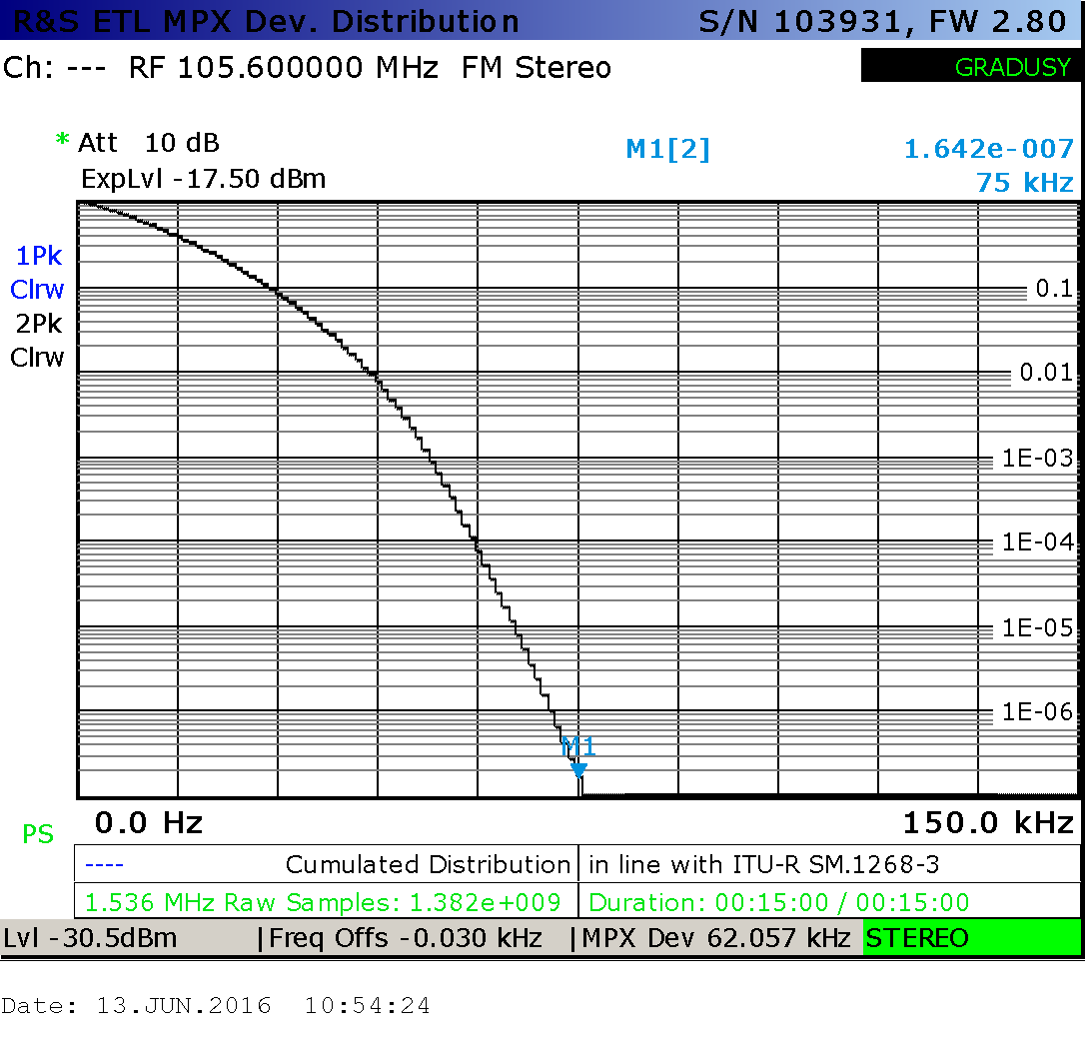
Fig.3. TV analyser ETL screen shot of a cumulative distribution of MPX deviation measurement according to Recommendation ITU-R SM.1268-3.

Measurement results and their interpretation
During the experiment, overshooting time of FM broadcasting stations was measured at fixed monitoring station in Šiauliai. Measurements were performed for four stations, which were chosen randomly. Measurement took about 10-24 hours to measure every station, and values of overshooting time were estimated every 15 minutes.
Fig.4 shows the summary measuring results for all measured stations. It can be seen that the different measurement methods give significantly different results. In average the values of overshooting time measured in line with Recommendation ITU-R SM.1268-2 are 10⁴ times higher than measured in line with Recommendation ITU-R SM.1268-3. So high difference has come as a surprise, but it can be easily explained.
During 15 min (900 s) in line with ITU-R SM.1268-3 analyser ETL collect N₃=900*1.536*10⁶=1.382*10⁹ samples (1.536*10⁶ – ETL sampling frequency). These samples will be called the original sample. Let the measured overshooting time is equal τ₃. Therefore the number of the original samples exceeding 75 kHz deviation is N₃*τ₃. Assume that the samples exceeding 75 kHz deviation are located in identical packages which are distributed evenly and that in every package falls k samples which exceeding 75 kHz deviation. The total number of such packets is m=N₃*τ₃/k.
During the same 15 min in line with ITU-R SM.1268-2 analyser ETL collect only N₂=900/0.05=1.8*10⁴ samples (0.05 s- measuring interval, at which only the peak value is being observed). These samples will be called the peak samples.
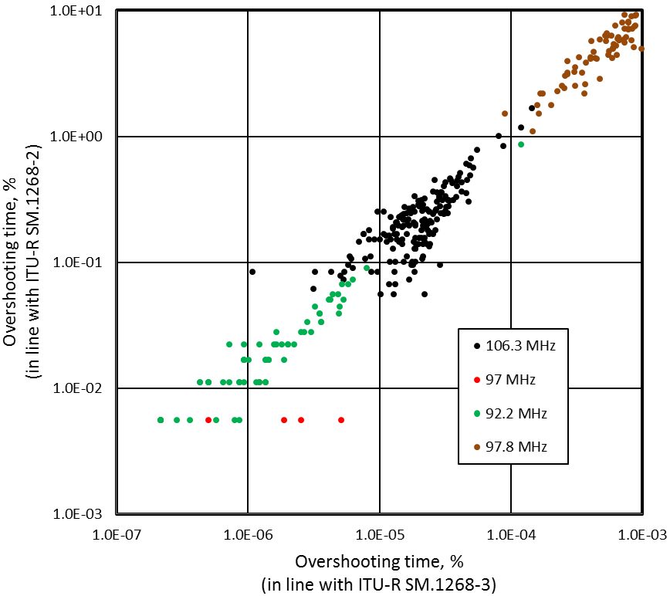
Fig.4. Comparison of overshooting time measuring methods (each dot represents one measuring result by two methods).
The distance between m packages (with was mentioned above) is much more than 50 ms measuring intervals therefore it possible to fall within this interval only one package. As result the number of peak samples exceeding 75 kHz deviation is m. Accordingly the overshooting time is
τ₂=m/N₂= N₃*τ₃/(k*N₂)= (1.382*10⁹/1.8*10⁴)*(τ₃/(k). (1)
From the equation (1) we obtain the relationship between the overshooting time τ₂ and τ₃:
τ₂/τ₃= 7.68*10⁴/k. (2)
IF the original samples exceeding 75 kHz deviation are distributed evenly then coefficient k=1 and ratio τ₂/τ₃=7.68*10⁴. Such ratios are occasionally observed in the case if the measurements of overshooting time were carried out during a very short time (1-2 min).
Assume, that the frequency deviation exceed ±75 kHz by one going and overshooting time is equal τ₃. Of course in this case the samples exceeding 75 kHz deviation are distributed evenly one by one and their number is N₂*τ₃. 0.05 s time interval contain 1.536*10⁶*0.05 original samples. Therefore the number of peak samples is equal m=(N₃*τ₃)/(1.536*10⁶*0.05). As results the overshooting time τ₂ is:
τ₂=m/N₂==(N₃*τ₃)/(N₂*1.536*10⁶*0.05)= τ₃ (3)
Of course this scenario is unrealistic. The equation (2) describes the situation which is closer to the reality. Taking k value equal to the 8, which is quite possible, for τ₂/τ₃ we get the experimental value 1*10⁴.

Conclusion
Experimental results has confirmed theoretical calculations, that the method for measurement of overshooting time in line with Recommendation ITU-R SM.1268-3 gives about 10⁴ smaller value of overshooting time in comparison with ITU-R SM.1268-2. So it is very important to know, which method is being used by your equipment and set corresponding maximum allowed overshooting time.
The maximum allowed overshooting time set by Lithuanian administration was 1% when measurements were carried out in line with ITU-R SM.1268-2. Now is being reconsidered to be 10⁻⁴ % as the measurements will be carried out in line with the new Recommendation ITU-R SM.1268-3.

