 |  | CG X-border #29_4
ECC PT1 CG cross-border coordination
Web meeting, 7 December 2021
Date issued: | 6 December 2021
Source: | Lithuania
Subject: | Implication of field strength value for border areas
Group membership required to read? (Y/N)
N
Summary:
Synchronised operation requires agreement between regulators (and mobile operators) of neighbouring countries.
It is likely that such agreements could be easily obtained for the countries in the middle of Europe where the usage could be more or less coordinated between neighbours.
However situation with the non-EU neighbours is less predictable. It is quite possible that mobile operators might end up operating in unsynchronised mode. If frame structure could be agreed, then unsynchronised operation based on ECC Recommendation (20)03 with partial duplex misalignment might also be a choice. However even with that choice it is difficult to envision that implementation of DSB could be agreed (hence such operation should be considered without DSB).
ECC Report 331 section 1.2 provides information regarding recent changes to the field strength values between unsynchronised TDD networks. Noting that unsynchronised operation can lead in practice to very large exclusion zones in cross-border areas it is critical that ECC Recommendation (15)01 should include reasonable field strength values which would facilitate negotiation for the European countries with their non-EU neighbours.
This paper investigates implications of the values obtained in ECC Report 331 for the mobile operators to deploy TDD networks in the Republic of Lithuania focusing on unsynchronised operation.
In order to help administration in their negotiations to find balance between capacity loss and coverage, it is proposed that field strength values in revised ECC Recommendation (15)01 for unsynchronised operation (and unsynchronised operation based on ECC Recommendation (20)03 with partial duplex misalignment without DSB should be based on UL TP loss of 30%. The values from ECC Report 331 for rural scenario between AAS to AAS operation could be taken as representative case.
Proposal:
invites Group to
- take into account challenges regarding coordination between EU and non-EU countries when revising conditions for operation for 3400-3800 MHz frequency band in ECC Recommendation (15)01;
- to set field strength values in new version of recommendation for unsynchronised operation as follow:
- median field strength of 16 dBμV/m/5 MHz @ 0 km @ 3m for unsynchronised operation without preferential frequency blocks
- median field strength of 32 dBμV/m/5 MHz @ 0 km @ 3m for unsynchronised operation with partial duplex misalignment and ECC Recommendation (20)03 recommended scenario without DSB
Background:
ECC PT1 work item PT1_43 on update of ECC Recommendation (15)01 on 3.4-3.8 GHz part taking into account ECC Recommendation (20)03 and draft ECC Report 331 on “Efficient usage of the spectrum at the border of CEPT countries between MFCN TDD networks in the frequency band 3400-3800 MHz”

Analysis of exclusion zones in cross-border areas between TDD networks
Simulation results on the throughput loss corresponding to various separation distances D between two networks could be found in Annex 2 of ECC Report 331. Field strength values were derived from this distance D and the result could be found in Annex 3 of ECC Report 331.
Below (in Table 1 and Table 2) is the summary for mode #4 and mode #3. For unsynchronised case, a shared exclusion area is assumed and therefore field strength values are for Dx=D/2, where Dx is the distance between the transmitting BS and the borderline. For operation mode #3 the simulation results accounts fully-unsynchronised operation (operation mode #4) with a scaling factor of 0.5 on the UL throughput loss to take into consideration the partial duplex misalignment.
Table 1: Distance and field strength results for mode #4
UL TP loss |  | 30% |  | 20% |  | 10%
Scenario | Case | D (km) | E_median | D (km) | E_median | D (km) | E_median
suburban | AAS to AAS | 16.76 | 8.59 | 19.9 | 4.49 | 28.51 | -4.41
suburban | AAS to non-AAS | 23 | 0.82 | 26.5 | -2.63 | 32 | -7.22
suburban | non-AAS to AAS | 26 | 14.79 | 30 | 11.42 | 38 | 5.94
rural | AAS to AAS | 37.52 | 15.89 | 46.38 | 10.49 | 64.22 | 2.19
rural | AAS to non-AAS | 38 | 15.54 | 45 | 11.26 | 60 | 4.04
rural | non-AAS to AAS | 44 | 21.66 | 54 | 17.07 | 80 | 8.26
E_median is field strength for data channel expressed in dBµV/m/(5 MHz) and derived at the border at 3 m receiving antenna height
Table 2: Distance and field strength results for mode #3
UL TP loss |  | 30% |  | 20% |  | 10%
Scenario | Case | D (km) | E_median | D (km) | E_median | D (km) | E_median
suburban | AAS to AAS | 9.32 | 21.49 | 13.91 | 13.09 | 19.9 | 4.59
suburban | AAS to non-AAS | 17 | 8.13 | 20.5 | 3.64 | 26.5 | -2.63
suburban | non-AAS to AAS | 15 | 28.00 | 22 | 18.77 | 30 | 11.42
rural | AAS to AAS | 19.77 | 31.49 | 29.91 | 21.59 | 46.38 | 10.59
rural | AAS to non-AAS | 28 | 23.02 | 30 | 21.53 | 45 | 11.26
rural | non-AAS to AAS | 23 | 36.92 | 37 | 25.61 | 54 | 17.07
E_median is field strength for data channel expressed in dBµV/m/(5 MHz) and derived at the border at 3 m receiving antenna height
All calculations were based on the technical parameters and assumptions as described in Annex 1 of ECC Report 331. Table 3 below extracts for reference the most relevant characteristics.
Table 3: MFCN technical parameters and assumptions for simulations
System | Tx power | Antenna gain | EIRP | Antenna height | Antenna pattern | Mechanical downtilt | BW
AAS  (data ch.) | 53 dBm | 25.2 dBi rural  24.5 dBi suburban | 78 dBm | 35 m rural  25 m suburban | ITU-R Rec M.2101 | 3 rural  6 suburban | 80 MHz
non-AAS | 49 dBm | 18 dBi | 64 dBm | 35 m rural  25 m suburban | ITU-R Rec F.1336 | 3 rural  6 suburban | 20 MHz
Propagation model ITU-R Recommendation P.1546-6 with 50% location and 10% time probability without clutter layer was used in ECC Report 331 to calculate field strength values.
Since border areas in Lithuania are mainly in rural environment the example of exclusion zones for unsynchronised operation between AAS to AAS in rural environment is provide in Figure 1 below. Green line is for 30% UL TP loss, blue is for 20% and red is for 10%.
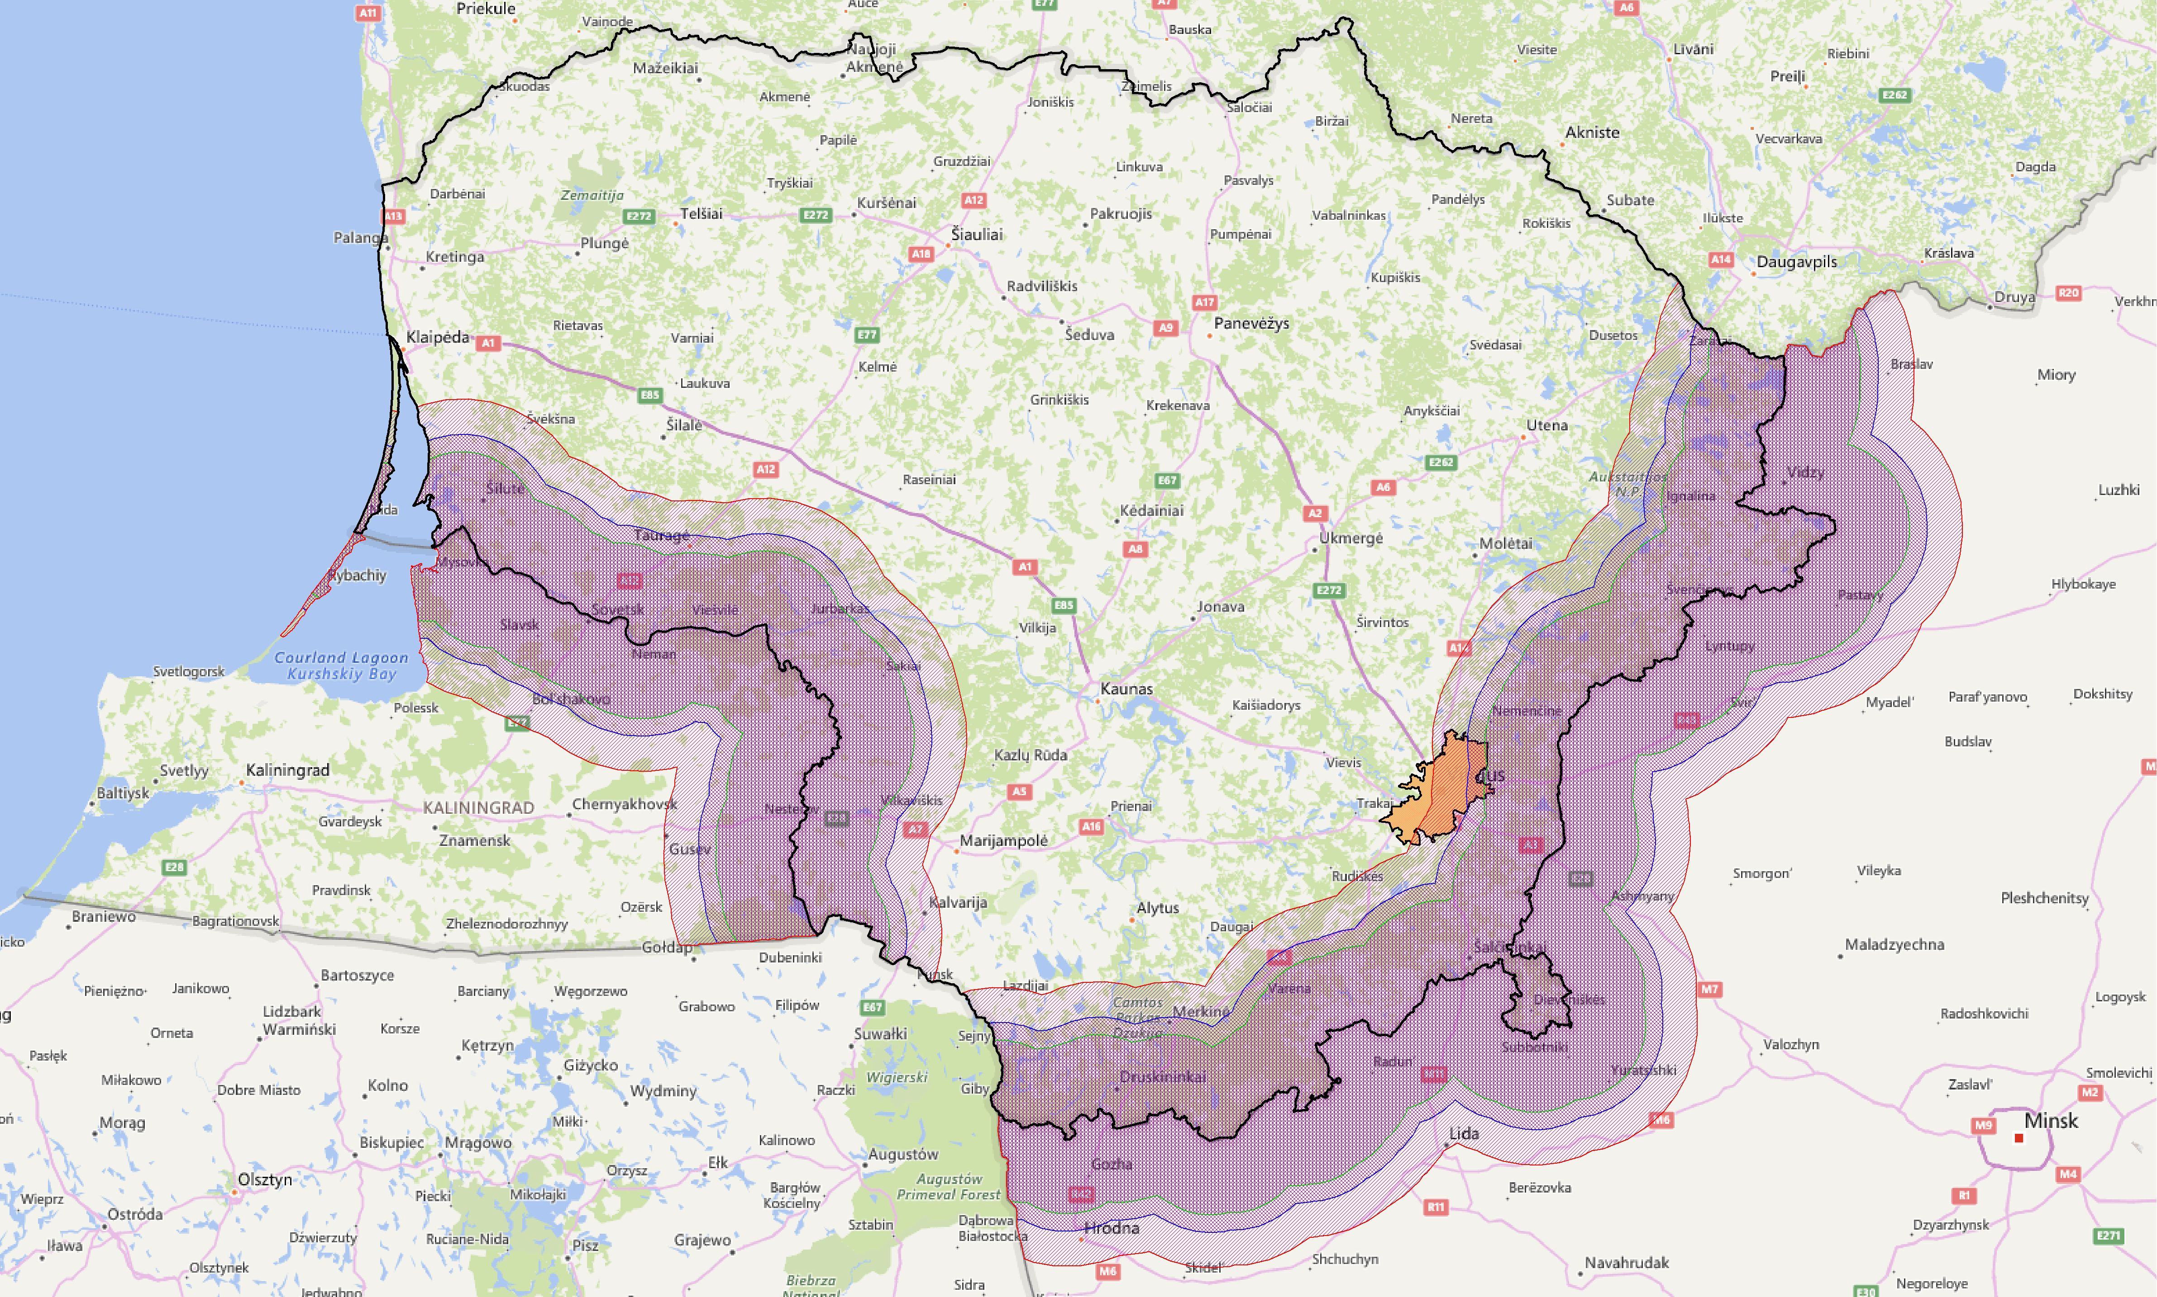
Figure 1: Exclusion zones for unsynchronised operation between AAS to AAS in rural environment
(green line for 30% UL TP loss, blue for 20%, red for 10%)
It should be note that capital of Lithuania (city Vilnius, indicated in the map) is less than 30 km from the border and more than half a million people live there.
It should be also noted that exclusion zones for rural environment between AAS and non-AAS will be bigger (see Table 2).
Example of exclusion zones for unsynchronised operation with partial duplex misalignment and ECC Recommendation (20)03 recommended scenario without DSB between AAS to AAS in rural environment is provide in Figure 2 below.
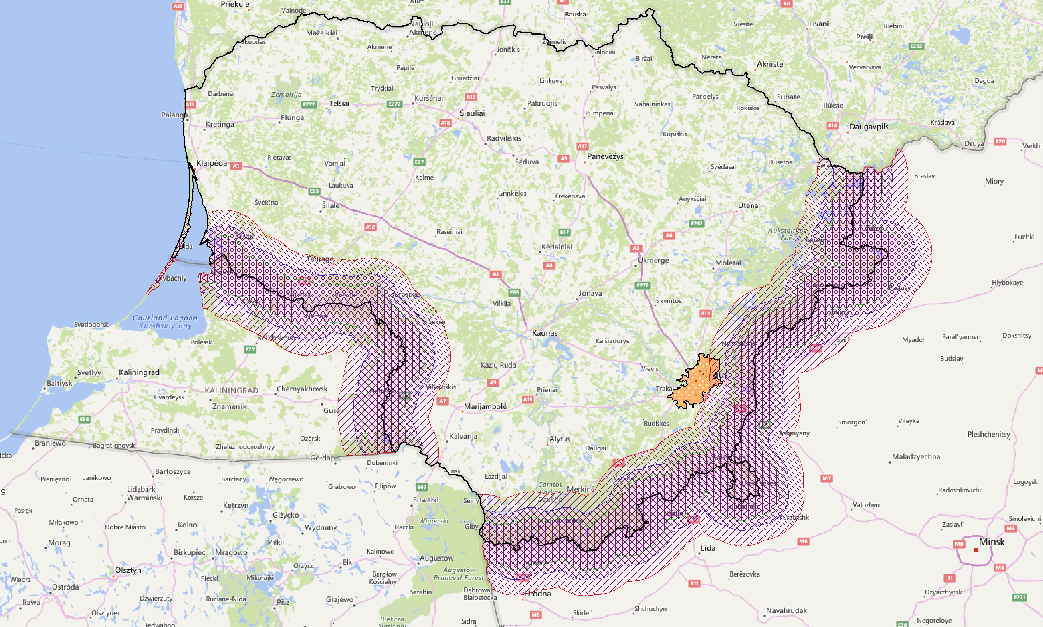
Figure 2: Exclusion zones for unsynchronised operation without DSB between AAS to AAS in rural environment
(green line for 30% UL TP loss, blue for 20%, red for 10%)
In order to estimate potential constrains of exclusion zones the population in those areas was calculated. The results are provided in Table 4 and Table 5 below (as percentage of all population in the country).
Table 4: Population in exclusion zones for mode #4
UL TP loss |  | 30% |  | 20% |  | 10%
Scenario | Case | D (km) | Popul. (%) | D (km) | Popul. (%) | D (km) | Popul. (%)
suburban | AAS to AAS | 16.76 | 3.8 | 19.9 | 4.9 | 28.51 | 6.9
suburban | AAS to non-AAS | 23 | 5.9 | 26.5 | 6.5 | 32 | 7.7
suburban | non-AAS to AAS | 26 | 6.4 | 30 | 7.2 | 38 | 9.7
rural | AAS to AAS | 37.52 | 9.5 | 46.38 | 13.1 | 64.22 | 26.4
rural | AAS to non-AAS | 38 | 9.7 | 45 | 12.7 | 60 | 21.7
rural | non-AAS to AAS | 44 | 12.4 | 54 | 15.8 | 80 | 35.8
Table 5: Population in exclusion zones for mode #3
UL TP loss |  | 30% |  | 20% |  | 10%
Scenario | Case | D (km) | Popul. (%) | D (km) | Popul. (%) | D (km) | Popul. (%)
suburban | AAS to AAS | 9.32 | 1.9 | 13.91 | 2.9 | 19.9 | 4.9
suburban | AAS to non-AAS | 17 | 3.9 | 20.5 | 5.0 | 26.5 | 6.5
suburban | non-AAS to AAS | 15 | 3.2 | 22 | 5.5 | 30 | 7.2
rural | AAS to AAS | 19.77 | 4.8 | 29.91 | 7.2 | 46.38 | 13.1
rural | AAS to non-AAS | 28 | 6.8 | 30 | 7.2 | 45 | 12.7
rural | non-AAS to AAS | 23 | 5.9 | 37 | 9.4 | 54 | 15.8
Results show that even with the 30% UL TP loss around 10% of population will not be covered in case of fully unsynchronised operation (mode #4). Consideration of 10% UL TP loss would mean that at least off a quarter of population will not be able to use 5G service in C-band.
It is possible to argue that in order to provide coverage closer to the border with unsynchronised operation countries can choose the option to divide the frequency band into preferential and non-preferential frequency blocks. However that would mean huge capacity loss for operators. For bilateral case capacity loss will be at least 50% and for trilateral case at least 66%. In addition, due to adjacent channel interference, the loss will be even greater (depending on UL TP loss related to the field strength level). Hence such option should be avoided as much as possible.

Proposal
Since ECC Recommendation (15)01 is a reference document for negotiating bilateral or multilateral cross-border coordination agreements it is proposed that field strength values in new version of recommendation for C-band should be based on UL TP loss of 30%. It is assumed that C-band will be 5G driven hence AAS case could be taken as representative one. Noting that majority of cross-border areas are in rural area, we propose the following values for unsynchronised operation:
- Median field strength of 16 dBμV/m/5 MHz @ 0 km @ 3m for unsynchronised operation without preferential frequency blocks;
- Median field strength of 32 dBμV/m/5 MHz @ 0 km @ 3m for unsynchronised operation with partial duplex misalignment and ECC Recommendation (20)03 recommended scenario without DSB.
This would greatly facilitate the negotiation of bilateral/multilateral agreements between administrations of EU and non-EU countries.
It would also be useful to keep SSB values for information in the revised recommendation (e.g. in the separate Annex), since SSB field strength value is easier to measure in the field.

Fully-unsynchronised operation (100% duplex misalignment) without preferential frequency blocks
Unsynchronised operation with partial duplex misalignment and ECC Recommendation (20)03 recommended scenario without DSB

