|  |  |  |  |  |
| --- | --- | --- | --- | --- |
|  | | | FM22(22)45 | |
| Project Team FM22 | | | | |
| 58th Meeting of FM22 Copenhagen / Web Meeting, 04 – 07 October 2022 | | | | |
|  | | | | |
| Date issued: | 21 September 2022 | | | |
| Source: | Lithuania | | | |
| Subject: | Modification of ITU-R SM.1838 on NF of Receivers Measurements | | | |
|  | | | | |
| Group membership required to read? (Y/N) | | N | |  |
|  | | | | |
|  | | | | |
| Summary: | | | | |
| The Annex contains a suggestion on a modification of Recommendation ITU-R SM.1838 on measuring the noise figure of radio monitoring receivers. Compared to the current version, a new measurement method been introduced. This method for measuring the noise figure of radio monitoring receivers is extremely simple to implement and does not require the use of any additional measuring instruments. | | | | |
| Proposal: | | | | |
| FM22 is invited to consider this proposal in the development of an update of ITU-R SM.1838.  Annex: Draft Revision of Recommendation ITU-R SM.1838. | | | | |
| Background: | | | | |
| * Recommendation ITU-R SM.1838-0 Test procedure for measuring the noise figure of radio monitoring receivers. * Results of the practical application of the new simple method for measuring the noise figure of radio monitoring receivers. | | | | |

Annex: Draft Revision of Recommendation ITU-R SM.1838.

# Introduction

The recommendation ITU-R SM.1838 describes three methods for measuring the noise figure of radio monitoring receivers: “gain” method, “Y-factor” method (noise source method) and “sensitivity” method. The listed methods are applicable for measuring the noise figure of a wide class of radio receivers, and not just radio monitoring receivers.

The implementation of all the above measurement methods at radio monitoring stations faces certain difficulties, since a number of measuring instruments are required. In the case of radio monitoring receivers, the situation with noise figure measurements can be greatly simplified, since they are usually calibrated and often measure the signal level with an accuracy of no worse than 1 dB.

The following is a simple method for measuring the noise figure of radio monitoring receivers, which does not require any measuring instruments. Therefore, further this measurement method will be called the “self-measuring” method.

# self-measuring method for measuring the noise figure of radio monitoring receivers

Like any two-port device, in general terms, the noise coefficient of a receiver is defined as

$F=\frac{P_{n}}{P_{s}}$, (1)

where *Pn* is receiver’s total equivalent input noise power and *PS* is input noise power due noise source only. It is important to note here that both powers must be determined at the same frequency bandwidth.

The input impedance of radio monitoring receivers is usually 50 Ω. Therefore, their noise coefficient is specified with thermal noise from a 50 Ω resistor at room temperature. The input (available) thermal noise power from this resistor is

$P_{s}=kTΔf$, (2)

where *k* is Boltzmann constant (1.38*10−23 J/K), *T* is resistor’s absolute temperature (K) and Δ*f* is receiver’s noise bandwidth (Hz).

Thus, formula (1) can be rewritten as

$F=\frac{P_{n}}{kTΔf}$*,*  (3)

where *Pn* is the sum of 50 Ω resistor (load) thermal noise and the receiver’s equivalent input noise (recalculated to the input internal noise of the receiver).

Formula (3) at room temperature (T=290 K) can be expressed in more useful form:

$NF\left(dB\right)=P_{n}\left(dBm\right)-10logΔf\left(kHz\right)+144$, (4)

where $NF=10logF$ is noise figure.

Is It follows from the formula (3) and (4) that the measurement of the noise figure *NF* of a radio monitoring receiver is reduced to measuring its noise power with a 50 Ω load connected to input. When measuring noise power, it is important to choose the right measurement time and bandwidth. As is known, the RMS value of the relative measurement error δ of the Gaussian noise signal level is equal to

$δ=\frac{1}{\sqrt{2Δft}}$, (5)

where *t* is measurement time.

Is It follows from the formula (5), if we take the measurement error as 0.01 (1 %), then the product of the bandwidth Δ*f* and the measurement time *t* should be no less than 10000. So, if the noise bandwidth Δ*f* is 10 kHz, the minimum measurement time has to be 0.5 s.

If the receiver measures not the noise power *Pn* , but only its voltage *Un*, then another form of the formula (4) is used:

$NF\left(dB\right)=U_{n}\left(dBμV\right)-10logΔf\left(kHz\right)+37$. (6)

From the description of the proposed measurement method, it follows that it is self-evident. Therefore, it was hard for us to believe that no one had implemented it. However, as a result of searches in the literature and the Internet, not a single mention of it was found.

# Experimental verification of the self-measuring method

To test the self-measuring method, its noise figure measurements results were compared with those measured by gain method. During testing, the noise figure of the radio monitoring receiver R&S EB500 was measured. The measurements were carried out in two modes of receiver operation: normal and low distortion. In both modes, the measurements were carried out at 18 frequencies in the range from 10 MHz to 3.3 GHz.

During the measurement, the following receiver settings were used:

– Measurement type: FFM periodic;

– IF bandwidth: 50 kHz;

– Detector: r.m.s.;

– Measurement time: 1 s.

The self-measuring measurement method was carried out in the following order. Initially, a 50 Ω load was connected to the input of the receiver. Then, at each measurement frequency, the indication of the receiver *Un* was read and, using formula (6), the value of its noise figure was calculated.

The receiver R&S EB500 uses Gaussian-type digital filters for IF filtering (at least up to the formation of filters with a bandwidth of 2 MHz). For this type of filter, the noise bandwidth is 1.065 times wider than the 3 dB bandwidth [1]. Therefore, the value Δf(kHz) = 50*1.065 was substituted into formula (6).

Measurements by the Gain method were carried out according to the procedure described in the recommendation ITU-R SM.1838. A microwave signal generator R&S SMR40 served as the source of the CW signal. The levels of noise and CW signals were measured with a spectrum analyzer R&S ESPI7. Using a spectrum analyzer, the power of the CW signal Pout and the power of the noise signals Pn at the receiver EB500 IF output and the power of the CW signal Pin at the microwave signal generator output was measured.

During the noise signals Pn measurement, the following spectrum analyzer settings were used:

– RBW: 10 kHz;

– Detector: r.m.s.;

– Trace mode: ClearWrite;

– Sweep time: 60 s.

Using the obtained results of measurements, the receiver noise figure was calculated by the formula:

$NF\left(dB\right)=P_{n}\left(dBm\right)+P_{in}\left(dBm\right)-P_{out}(dBm)-10logΔf\left(kHz\right)+144$. (7)

The spectrum analyzer R&S ESPI7 also uses Gaussian filters. For this reason, the value Δf(kHz) = 10*1.065 was substituted into formula (7).

The results of measuring the noise figure of the receiver R&S EB500 in normal mode by two methods are shown in Table 1. It can be seen from it that the results of measurements by both methods are almost the same. The largest difference is 0.52 dB.

**Table 1: The noise figure of the receiver R&S EB500 in normal mode**

| **F MHz** | **Pin dBm** | **Pout dBm** | **Pn dBm** | **NFG dB** | **Un dBµV** | **NFS dB** | **NFS-NFG dBm** |
| --- | --- | --- | --- | --- | --- | --- | --- |
| 10 | -70.4 | -23.12 | -75.84 | 10.61 | -9.3 | 10.38 | -0.23 |
| 15.8 | -70.45 | -23.15 | -75.07 | 11.36 | -8.8 | 10.88 | -0.52 |
| 31 | -70.35 | -22.65 | -72.64 | 13.39 | -6.25 | 13.43 | 0.04 |
| 31.8 | -70.39 | -22.52 | -72.32 | 13.54 | -5.7 | 13.98 | 0.44 |
| 32.2 | -70.38 | -22.86 | -76.74 | 9.47 | -10.3 | 9.38 | -0.09 |
| 39.8 | -70.41 | -22.83 | -76.86 | 9.29 | -10.3 | 9.38 | 0.09 |
| 63 | -70.47 | -22.8 | -76.42 | 9.34 | -9.9 | 9.78 | 0.44 |
| 100 | -70.53 | -22.93 | -76.98 | 9.15 | -10.6 | 9.08 | -0.07 |
| 158 | -70.57 | -22.94 | -76.77 | 9.33 | -10.3 | 9.38 | 0.05 |
| 251 | -70.53 | -22.98 | -75.99 | 10.19 | -9.5 | 10.18 | -0.01 |
| 398 | -70.72 | -23.05 | -75.93 | 10.13 | -9.6 | 10.08 | -0.05 |
| 630 | -71.24 | -23.48 | -76.15 | 9.82 | -9.6 | 10.08 | 0.26 |
| 649.5 | -71.12 | -23.47 | -76.02 | 10.06 | -9.5 | 10.18 | 0.02 |
| 650.5 | -71.08 | -23.58 | -75.84 | 10.39 | -9.3 | 10.38 | -0.01 |
| 1000 | -71.17 | -23.55 | -76.63 | 9.48 | -10.1 | 9.58 | 0.1 |
| 1580 | -71.13 | -23.79 | -77 | 9.39 | -10.5 | 9.18 | -0.21 |
| 2510 | -71.34 | -23.93 | -76.48 | 9.84 | -10.1 | 9.58 | -0.26 |
| 3300 | -72.09 | -24.23 | -75.94 | 9.93 | -9.4 | 10.28 | 0.35 |

*NFG - noise figure value measured by the Gain method, NFS – noise figure measured by Self-measuring method.

Similar results were obtained when measuring the receiver in the low distortion mode (see Table 2). In this case, the largest difference is 0.74 dB at 3300 MHz.

**Table 1: The noise figure of the receiver R&S EB500 in low distortion mode**

| **F MHz** | **P(in) dBm** | **P(out) dBm** | **Pn(out) dBm** | **NF(G) dB** | **Un dBµV** | **NF(s) dB** | **NF(s)-NF(G) dBm** |
| --- | --- | --- | --- | --- | --- | --- | --- |
| 10 | -70.4 | -23.25 | -66.82 | 19.77 | -0.4 | 19.28 | 0.49 |
| 15.8 | -70.45 | -22.93 | -66.01 | 20.2 | 0.4 | 20.08 | -0.12 |
| 31 | -70.35 | -22.7 | -63.34 | 22.74 | 3.2 | 22.88 | 0.14 |
| 31.8 | -70.39 | -22.63 | -62.72 | 23.25 | 3.8 | 23.25 | 0 |
| 32.2 | -70.38 | -22.45 | -67.96 | 17.84 | -1.7 | 17.98 | 0.05 |
| 39.8 | -70.41 | -22.41 | -67.66 | 18.07 | -1.4 | 18.28 | 0.21 |
| 63 | -70.47 | -22.58 | -76.42 | 18.59 | -0.9 | 18.78 | 0.19 |
| 100 | -70.53 | -23.32 | -68.03 | 18.49 | -1.7 | 17.98 | -051 |
| 158 | -70.57 | -22.9 | -68 | 18.06 | -1.5 | 18.18 | 0.12 |
| 251 | -70.53 | -22.93 | -66.93 | 19.2 | -0.7 | 18.98 | -0.22 |
| 398 | -70.72 | -22.68 | -66.87 | 18.82 | -0.6 | 19.08 | 0.26 |
| 630 | -71.24 | -23.21 | -66.74 | 18.96 | -0.4 | 19.28 | 0.32 |
| 649.5 | -71.12 | -23.25 | -66.84 | 19.02 | -0.4 | 19.28 | 0.26 |
| 650.5 | -71.08 | -23.25 | -69.17 | 16.73 | -2.7 | 16.98 | 0.25 |
| 1000 | -71.17 | -23.26 | -69.6 | 16.22 | -3.2 | 16.48 | 0.26 |
| 1580 | -71.13 | -23.33 | -69.46 | 16.45 | -3.1 | 16.58 | 0.13 |
| 2510 | -71.34 | -23.35 | -69.03 | 16.71 | -2.6 | 17.08 | 0.37 |
| 3300 | -72.09 | -24.58 | -67.38 | 17.84 | -1.1 | 18.58 | 0.74 |

The measured results of noise figure versus frequency are shown in Figures 1 and 2. It can be seen from these figures that in both modes the noise figure varies greatly with frequency. The noise coefficient changes especially sharply at frequencies below 32 MHz.

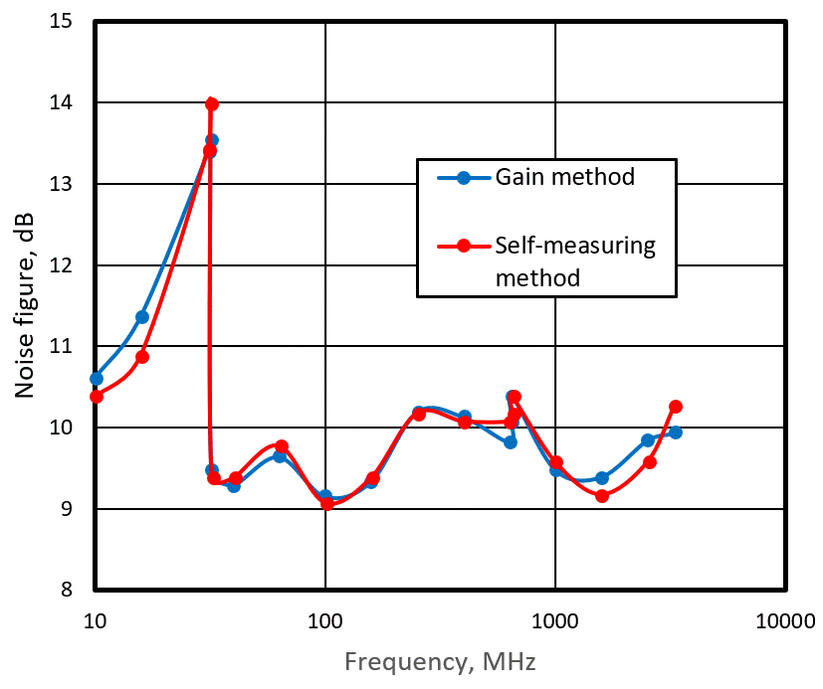

Figure 1: The dependence of the noise figure of the receiver R&S EB500 in normal mode on the frequency.

The measured frequency dependences of the noise figure are useful for practical purposes. For example, the datasheet for a radio monitoring receiver R&S EB500 in low distortion states that the noise figure is typically 20 dB over the frequency range 8 kHz to 3600 MHz. At the same time, it follows from Figure 2 that at frequencies somewhat less than 32 MHz, the noise factor of the measured receiver is noticeably greater than 20 dB, and in the frequency range from 650 MHz to 2500 MHz it is noticeably less than 20 dB.

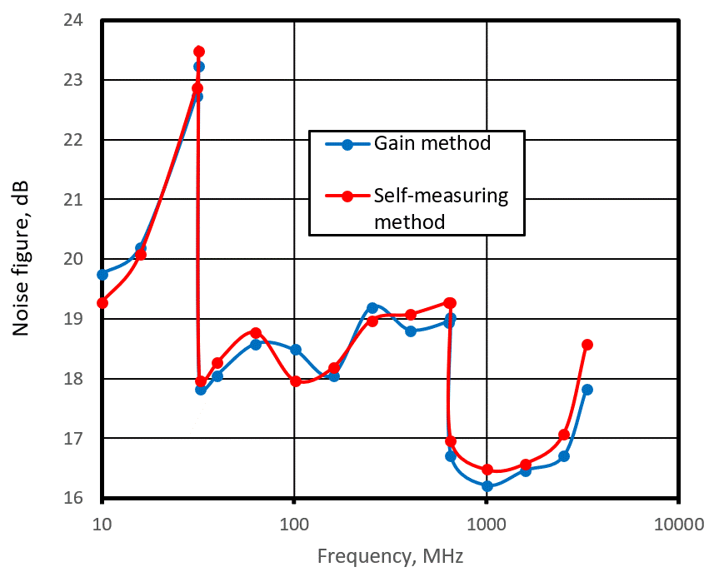

Figure 2: The dependence of the noise figure of the receiver R&S EB500 in low distortion mode on Maximum distances between field strength measurement points allowed when using the route scan method

1. **conclusions**

The described method for measuring the noise figure of radio monitoring receivers is extremely simple to implement and does not require the use of any additional measuring instruments. It does not require the receiver to have an analog IF output, as is the case with the Gain method. However, despite its simplicity, it allows, with enough accuracy for practical purposes, to measure the noise figure of the radio monitoring receivers.

1. **LIST OF REFERENCES**
2. Christoph Rauscher, Volker Janssen, Roland Minihold. Fundamentals of Spectrum Analysis, sixth edition.