Document FM22(22)46Annex

ECC Recommendation (12)03

Determination of the radiated power through ground-based field strength measurements in the frequency range from 30 MHz to 6000 MHz
Approved xx 2022

Table of Contents
introduction 3
ECC recommendation (12)03 of 8 February 2013 on determination of radiated power through field strength measurements in the frequency range from 30 MHz to 6000 MHz, amended 8 February 2019 4
ANNEX 1: radiated power determination based on field strength measurements in the frequency range from 30 MHz to 6000 MHz 5
A.1.1 introduction 5
A.1.2 Basic description of the measurement methods 5
A.1.2.1 Height scan method 5
A.1.2.2 Route scan method 6
A.1.3 Decision on the applicable method 7
A.1.4 Equipment, procedure and calculation of radiated power 10
A.1.4.1 Height scan method 10
A.1.4.1.1 Measurement equipment 10
A.1.4.1.2 Measurement procedure 10
A.1.4.1.3 Result evaluation 13
A.1.4.2 Route scan method 15
A.1.4.2.1 Measurement equipment 15
A.1.4.2.2 Measurement procedure 15
A.1.4.2.3 Evaluation of the results 17
A.1.4.2.4 Impact of hilly terrain 18
A.1.5 Measurement uncertainty calculation 18
A.1.5.1 Typical measurement uncertainty 19
A.1.5.2 Actual measurement uncertainty 19
A.1.5.3 Methodology 19
A.1.5.4 Example of a measurement uncertainty calculation 19
ANNEX 2: Theoretical Background 22
A.2.1 Two-ray ground reflection model for flat surface 22
A.2.2 Field strength dependency on distance 23
A.2.3 Field strength dependency on height 25
A.2.4 Theoretical background for the height scan method 27
A.2.4.1 Max-min method 28
A.2.4.2 Averaging of the log-scaled values method 28
A.2.5 theoretical baground of the Route scan method 30
ANNEX 3: Properties of typical broadcast antennas 32
ANNEX 4: Terms, definitions and abbreviations 36
ANNEX 5: list of references 38

introduction
The radiated power of a transmitter is one of the most important parameters which characterise a transmitter and its emissions. Usually, it is not possible to measure the radiated power directly. However, there are two different methods to determine the radiated power indirectly. The first method would measure the transmitter output power and calculate the radiated power by taking into account cable losses and antenna gain. The second method measures the field strength and calculates the radiated power by taking into account the measurement distance and the propagation loss.
The purpose of this ECC Recommendation is to provide common measurement methods which will enable CEPT administrations to determine the radiated power of a transmitter in the frequency range from 30 MHz to 6000 MHz from field strength measurements reducing as much as possible the uncertainty of the measurement.

ECC recommendation (12)03 of 8 February 2013 on determination of radiated power through field strength measurements in the frequency range from 30 MHz to 6000 MHz, amended 8 February 2019
“The European Conference of Postal and Telecommunications Administrations,
considering
- that the limitation of the radiated power of a transmitter is essential for the limitation of co-channel re-use distances and for interference mitigation in neighbouring channels,
- that radiated power is one of the parameters which is specified in authorisations,
- that the verification of radio stations emissions for compliance with the authorisation conditions is an important task of the radio monitoring or inspection services,
- that radiated power determination through measurements at the transmitter output are often impossible due to access problems or lacking test output,
- that these measurements can be substituted by field strength measurements with subsequent conversion to radiated power under certain conditions,
- that a radiated power determination through measurement at the transmitter output generally can only be done with the agreement and thus with the knowing about measurement activities of the operator or the operating company,
- that the radiated power of some systems may vary in relation with many parameters such as traffic load of the network and/or downlink power control,
recommends
that the measurement methods described in Annex 1 should be used to determine the radiated power of a transmitter based on field strength measurements in the frequency range from 30 MHz to 6000 MHz.”
- radiated power determination based on field strength measurements in the frequency range from 30 MHz to 6000 MHz
  - introduction
Field strength measurements are one of the basic tasks of all radio monitoring services. It is feasible to measure the field strength at a single location in the electromagnetic field but due to reflections and other propagation effects, the measured values may change extremely from one measurement location to the next. The following measurement methods describe how these effects can be handled in order to retrieve reliable field strength values which may be used for the determination of the radiated power of a transmitter.
Airborne measurements are not covered in this ECC Recommendation.
  - Basic description of the measurement methods
    - Height scan method
The measurement method relies on the correction of the influence of possible ground reflections from information gained through a height scan of the field strength at the location of reception.
Direct wave
Reflected wave
Transmitter
Meas. vehicle
d
H
h
- Situation of a height scan measurement
Depending on the phase difference between direct and reflected wave, the amplitude of the measured field strength will vary with the height of the measurement antenna (h).
If there are less than 5 clearly visible maxima and minima during a height scan, the magnitude of the reflection can be determined from the absolute maximum and the adjacent minimum field strength to calculate the field strength of the direct wave. This evaluation is herein called “Max-Min evaluation”.
Especially at frequencies above about 3 GHz, maxima and minima are often so close to each other that their levels are difficult to determine. In addition, in these frequency ranges usually multiple reflections occur, resulting in height scans with no clear maxima and minima. In these cases, the field strength of the direct wave can be calculated by averaging the logarithmic field strength values of each measurement point during the complete height scan. This evaluation is herein called “log averaging evaluation”.
The radiated power of the transmitter can then be calculated using the formula for free space propagation.
The height scan method is basically frequency independent. However, there are many cautions to take into account in order to reduce external influence factors which may lead to errors in the measurement process.
The suggested measurement method loses accuracy for frequencies below 400 MHz and for transmitters with high vertical directivity (such as DAB and DVB-T transmitters) because the height accessible by customary measurement antennas (10 m) may not be sufficient to capture both a maximum and a minimum of the field strength distribution while being in the main beam.
There are, however, even more constraints with regard to the applicability of the method. Field strength measurements have to be performed in the far field. The far field is usually defined as the range from 2D²/λ to ∞ with D being the largest dimension of the transmitting antenna. If D=1 m (typical base station antenna) and λ=0.1 m (3 GHz) the measurement distance between the transmitter and the receiving antenna has to be at least 20 m.
It has further to be considered that the actual location where the effective ground reflection occurs is different for different heights of the measurement antenna. A valid estimate of the reflection coefficient from a field strength height scan can thus be obtained under the provision only that locations of reflection for the “maximum” and the “minimum” reflection nearly coincide.
The measurement method assumes the free space propagation, i.e. a 20 dB path loss per decade of distance, for the direct wave. Hence the method loses accuracy if this condition is not fulfilled.
Finally, it should be mentioned that measurement errors due to the aforementioned effects usually result in undervalued field strength or radiated power levels and not in increased levels.
This procedure may not be suitable for systems using advanced radio technology as such dynamic beam forming.
    - Route scan method
In cases where the height scan method does not result in at least one maximum and one minimum, field strength measurements can be taken at a constant antenna height while driving along a pre-defined route that approximately runs straight towards or away from the transmitter and always maintains line-of-sight conditions. Measurement samples are taken at a high rate and at the same time the geographical coordinates of each measurement point along the route is recorded.
In the evaluation process the distance to the transmitter is calculated for every measurement point. All measured field strength values are compared to the theoretical field strength for the respective distance that are derived from a two-ray propagation model. The theoretical field strength curve is adjusted by varying the radiated transmitter power until that the average difference between this curve and the measurement results is minimised.
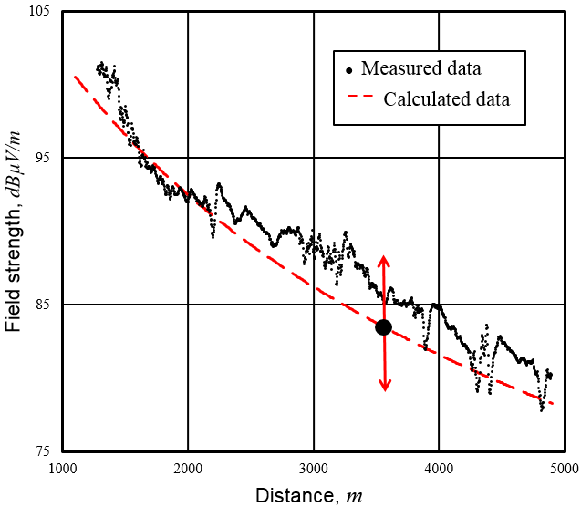
- Example result of a route scan
The route scan method is especially applicable when measuring the e.r.p. of FM broadcast, DAB and DVB-T/T2 transmitters having high vertical directivity.
However, accurate measurements are only possible if the terrain along the route is flat and has constant line-of-sight to the transmitter. Especially in frequency ranges above about 200 MHz it is important that there are no reflecting obstacles such as trees and/or buildings near the measurement route.
Moreover, the method is only valid at relatively high measurement distances where the two-ray model has no more minima and maxima (see Figure 12: in A.2.2).
  - Decision on the applicable method
The applicability of the measurement method depends on several technical and practical conditions. The following flow chart provides guidance on the decision-making which method is applicable from the technical point of view. Details and background information on the individual steps are provided in Table 1: and following sections. From the practical point of view, the applicability of the recommended measurement method may be restricted by a lack of access to a suitable measurement location or route.
Inspect Tx installation and collect available technical information about transmitter (Tx)
Is the Tx vertical antenna pattern available?
Use the route scan method
Calculate maximum measurement angle θmax for the 10 dB point
using the actual antenna pattern
Calculate minimum measurement angle θmin to obtain at least one Minimum and one maximum in a height scan
1
3
4
2
5
7
Calculate maximum measurement angle θmax for the 3 dB point
using a typical antenna pattern
Yes
No
Compare θmax and θmin
6
Use the height scan method
θmin > θmax
θmin ≤ θmax
8
- Decision of the applicable measurement method
- Explanations for decision making flow chart elements
Element number | Explanation
1 | In the context of the decision which method to apply, the following information from the transmitter (Tx) should be collected:  Tx antenna height above ground  Tx antenna type (model or number of antenna elements, in case of stocked dipoles used as broadcast antennas the number of antenna bays)  Vertical angle (elevation, downtilt) of the Tx antenna  In case of directional Tx antennas: azimuth of the main beam  In case the antenna data has been declared (e. g. stated in the licence), check whether the actual installation matches the declaration.
2 | Normally all measurements have to be done inside the main beam of the Tx antenna. When this is not possible due to practical constraints, a correction may be applied that is dependent on the vertical antenna pattern. This is more accurate if this antenna pattern is known. In this case it is acceptable to measure at locations that are as much as 10 dB outside the main beam.  If the antenna pattern is not known, typical values for the antenna type are applied, but the measurement location has to be inside the 3 dB range of the main beam. Typical values for multi-bay broadcast antennas can be found in ANNEX 3:.
3 and 4 | The maximum measurement angle θ_{max} for antennas with known vertical patterns is determined at the point where the measurement antenna is 10 dB outside the main beam. This is the angle where the gain of the Tx antenna is 10 dB less than the maximum gain. If the vertical antenna pattern is not known, a typical value for the antenna type may be used, but θ_{max} has to be inside the 3 dB range of the maximum gain. Guidance on typical values for broadcast antennas can be found in ANNEX 3:.  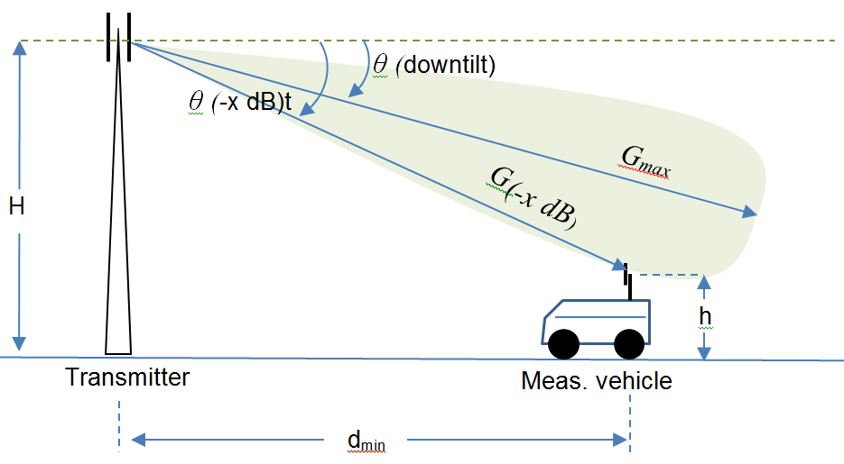  It is obvious that the downtilt of the Tx antenna has to be added to the x dB opening angle of the antenna according to the data sheet. Example: If the antenna pattern has a 10 dB opening angle of +/- 4° and the downtilt is 1°, the maximum elevation angle θ (-10 dB) to the measurement position is 4° + 1° = 5°.  The maximum measurement angle determines the minimum measurement distance.
5 | The minimum angle under which at least one minimum and one maximum during a height scan with the typical scan range of 3m to 10m is obtained can be calculated as follows:  $$θ_{min}\left(deg\right)=\frac{}{f\left(MHz\right)}$$  This calculation assumes that the transmitter height H is much higher than the maximum height of the receiving antenna h_{max}, and that the resulting measurement distance is much higher than the transmitter height. See section A.2.3 of ANNEX 2: for theoretical background of this formula.  The minimum elevation angle determines the maximum measurement distance. Because it is independent of the transmitter height, the calculation also applies in situations where the terrain between transmitter and measurement location is not flat, for example if the transmitter is located on a mountain.
6 | A comparison between θ_{min} and θ_{max} leads to the applicable measurement method.
7 | If θ_{min} is less or than (or equal to) θ_{max}, a height scan resulting in at least one minimum and one maximum can be performed.
8 | If θ_{min} is greater than θ_{max}, a height scan that is performed in the main beam would not result in a maximum and a minimum. In these cases, the route scan method may be applied.

  - Equipment, procedure and calculation of radiated power
    - Height scan method
      - Measurement equipment
For the field strength measurement of many types of emissions a spectrum analyser or measurement receiver may be used.
Any calibrated measurement antenna can be used. However, directional antennas are preferable as they provide some suppression of reflected waves arriving from different directions.
To perform the height scan, a retractable mast carrying the measurement antenna is necessary. Possible antenna heights above ground should be in the range from 3 to 10 m. The mast must be able to perform a height scan at a constant speed or has the possibility to read out the actual height.
A laser distance measuring device, a GNSS receiver, binoculars and a compass are usable tools for the visual inspection of the transmitter and the determination of the antenna height.
      - Measurement procedure
The measurement procedure is as follows:
- Inspect the installation
The field strength measurement requires that the measuring antenna can be positioned in the main lobe of the transmitter and that the area between transmitter and monitoring antenna is unobstructed. Height, directivity and down tilt of the transmitter antenna have to be determined.
- Determination of the maximum measurement distance
The maximum measurement location distance d_{max} is calculated from centre measuring frequency f, height of the transmitting antenna H and maximal height of the measuring antenna h_{max} using the following formula:
$$d_{max}\left(m\right)=\frac{f\left(MHz\right)H\left(m\right)h_{max}\left(m\right)}{}$$
Theoretical background information on this calculation can be found in ANNEX 2:.
The following Figure 4: gives guidance on the determination of the maximum measurement location distance for a common height range that ensures to obtain at least one maximum and one minimum during a height scan.
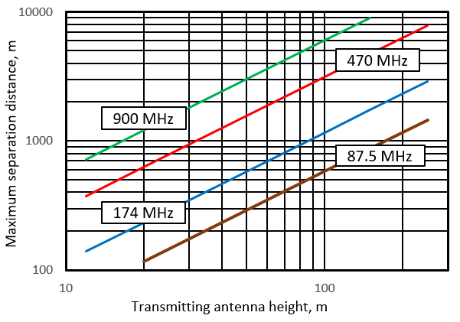
- Maximum separation distance between transmitting and measuring antenna position as a function of transmitting antenna height at some frequencies
- Exception: expanded maximum measurement location distance
Common heights and designs of FM broadcast antennas often lead to maximum measurement distances that are still out of the vertical main lobe, resulting in an underestimation of the calculated e.r.p. In the exceptional case where the transmitter uses a 4-bay antenna array and its vertical diagram is not known, the measurement method described here may also be applied at distances up to about 13 times transmit antenna height where the height scan will provide only a maximum and no minimum. In these cases, a general correction for the ground reflection is applied to the maximum field strength value according to the following table. The values given originate from multiple measurements.
- General correction for ground reflection
Polarisation | n_{k} for general ground reflection
Horizontal | -5 dB
Vertical | -2 dB

- Determination of the minimum measurement distance
In section A.1.3, the maximal elevation angle θ_{max} at which the measurements are possible according to this method has been identified. Knowing this angle, the minimum measurement location distance d_{min} can be calculated using the following formula:
$d_{min}=\frac{H−h}{tanθ_{max}}$
If the terrain is not flat, or the transmitter is located on a mountain, the height difference of the ground level of transmitter and receiver has to be taken into account, so that the term H – h denotes the absolute height difference (msl) between transmitter and receiving antenna.
- Search a suitable measurement location
The measurement location must be chosen at a distance that is between minimum and maximum distances determined in steps 2-4. The measurement location within that area must fulfil the far field condition and must have a line-of-sight to the transmitter. If directional transmitting antennas are used, the measuring antenna must be placed in the direction of the main lobe. The distance will often be in the range of hundreds to several thousand meters so that far field conditions apply.
It must be ensured that there are no other transmitters in close proximity or close in frequency that can impact the measurement, e.g. by overloading the receiver or by high unwanted emissions inside the wanted channel.
- Perform a height scan
Usually, the measurement has to be done with an RMS detector. For continuous emissions, the measurement time has to be long enough to equalise any changes due to traffic or propagation. For pulsed emissions (TDMA systems like RLAN), the average burst power has to be measured (this is the RMS power during the burst only). Some specific systems such as analogue TV require the use of the Peak detector.
The measurement bandwidth should be equal to or higher than the occupied bandwidth of the signal under investigation. The polarisation of the measurement antenna should be the same as used by the transmitter. In case of cross-polarised transmitter antennas the polarisation of the measurement antenna is not relevant. In this case, special care should be taken as in some situations the cross polarisation is used to transmit two different signals and both polarisations have to be addressed separately. Further details regarding field strength measurements may be found in section 4.4 of the ITU Handbook Spectrum Monitoring [1].
The height scan is done by permanently recording the received field strength while the mast rises from minimum height (from car roof level) to 10 m above ground. The path difference of the direct and the reflected signals varies with the height of the receiving antenna. Figure 5: represents a typical form of the field strength during the height scan.
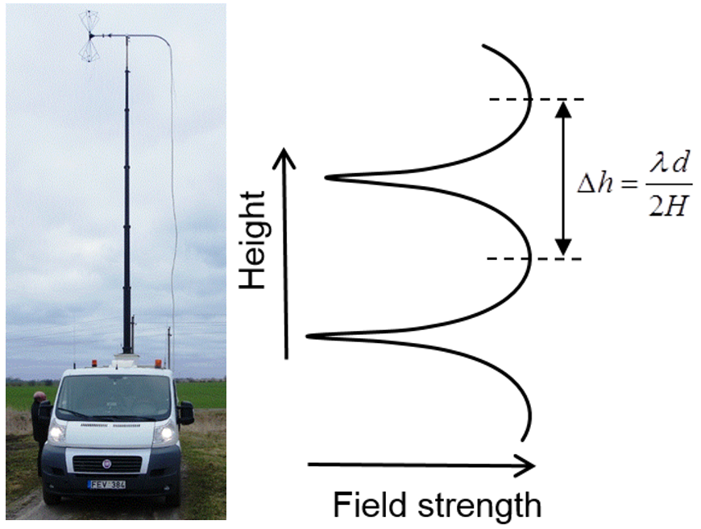
- Change of the field strength depending on height of the measuring antenna
To accurately determine the minimum and maximum of the received signal it is necessary to conduct the height scan with incremental steps of S << Δh, e.g.
S = Δh/10 = (λ * d) / (20 * H).
Example: λ = 0.1 m (f = 3 GHz), d = 500 m, H = 50 m results in S = (0.1 * 500) / (20 * 50) = 0.05 m.
If a swept spectrum analyser is used for the measurements, the recommended settings are presented in Table 3.

- Recommended settings for a swept spectrum analyser
Parameter | Value
Centre frequency | corresponding measured signal working frequency in MHz
Resolution bandwidth (RBW) | equal to or higher than the occupied bandwidth of the measured signal
Video bandwidth (VBW) | 10*RBW
Span | 0 Hz (Zero Span)
Sweep time | corresponding to approximate measurement antenna mast height change from 3 m to 10 m in seconds
Sweep mode | Single Sweep
Trace detector | RMS (root mean square) or AV (average)
Trace mode | Clear Write
      - Result evaluation
In any measurement situation there is at least one reflection overlaying the direct wave. Most commonly this is the ground reflection. The effect of the reflection has to be cancelled out by calculating only the field strength of the direct wave.
If the height scan shows between one and 5 distinguishable maxima and minima, the “Max-Min method” can be used as follows:
The value of the absolute measured maximum E_{max} and the value of the adjacent local minimum E_{min} from the height scan are noted. The following figure shows a typical height scan.
E_{min}
E_{max}
- Measured field strength vs. measurement antenna height (example)
For the elimination of effects due to ground reflections a correction value n_{k} has to be applied (see Figure 7:). It can be determined from the difference between the maximum field strength and the adjacent minimum field strength.
$$\begin{aligned}ΔE=E_{\text{max}}−E_{\text{mim}} \\ n_{k}=\text{20}\text{log}\left(\frac{1+{\text{10}}^{−\left(\frac{ΔE}{\text{20}}\right)}}{2}\right)\end{aligned}$$
with ΔE, E_{max} and E_{min} in dBµV/m.
- Correction curve for n_{k}
The free space field strength value E of the direct wave is determined by the following formula:
$$E=E_{\text{max}}+n_{k}$$
In case there are more than one maximum and minimum in the height scan, measurement accuracy can be increased by calculating the free space field strength for each of these pairs separately and average the result.
In cases where there is no clear maxima and adjacent minima or when their number exceeds 5, the field strength of the direct wave can be calculated by averaging all field strength values measured during the height scan in logarithmic units (“log average evaluation”):
$$E=\frac{1}{N}\sum_{i=1}^{N}{E_{i}}$$
Where:
- E = Field strength of the direct wave in dBµV/m;
- N = number of measurement samples obtained during the height scan;
- E_{i} = Measured field strength of sample i in dBµV/m.

Theoretical background for these two evaluation methods is contained in ANNEX 2:.
If the measurement has been performed outside the main beam of the transmitting antenna at an elevation angle where the antenna gain G differs from the maximum gain Gmax, by more than 1 dB, the difference
Gmax – G in dB should be added to the measured field strength E. Gain differences may be taken from known vertical antenna patterns, or values from typical antennas may be taken as appropriate. Guidance on vertical antenna patters for broadcast antennas may be taken from ANNEX 3:.
The radiated power of the transmitter can be calculated from the field strength value using the following formula that is based on free space propagation:
$$e.i.r.p.=E+20log\left(L_{D}\right)−134.8dB$$
Where:
- e.i.r.p. = effective radiated power in dBW relative to an isotropic antenna;
- E = field strength of the direct wave in dBμV/m;
- L_{D} = Path length of the direct wave (distance between transmit and measurement antenna) in meters.
    - Route scan method
      - Measurement equipment
For the field strength measurement, a spectrum analyser or measurement receiver with an interface to download the measured input level may be used.
Any calibrated measurement antenna may be used. However, an antenna with omnidirectional properties in the horizontal plane is preferable. The antenna must be mounted on a measurement vehicle at a fixed height having the same polarisation as the transmitter to be measured.
The measurement vehicle must be equipped with a GNSS receiver having an interface to a computer.
For control of the spectrum analyser, download of raw data and for collection of GNSS information a computer is needed.
The speed of measurement system must ensure that when the measurement vehicle moves, the measurement points must be taken at the highest possible speed, ideally not less than 0.8 wavelengths apart [9], but in any case should not exceed 10 wavelengths.
A laser distance measuring device, a GNSS receiver, binoculars and a compass are usable tools for the visual inspection of the transmitter and the determination of the antenna height.
      - Measurement procedure
The measurement procedure is as follows:
- Inspection of the installation (radio station checks on-site)
Transmitter frequency, antenna height above ground, polarisation, directivity, maximum or minimum emission azimuth, and transmitter location geographical coordinates must be determined before measurements.
- Selection of a suitable route
The route should be selected about across a radial line from the transmitting antenna. This minimises necessary horizontal adjustments during the drive in case a directional measurement antenna is used. In case of directional transmitting antennas, it is necessary that the route lies in the direction of the main horizontal lobe.
The route should also be in a rural area to avoid reflections from buildings and other big structures and helps to ensure a constant line of sight during the drive.
- Selection of the starting point
The first condition is that the measurement has to be taken inside the 1 dB range of the main beam of the transmitting antenna. In section A.1.3 the maximum elevation angle θ_{max} at which the measurements are possible according to this method has been identified. Knowing this angle, the minimum measurement distance d_{min} can be calculated using the following formula:
$d_{min1}\left(m\right)=\frac{H\left(m\right)−h\left(m\right)}{tanθ_{max}}$
If the transmitter is located on a mountain, the height difference of the ground level of transmitter and receiver has to be taken into account, so that the term H – h denotes the absolute height difference (msl) between transmitter and receiving antenna.
The second condition is that the measurement has to be taken at a minimum distance where the Vvedenskij formula can be used to calculate the field strength. Theoretical calculations supported by practical measurements showed that this distance is equal to:
$d_{min2}\left(m\right)=\frac{H\left(m\right)h\left(m\right)f\left(MHz\right)}{30}$ .
If the transmitter is located on a mountain, the height H is the sum of the height of the transmitter mast or tower and the elevation of the mountain above the measurement level.
If the terrain of the measurement route is not flat, the average height of the route has to be used in all calculations (see Section below).
The starting point of the measurement route has to be at a distance that is at least as far as the greater of d_{min1} and d_{min2}.
- Selection of the length of measurement route
The measurement accuracy generally gets higher as the distance driven increases. The minimum length of the measurement route depends on the start distance. Practical measurements have shown that a value for the term length/start distance of 1 is feasible, which means the route should have about the same length as the distance where the measurement is started (driving away from the transmitter is assumed).
- Driving along the route
The selected route is driven, preferably away from the transmitter, while recording field strength and actual position of the measurement car simultaneously. If the measurement samples are taken at a constant rate, the speed of the vehicle during the measurement also has to be constant. If measurement samples can be taken at defined distances (receiver is triggered at any change of coordinates from the GNSS device), the driving sped may vary.

      - Evaluation of the results
The distance d to the transmitter is calculated from the geographical coordinates of the transmitter and the measurement results for every measurement sample.
Assuming the authorised radiated power P_{a} of the transmitter (e.i.r.p), the field strength function between minimum and maximum distance driven along the route is calculated using the Vvedenskij formula:
$E\left({dBμV}/m\right)=e.i.r.p.\left(dBW\right)+20log⁡\left[\frac{4πH\left(m\right)h\left(m\right)f\left(Hz\right)}{c\left(\frac{m}{s}\right)}\right]−40log⁡\left[d\left(m\right)\right]+134.8dB.$
The arithmetic mean of the field strength $\overline{E_{c}}$ for the whole route is calculated.
For a visual assessment of the validity of the measurement it is very helpful to plot both measurement results and calculated theoretical field strength vs. distance in a diagram:
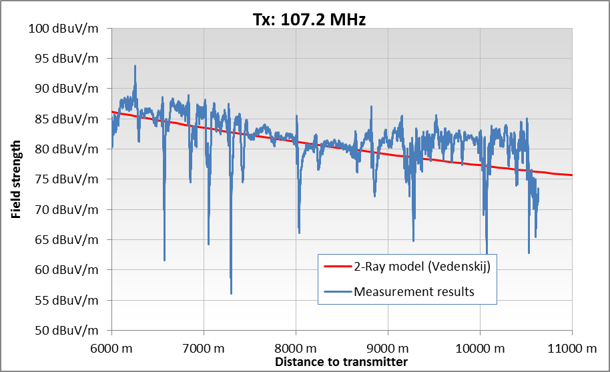
- Example evaluation of a route scan
An arithmetic mean of all measured field strength samples $\overline{E_{m}}$ is calculated.
The measured transmitter power P_{m} is calculated from the authorised power P_{a} and the mean field strengths $\overline{E_{c}}$ and $\overline{E_{m}}$ to
P_{m} = P_{a} + ($\overline{E_{m}}$- $\overline{E_{c}}$
Theoretical background information on the evaluation method can be found in ANNEX 2:.
Note that when calculating the arithmetic mean $\overline{E_{m}}$ it is assumed that the field strength is measured at equidistant points. Practically, for a few reasons, this condition is not always fulfilled (for example, it is not always possible to maintain the car's speed constant). Under those circumstances the arithmetic mean $\overline{E_{m}}$ is calculated as follows:
First, the initial measurement data is separated into a number of equidistant route sections (of example sections of 10 m length). Then, all field strength values in each section is averaged. The final value of $\overline{E_{m}}$ is then calculated by averaging all section averages.

      - Impact of hilly terrain
In most cases the surface of the measurement is not completely flat, and its height does not coincide with the area where the broadcast antenna mast is built. This is covered by the introduction of effective transmitting antenna height H_{ef}. Using a digital map with terrain heights, the height of antenna mast area above the sea level H_{A} is determined. The average route height above the sea level H_{AV}.is also determined. Practically in most cases it is sufficient to take the average of the highest and the lowest points of the route. Then the effective antenna height H_{ef} is calculated as follows:
$H_{ef}=H+H_{A}−H_{AV}$ .
This effective transmitter antenna height is used for the field strength calculations.
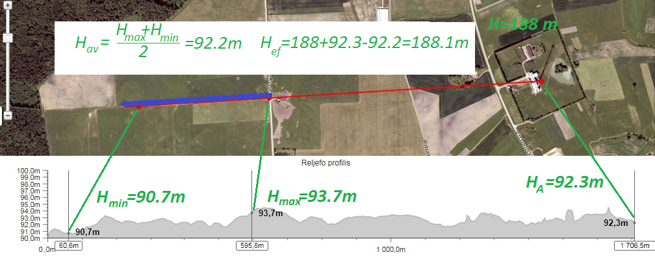
- Example of effective height calculation
  - Measurement uncertainty calculation
The described height scan method assumes that the main contributor to the measurement uncertainty is caused by reflections, which is usually the case. Reflections from distant objects may be minimised by using a measurement antenna with high directivity.
The main contributor the route scan method is usually the environment between transmitter and measurement vehicle causing reflections or partially blocking a line of sight.
Several 1000 measurements at base stations of mobile phone operators using the height scan method and verifications using test transmitters with known parameters have shown a maximum measurement uncertainty of 3 dB. Likewise, measurements using the route scan method have shown equal measurement uncertainties if the conditions for valid measurement routes described in this ECC Recommendation are met.
It is possible to verify the actual contribution of the spectrum environment (such as the impact of reflexions) on the error of the measurement. If the location of the transmitter antenna (roof, mast) is accessible, the general principle outlined as follows may be applied: A test transmitter with known parameters (power, antenna gain) is installed close to the antenna, operating on a free frequency close to the frequency of the transmitter to be measured. A height scan or route scan of the test transmitter at the predetermined measurement location or route is performed and its radiated power is calculated using the methods described in this document. By comparing the result with the known true radiated power of the test transmitter the additional measurement error for the particular radio path can be determined. The calculated power of the transmitter to be measured can then be corrected by the magnitude of the error. Environmental effects may be assumed to be “zeroed out” this way. It should be noted that also this method may introduce uncertainties in the measurement result. For example, the used antenna may not be identical and the frequency is slightly different from those of the transmitter to be measured. The more such parameters are close to those of the transmitter to be measured, the more the uncertainty is negligible.
To ensure the reliability of the measurement, the uncertainty should be calculated. Keeping the previous chapter in mind a single calculation for the specific test set used is sufficient in many cases. This is called the typical measurement uncertainty of the test set.
    - Typical measurement uncertainty
For determining the typical measurement uncertainty all uncertainty sources that are normally present in the measurement system and during the measurement are identified and estimated and an overall uncertainty calculation is made. A typical measurement uncertainty between 1.5 dB and 2.5 dB for a 95% confidence interval can be considered a good achievement for a field strength measurement system but can only be achieved when all main contributing error sources are minimised and when the measurement is conducted very precisely.
    - Actual measurement uncertainty
For measurements where the assumptions described in Sections A.1.4.1.2 or A.1.4.2.2 cannot be met completely, an individual measurement uncertainty calculation must be made, taking specific circumstances as they occur during the actual measurements into account. A good way to do this is to start with the typical measurement accuracy calculation examining all values in that calculation and correcting them for the specific circumstances that occurred during the measurement. An analysis of the measurement data in the height and horizontal profiles gives important input to this process. The value calculated this way is called the actual measurement uncertainty, and is unique for every measurement. This actual value has to be mentioned in the measurement report, not the typical value.
    - Methodology
The measurement uncertainty calculation should be performed and presented conforming to applicable international standards, e.g. ISO “Guide to the Expression of Uncertainty in Measurements” [2]. When using this method, each measurement is described first, followed by the mathematical formula with which the end result is calculated from the individual variables involved. Then all these variables are described with their uncertainties and their weighting factors of their influence on the final result is established. When the source variables are expressed logarithmically, they first have to be converted to linear values. With this information, the uncertainty of the end result is calculated and is presented in the standardised form. Also the main contributors to the overall uncertainty are identified.
    - Example of a measurement uncertainty calculation
In this section, a practical example is given of an actual uncertainty calculation for radiated power measurement using the height scan method. The example illustrates the influence of different error sources, and is meant to assist the making of one’s own measurement uncertainty analysis. The spread sheet with calculations is incorporated in this Recommendation.
The values used in this example are typical for a particular setup and could in practice be worse or better depending on the effort made to optimise the design.
The example describes a radiated power measurement system. The power P_{RX} is measured at a distance R from the transmit antenna. This is done using a measurement antenna with antenna gain G_{RX} and a measurement receiver.
transmit antenna
Prad
radiated power
transmitter
GRX
measurement
antenna

distance R
PRX
measured power
- Radiated power measurement
The calculation as given before is $P_{\text{rad}}=\frac{P_{\text{RX}}\text{.}R^{2}\text{.}\text{16}π^{2}}{G_{\text{RX}}\text{.}λ^{2}}\text{.}A_{\text{ref}}$
with the additional parameter A_{ref} representing reflections = interference of direct and reflected waves;
The measurement uncertainty of P_{rad.} is a result of the measurement uncertainty of the input parameters. Some of these parameters again have multiple error sources creating their uncertainty. The error sources relevant in this example are discussed hereafter.
Frequency The frequency f used in the formula is that of the carrier frequency. In reality not all the power components measured are on that frequency due to the modulation of the transmitter. Assuming that most of the power is concentrated within known boundaries from the carrier, the relative uncertainty Δf is about 0.1%. The error distribution is assumed uniform.
Distance The uncertainty of the distance is caused by the measurement uncertainty of the position of the transmit antenna and of the measurement antenna.
Antenna gain The uncertainty of the antenna gain is caused by the calibration uncertainty of the antenna, the RF cables, the residual polarisation mismatch, and the horizontal and vertical misalignment of the antenna.
In formula: $G_{\text{RX}}=G_{\text{CAL}}\text{.}A_{\text{CBL}}\text{.}A_{\text{HOR}}\text{.}A_{\text{VERT}}\text{.}A_{\text{POL}}$
This also includes possible misalignment in cases where a down-tilted base station antenna is used.

RX power The uncertainty of the received power is caused by the calibration uncertainty of the receiver, mismatch between antenna and receiver, IF filter losses due to excess bandwidth of the transmitter and leakage of adjacent channel transmitters.
In formula:$P_{\text{RX}}=P_{\text{RX}−\text{CAL}}\text{.}A_{\text{MIS}}\text{.}A_{\text{FILT}}\text{.}A_{\text{NABU}}$
Reflections One of the main contributors to the overall measurement uncertainty are reflections. The relative amplitude of the reflections depends on the reflectivity of the ground and the objects built on it. The reflection is attenuated by the relative path length difference between direct wave and reflected wave and by the vertical pattern of transmit antenna and receive antenna. The amount of reflections in this example has been derived from analysis of the actual measurements as described in section A.1.8, which is 1.7 dB in this case.
The calculation of the total measurement uncertainty in this example is shown in the Table 4 below.

- Calculation example of the total measurement uncertainty

A calculator containing the Table 4 is also incorporated in this report and may be used as the basis for someone’s own application.
Administrations implementing this recommendation should evaluate and express uncertainties of their individual measurement equipment according to ETSI TR 100 028-1 and TR 100 028-2 [3], Uncertainties in the measurement of mobile radio equipment characteristics (Parts 1 and 2 - version 1.4.1).

- Theoretical Background
  - Two-ray ground reflection model for flat surface
The two-ray model is an improved version of the free space propagation model. It considers both line-of-sight (direct) and ground reflection paths and is based on ray optics. It is reasonably accurate for predicting the large-scale field strength at a distance of up to several tens of kilometres.
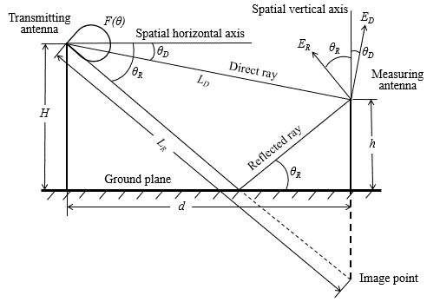
- Graphical representation of the two-ray model applied for a vertically polarised wave
Following the notations in Figure 11:, the length of direct propagation path can be geometrically derived to be
$L_{D}=\sqrt{{\left(H−h\right)}^{2}+d^{2}}$ (1)
and the length of indirect due to ground reflection path derived to be
$L_{R}=\sqrt{{\left(H+h\right)}^{2}+d^{2}}$ (2)
Let’s calculate field strength in the simplest case, when transmitting and receiving antennas are isotropic and wave polarisation is horizontal. These assumptions are not essential, but they make calculations simpler. In this case, based on the lengths L_{D} and L_{R} (see Figure 11:), on the equivalent isotropically radiated power e.i.r.p. and on the magnitude R and phase φ of the ground reflection coefficient, the direct wave can be expressed as
$E_{D}=\frac{\sqrt{60e.i.r.p.}}{L_{D}}sin\left[2πf\left(t−\frac{L_{D}}{c}\right)\right]$ (3)
and the reflected wave can be expressed as
$E_{R}=\frac{R\sqrt{60e.i.r.p.}}{L_{R}}sin\left[2πf\left(t−\frac{L_{R}}{c}\right)+φ\right]$ (4)
where f is the transmitting frequency and c is the velocity of light in free space.
In case of horizontal polarisation, the electric vectors of the direct and reflected wave are horizontal to the reflecting surface. So, these two vectors are parallel, and the resultant field strength can be calculated by adding direct and reflected waves accounting for the difference in phases. As it follows from the equations (1) and (2), the phase difference is
$∆Φ=\frac{2πf}{c}\left(L_{R}−L_{D}\right)+φ$. (5)
Therefore, for the resultant sinusoidal field strength; [4]:

$E=\sqrt{{\left(\frac{\sqrt{60e.i.r.p.}}{L_{D}}\right)}^{2}+{\left(\frac{R\sqrt{60e.i.r.p.}}{L_{R}}\right)}^{2}+2\left(\frac{\sqrt{60e.i.r.p.}}{L_{D}}\right)\left(\frac{R\sqrt{60e.i.r.p.}}{L_{R}}\right)cos\left(∆Φ\right)}∗sin\left(2πft\right).$ (6)
Depending on time terms sin(2πft), the r.m.s. value is equal to $1/{\sqrt{2}}$. Therefore the r.m.s value of the magnitude of the resultant field strength is
$E=\sqrt{{\left(\frac{\sqrt{30e.i.r.p.}}{L_{D}}\right)}^{2}+{\left(\frac{R\sqrt{30e.i.r.p.}}{L_{R}}\right)}^{2}+2\left(\frac{\sqrt{30e.i.r.p.}}{L_{D}}\right)\left(\frac{R\sqrt{30e.i.r.p.}}{L_{R}}\right)cos\left(∆Φ\right)}=$
$\sqrt{{\left(E_{D}\right)}^{2}+{\left(E_{R}\right)}^{2}+2E_{D}E_{R}cos⁡\left(ΔΦ\right)}$, (7)
where E_{D} and E_{R}, respectively, are the r.m.s field strength magnitudes of the direct and reflected waves.
In case of vertical polarisation, the electric vectors of direct and reflected waves lay in the plane of incidence. Following the notations in Figure 11: the vertical component of the total field strength (which is usually measured) is
$E_{V}=E_{D}cosθ_{D}+E_{R}cosθ_{R}$ (8)
Here it should be noted, that in order to determine radiated power using one of methods described below, field strength is always being measured far from transmitting antenna, so the angles θ_{D} and θ_{R} usually do not exceed 10 degrees and cos values of these angles are close to 1. Then, as it can be seen from equation (8), the total field strength in case of vertical polarisation (the same as in case of horizontal polarisation) is the sum of the direct and the reflected waves, and its r.m.s. value is described by equation (7).
Equation (7) allows calculating the resultant field strength dependency on distance d and height h. This equation contains the interference term 2E_{D}E_{R}cos(ΔΦ), which magnitude and sign depend on the path difference of direct and reflected waves. Therefore, field strength fluctuations occur when the height h or distance d changes. Below, this question will be discussed in more detail.
  - Field strength dependency on distance
When the distance d is very long relatively to the height of the transmitting antenna H and receiving antenna h, the angles θ_{D} and θ_{R} are nearly equal and close to zero (see Figure 11:). Therefore, the reflection coefficient of the ground is close to 1 [5] and the formula (7) for the calculation of field strength transforms into the simplified expression:
$E=\sqrt{30e.i.r.p.}\frac{4πHh}{d^{2}c}$. (9)
Or, in logarithmic terms:
$E\left({dBμV}/m\right)=e.i.r.p.\left(dBW\right)+20log⁡\left[\frac{4πH\left(m\right)h\left(m\right)f\left(Hz\right)}{c\left(\frac{m}{s}\right)}\right]−40log⁡\left[d\left(m\right)\right]+134.77dB.$ (10)
Equation (9) is usually called the Vvedenskij’s interferential formula. This formula can be applied under the following condition:
$\frac{2πHhf}{dc}≤\frac{π}{9}.$ (11)
It is more convenient to introduce the normalised distance d_{n}=d/(Hhf/c) and rewrite formula (11) as:
$d≥18d_{n}$ (12)
Figure 12: shows the calculated field strengths vs. distance for two different heights of an isotropic receiving antenna (left: 3 m, right: 10 m). In this example, the frequency is 100 MHz, radiated e.i.r.p. is 30 dBW, and the height of the transmitting antenna is 100 m. Dependencies of magnitude and phase of the reflection coefficient on grazing angle (equal to the elevation angle) were taken from [5].
- b)
- Field strengths vs. distance for different receiving antenna heights (a: 3m, b: 10m)
It can be seen that at distances larger than 18d_{N} the field strength decreases with ~d⁻² and the values from Vvedenskij”s formula and initial formulas (6) and (8) are very close.
The error when applying Vvedenskij’s formula, compared to the exact 2-ray formulas (6) and (8) that include the dependency of the ground reflection coefficient on grazing angle, is shown in Figure 13:. In the calculations, the height of the transmitter antenna was 100 m, and the height of the receiving antenna was 3 m. However, calculations with transmit antenna heights between 50 and 200 m have shown equal results.
A: horizontal polarisation b: vertical polarisation
- Difference in calculated field strengths between Vvedenskij’s formula and exact 2-ray equations
It can be seen that the error when applying Vedenskij’s formula is less than 1 dB for normalised distances above 10 in case of horizontal polarisation and 15 in case of vertical polarisation.
  - Field strength dependency on height
Figure 14: shows the received field strength vs. receiving antenna height for two different distances to the transmitter. In the example, the frequency is 100 MHz, the e.i.r.p. is 30 dBW, and the transmit antenna height is 100 m. It can be seen that the number of local minima and maxima during the height scan is decreasing with increasing the distance d.
a: measurement distance = 250 m b: measurement distance = 1000 m
- Field strength dependency on height at different measurement distances
Let’s determine the maximum distance d_{max} between transmitter and measurement location at which by varying the receiving antenna height one minimum and one maximum value of the field strength is detected. This is the maximum distance in which the height scan method can be applied. The measuring antenna height h is changed from the lowest value h_{min} to the highest value h_{max}. Following the notations in Figure 11:, when the height of measuring antenna above the ground is minimal, the length of the direct propagation path L_{D,min} can be expressed as follows:
$L_{D,min}=\sqrt{{\left(H−h_{min}\right)}^{2}+d^{2}}=d\sqrt{1+{\left(\frac{H−h_{min}}{d}\right)}^{2}}$ (13)
and the length of the indirect propagation path L_{R,min} due to the ground reflection will be:
$L_{R,min}=\sqrt{{\left(H+h_{min}\right)}^{2}+d^{2}}=d\sqrt{1+{\left(\frac{H+h_{min}}{d}\right)}^{2}}$. (14)
In practice, the horizontal separation distance d between the transmitting and the measuring antenna positions is very large compared to $(H+ h_{\text{min}})$ and $(H− h_{\text{min}})$. Therefore, formulas (13) and (14) simplify:
$L_{D,min}=d+\frac{1}{2d}{\left(H−h_{min}\right)}^{2}$ (15)
$L_{R,min}=d+\frac{1}{2d}{\left(H+h_{min}\right)}^{2}$. (16)

In this case, the path difference is:
$ΔL_{min}=L_{R,min}−L_{D,min}=\frac{2Hh_{min}}{d}$ . (17)
Similarly, when the height of the measuring antenna above the ground is maximal, the path difference will be:
$ΔL_{max}=L_{R,max}−L_{D,max}=\frac{2Hh_{max}}{d}$ . (18)
So, if the height of the receiving antenna above the ground is increased from h_{min} to h_{max}, the change in path difference is
$ΔL_{max}−ΔL_{min}=\frac{2H\left(h_{max}−h_{min}\right)}{d}$ . (19)
By varying the antenna height, at least one minimum and one maximum value of the measured field strength is always detected if the variation of the path differences is
$ΔL_{max}−ΔL_{min}=\frac{2H\left(h_{max}−h_{min}\right)}{d}=λ$ (20)
where λ is the wavelength of the transmitting signal.
It follows from equation (20) that the maximum measurement distance d_{max} is given by:
$d_{max}=\frac{2H\left(h_{max}−h_{min}\right)}{λ}=\frac{2fH\left(h_{max}−h_{min}\right)}{c}$ (21)
This equation is more useful when expressed as:
$d_{max}\left(m\right)=\frac{f\left(MHz\right)H\left(m\right)\left[h_{max}\left(m\right)−h_{min}\left(m\right)\right]}{150}$ . (22)
According to Recommendation ITU-R R.526 [7] LoS propagation can be assumed (i.e. diffraction is negligible), if there is no obstacle within the first Fresnel ellipsoid. For the calculations of the height scan method, his condition must be fulfilled even when the measurement antenna is at its lowest position. In this case, however, even the Earth's surface may become an obstacle (see Figure 15:).
- The first Fresnel zone and the effect of the Earth's surface to the direct ray
Assuming a flat surface, the first Fresnel ellipsoid just touches the Earth's surface at the measurement distance d_{max} when the minimum receiving antenna height is [7]
$h_{min}\left(m\right)=\frac{75d_{max}\left(m\right)}{H\left(m\right)f\left(MHz\right)}$ (23)
The system of equations (22) and (23) can be solved for d_{max} with the above mentioned additional limitation to [6]
$d_{max}\left(m\right)=\frac{f\left(MHz\right)H\left(m\right)h_{max}\left(m\right)}{225}$ (24)
It follows from this equation that the maximum distance is linearly dependent on the maximum achievable measuring antenna height. Comparing the expressions (23) and (24), the height h_{min} can be expressed in terms of h_{max}:
$h_{min}=\frac{1}{3}h_{max}$ . (25)
This ratio is very close to practically achieved heights when using retractable masts on monitoring vehicles.
It is obvious that for distances smaller than d_{max} the height h_{min} < h_{max}/3. So, when using retractable masts at all distances not exceeding d_{max} the first Fresnel ellipsoid never touches the Earth's surface.
The maximum distance d_{max} corresponds to the minimum elevation angle θ_{min}. To calculate it we can use equation (24). For broadcast frequencies the following assumption may be applied:
d_{max} >> H >> h. (26)
Therefore, elevation angles are very small and θ_{D} ≈ θ_{R} ≈ θ_{min}. Considering this fact, it follows from trigonometry and equation (24) that the elevation angle at the distance d_{max} is
$θ_{min}\left(deg\right)=\frac{180}{π}arctan\frac{H}{d_{max}}≅\frac{12900}{f\left(MHz\right)h_{max}\left(m\right)}$ . (27)
This formula is valid for frequencies above 30 MHz. At 30 MHz the error in the determination of θ_{min} is 24%. Above this frequency the error decreases with 1/f.
Note that the angle θ_{min} is independent of transmitting antenna height above the ground H.
From equation (20) follows the additional conclusion that the height difference between two adjacent peaks of field strength is approximately given by
$∆h=h_{max}−h_{min}=\frac{λd}{2H}$ . (28)
In practical measurements one minimum and one maximum of the measured field strength is very often at distances d_{m} which were up to 1.6 times higher than d_{max} calculated according to equation (21). This is due to the fact that expression (21) was obtained under a rather strict condition (20).. The fulfilment of condition (20) ensures that at least one maximum and one minimum during a height scan is obtained when the reflection phase changes over a wide range. According to the data presented in [5], for vertically polarized waves, depending on the grazing angle, the phase of the reflection coefficient can vary from zero to 180 degrees but at angles of above 13 degrees or less, the phase of the reflection coefficient of a vertically polarized wave is very close to unity. In the case of a horizontally polarized wave, the phase of the reflection coefficient is always equal to unity. Therefore, the strength of the resultant field of the direct and reflected waves at the surface is zero. In such a case, condition (20) can be replaced by a weaker condition:

. (29)
Under this condition, the first minimum of the resultant field strength will be at the surface, the second - at a height of h_{max}, and the first maximum - at a height of 0.5h_{max}. When comparing the right parts of expressions (18) and (29), the following expression is obtained for the maximum distance
. (30)
This equation is more useful when expressed as:
. (31)
Comparison of expressions (24) and (31) shows that the distance turn out to be noticeably larger than the distance :

. (32)
At a distance , the elevation angle will also decrease by 1.5 times

. (33)
It is necessary to check whether the Earth’s surface is an obstacle when the measuring antenna is at the level of the first maximum of the field strength h_{1max}. As mentioned above, the strength of the resultant field of the direct and reflected waves at the surface is zero. Therefore, the first maximum corresponds to the condition
. (34)
Similarly, as for ΔL_{max} and ΔL_{min} , you can get an expression for ΔL_{1max}:
. (35)
Comparing the expressions (34) and (35) the following expression is obtained for h_{1max}:
. (36)
This equation can be rewritten as follows:
. (37)
The resulting expression coincides with the expression (23). Therefore, when measuring the first maximum at any distance, the surface of the Earth is not an obstacle.

  - Theoretical background for the height scan method
From the dependency of the resultant field strength on the receiving antenna height, the field strength of a direct wave can be determined in two ways (further called the max-min method and the averaging of the log-scaled values method).

    - Max-min method
When changing the height of the measuring antenna, the field strength maximum E_{max} and minimum E_{min} caused by the constructive (when cos(ΔΦ)=1) and destructive (when cos(ΔΦ)= -1) combination of direct and ground reflected waves are observed (see Figure 6: as an example). These extreme field strength values are:
$E_{max}=E_{D}+E_{R}$ (38)
$E_{min}=E_{D}−E_{R}$. (39)
Combining these two equations, we get the field strength of the direct wave as:
$E_{D}={\left(E_{max}+E_{min}\right)}/2$ (40)
This expression can be rewritten to
$E_{D}=E_{max}−∆E/2$ , (41)
where ΔE is the difference between the maximum field strength E_{max} and the adjacent minimum field strength E_{min}.
In practice field strength is measured in logarithmic units (usually in dBµV/m). Therefore it is more convenient to use equation (41) in the following form:
$E_{D}=E_{max}+n_{k},$ (42)
$n_{k}=20log\left[\frac{1+{10}^{−\left(\frac{ΔE}{20}\right)}}{2}\right]$ . (43)
    - Averaging of the log-scaled values method
The common logarithm of both sides of equation (7) is:
$20logE=10log$. (44)
By introducing new symbols
${a=\left(E_{D}\right)}^{2}+{\left(E_{R}\right)}^{2}$, (45)
$b=2E_{D}E_{R}$ (46)
Equation (35) can be rewritten as:
$20logE=10log⁡$. (47)
By integrating this equation from 0 to π we will obtain
$\int_{0}^{π}{20logE}d\left(∆Φ\right)=10\int_{0}^{π}{log\left[a+b∙cos\left(∆Φ\right)\right]d\left(∆Φ | \right)}$. (48)
By changing logarithms from common to natural, the right side of equation (448) becomes:
$\frac{10}{ln\left(10\right)}\int_{0}^{π}{ln\left[a+b∙cos\left(ΔΦ\right)\right]d\left(ΔΦ | \right)}$. (49)

If a ≥│b│>1 (which is valid for our case), then this integral is computed to:
$\int_{0}^{π}{ln\left[a+b∙cos\left(ΔΦ\right)\right]d\left(ΔΦ\right)}=π·ln\frac{a+\sqrt{a^{2}−b^{2}}}{2}$. (50)
Taking into account (45) and (46), we obtain
$π·ln\frac{a+\sqrt{a^{2}−b^{2}}}{2}=π·ln{\left(E_{D}\right)}^{2}$. (51)
Using this equation and going back to common logarithms, equation (48) becomes:
$\int_{0}^{π}{20log}\left(E\right)d\left(ΔΦ\right)=π·20log\left(E_{D}\right)$. (52)
By dividing both sides by π we finally obtain:
$\frac{1}{π}\int_{0}^{π}{20log}\left(E\right)dΦ=20log\left(E | | D\right)$. (53)
From this equation it follows that in case the field strength is measured in logarithmic units (e. g. in dBµV/m), the field strength of direct wave is equal to the average value of the resultant field strength values within the interval in which the phase difference ΔΦ changes from 0 to π:
$\frac{1}{π}\int_{0}^{π}{E\left({dBμV}/m\right)}dΦ=E_{D}\left({dBμV}/m\right)$. (54)
More generalised the lower limit of the integration and integration interval can be set to k*π, where
k=1; 2; 3; …
In practice, during a height scan, field strength samples are taken in uniform, fixed time intervals. Assuming the antenna speed during the height scan is constant, these samples correspond to uniform phase changes δΦ. If we measure N values while the phase ΔΦ changes by π, then phase change δΦ between adjacent samples is equal to π/N. As a result the integral in the left side of equation (54) can be changed to a summation:
$\frac{1}{π}\int_{0}^{π}{E\left({dBμV}/m\right)}dΦ≅\frac{1}{π}\sum_{i=1}^{N}{E\left({dBμV}/m\right)δΦ}=\frac{δΦ}{π}\sum_{i=1}^{N}{E\left({dBμV}/m\right)=\frac{1}{N}\sum_{i=1}^{N}{E\left({dBμV}/m | \right)}}$ (55)
Equations (54) and (55) show that if field strength is measured in logarithmic units, the arithmetic mean of these logarithmic values in specific height intervals is equal to the field strength of a direct wave.
In practice it is inconvenient to average the field strength over the interval in which the phase difference ΔΦ changes from 0 to π, because 0 corresponds to the resultant field strength maximum which is not sharp. The minima can be determined much more accurately. Therefore, more precise results can be obtained by averaging between two adjacent minima of the of resultant field strength during the height scan. The phase change ΔΦ over the interval between two minima is equal to 2π, and equation (55) is still valid for the calculation of the field strength of the direct wave.
If the field strength measurements are carried out under strict line-of-sight conditions with an unobstructed propagation path (no objects causing considerable reflections in the vicinity), the field strength of direct wave E_{D} is the free space field strength E_{FS}.

  - theoretical baground of the Route scan method
The route scan method is based on the comparison of the field strength values measured along the route with calculated field strength values according to Vvedenskij’s formula (9) and (10). The radiated power value used in calculations is being adjusted in such a way that difference between theoretically calculated and experimentally measured data curves is minimised (see Figure 2: for an example). The best-fit radiated power value P_{bf}, is the measured radiated power P_{m}.
For data fitting, we suggest using the Root-Mean-Square Error (RMSE), which is a frequently used measure of the differences between a series of calculated and measured values. In our case, the expression for RMSE is
$RMSE={\left[\frac{1}{N}\sum_{i=1}^{N}{{\left(E_{m,i}−E_{c,i}\right)}^{2}}\right]}^{1/2}$ (56)
where N is the number of measurement points along the route; $E_{m,i}$ and $E_{c,i}$are the measured and calculated field strength values at the point i.
Let’s define the condition corresponding to the minimum value RMSE. In logarithmic scale the field strength at a given reception point is linearly dependent on the radiated power P. In a general form, the calculated field strength at the point i could be expressed as
$E_{i}=K_{i}+P,$ (57)
where K_{i} is an aggregated parameter resulting from the propagation model at the point i.
Considering formula (56) the partial derivative of RMSE with respect to P is
$\frac{∂RMSE}{∂P}=\frac{−1}{RMSE}\left[\frac{1}{N}\sum_{i=1}^{N}{2\left(E_{m,i}−E_{c,i}\right)}\right].$ (58)
The minimum of RMSE corresponds to the condition (δRMSE)/(δP) = 0. It follows from (58) this condition is fulfilled if
$\frac{1}{N}\sum_{i=1}^{N}{2\left(E_{m,i}−E_{c,i}\right)}=2\left(\overline{E_{m}}−\overline{E_{c}}\right)=0.$ (59)
This means that the minimum RMSE is achieved when the arithmetic mean of all measured values along the route is equal to the arithmetic mean of all calculated values. This fact makes it easy to determine the best-fit radiated power P_{bf} .
The difference between the measured value $\overline{E_{m}}$ and $\overline{E_{c}}\left(P_{s}\right)$ calculated for a certain radiated power $P_{s}$ is expressed as Δ. With this definition, taking formula (57) into account, we can write
$\overline{E_{m}}−\overline{E_{c}}\left(P_{s}\right)=\overline{E_{m}}−\overline{K}−P_{s}=∆.$ (60)
From this expression it follows that
$\overline{E_{m}}−\overline{K}−\left(P | | s+∆\right)=\overline{E_{m}}−\overline{K}−$ (61)
Thus, we obtain the best-fit radiated power P_{bf} (and, hence, also the measured radiated power P_{m}):
$P_{bf}=P_{s}+\left(\overline{E_{m}}−\overline{E_{c}}\right).$ (62)
For practical reasons it is convenient to take the value of the authorised radiated power P_{a} as P_{s} in the calculations of $\overline{E_{c}}$.

From formula (62) it follows that the procedure for determination of radiated power of a radio station can be performed in three stages:
- for the selected route, an arithmetic mean $\overline{E^{c}}$of the field strength is calculated for authorised radiated power $P_{a}$;
- the field strength along the route is measured and its arithmetic mean $\overline{E^{m}}$is calculated;
- the radiated power P_{m} is calculated according to:
$P_{m}\left(dBW\right)=P_{a}\left(dBW\right)+\left(\overline{E_{m}}−\overline{E_{c}}\right)dB.$ (63)
In order to correctly determine the arithmetic mean $\overline{E_{m}}$ , the distance between the measurement points along the route must not be too large. To determine the maximum allowable distance between the measurement points, the results of measuring the field strength of FM transmitters along six different routes were used. With these measurements, the distances between the measurement points were less than 0.1 wavelength. Using these data, for each route, the arithmetic mean for a series of increasing distances between measurement points were calculated. Figure 16 shows how the arithmetic mean $E_{m}$ of the field strength changes (relative to its value at the minimum distance between measurement points) with increasing distance between measurement points.
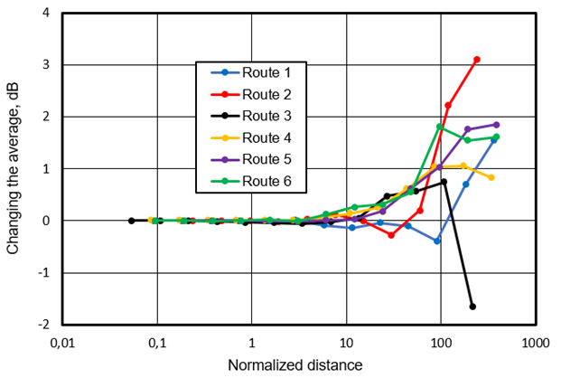
- Change in the average value of the field strength along the route with an increase in the distance between the measurements points (the distance is normalized relative to the wavelength).
Figure 16 shows that as the distance between the measurement points increases to 3λ, the arithmetic mean $E_{m}$ remains practically unchanged. When this distance is increased to 10λ, the maximum change in the arithmetic mean is 0.2 dB. With a further increase in the distance between the measurement points for most routes, the arithmetic mean $E_{m}$ begins to increase noticeably. An acceptable one can still take a distance of 10 wavelengths, when the change in average does not exceed 0.2 dB.
- Properties of typical broadcast antennas
The accuracy and the applicability of the over-the-air measurement methods highly depend on the transmitting antenna design. If the actual pattern is not known, it is useful to apply typical vertical radiation patterns for broadcast antennas consisting of several bays. Tables 5 to 7 (see also Figures 19, 21 and 23 for typical vertical patterns of antennas) below present elevation angles at which the gain of typical professional broadcasting antennas is 1 dB and 3 dB less than the maximum gain (further they will be denoted as θ(-1dB), and θ(-3dB)). If the elevation angle at the measurement point is lower than the -1 dB elevation angle, the vertical directivity of the antenna can be neglected; otherwise it must be taken into account.
It was shown in section A.1.3 that the height scan method can only be applied if the measurement is performed under an elevation angle bigger or equal to a minimum elevation angle θ_{min} obtaining at least one field strength maximum and one minimum during the height scan. In order to evaluate the possibility of applying the height scan method, the minimum elevation angle θ_{min} values are also shown in the tables. These angles were calculated using formula (27) with h_{max}=10 m.
If θ_{min} > θ(-3dB), the height scan method can only be applied if the actual vertical directivity of the transmitting antenna is known.
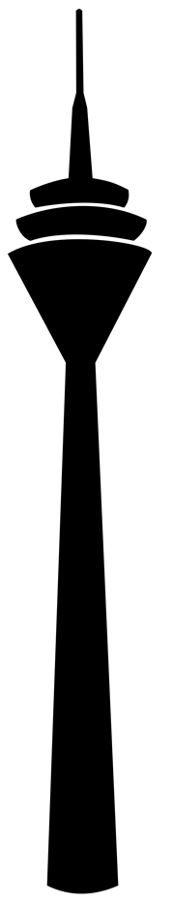
Transmitter
Measurement vehicle
Downtilt
(main beam)
θmin
θ(-3dB)
dmin
dmax
- Determination of the measurement location
The values in the following tables assume null fill and a downtilt of 1° (for FM and VHF-DAB) or 0.5° (for UHF-DVB-T/2). If it is known that the actual downtilt is different, the given values must be changed according to this difference.
The values for the 10 dB elevation angle are given for information only. It is not recommended to use typical antenna patterns outside the 3 dB angle range.
The figures of typical antenna designs are examples only. They apply to omnidirectional antennas mounted on different masts. The values given in the tables, however, apply to any mast shape (rectangular, triangular or round).

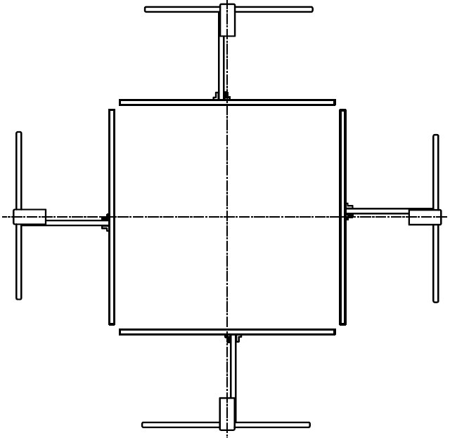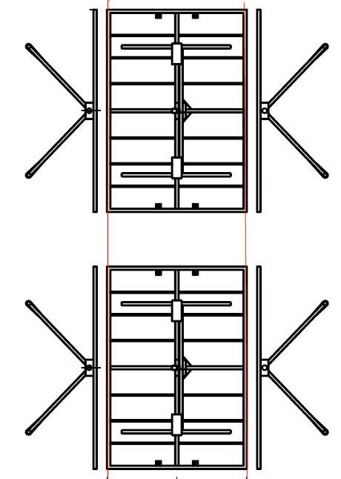
- Top and side view of a typical FM broadcast antenna design on a rectangular mast
- Typical vertical radiation pattern parameters for FM broadcast multi-bay antenna arrays with null fill and 1° down tilt
Number of bays in antenna array | 1 | 2 | 4 | 6 | 8
Elevation angle Φ(-1dB), deg | 12 | 8 | 5 | 4,5 | 3
Elevation angle Φ(-3dB), deg | 21 | 14 | 8 | 6 | 4.5
Elevation angle Φ(-10dB), deg | 40 | 23 | 12.5 | 8.7 | 7
Elevation angle Φ_{min} to obtain min. and max during height scan, deg | 11.9 (at 108 MHz) … 14.7 (at 87.5 MHz)

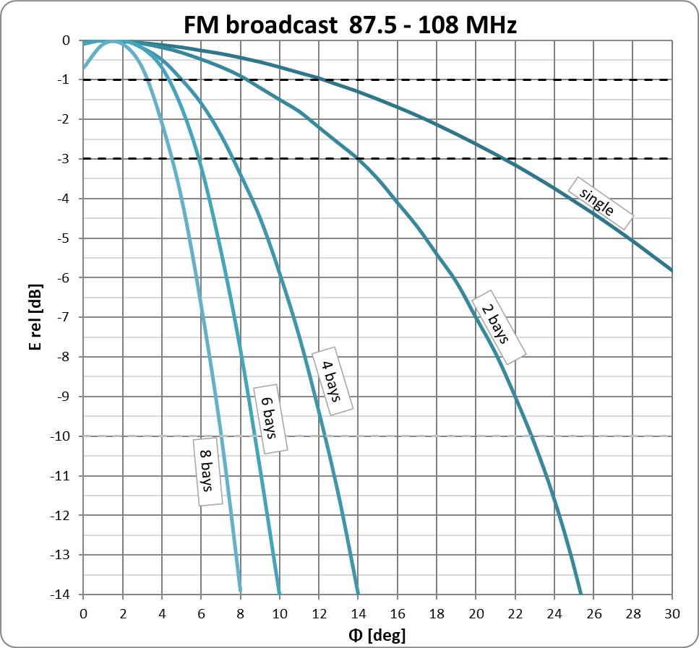
- Typical vertical patterns of FM broadcast antennas
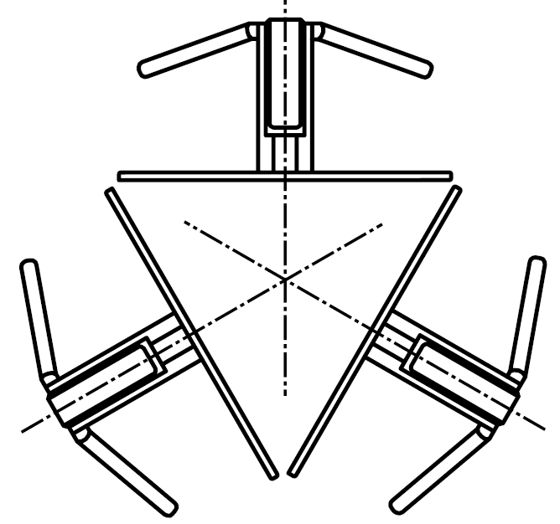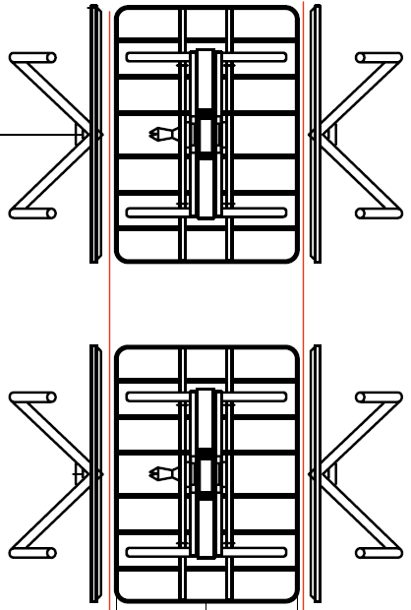
- Top and side view of a typical VHF DAB antenna design on a triangular mast
- Typical vertical radiation pattern parameters for VHF DAB multi-bay antenna arrays with null fill and 1° down tilt
Number of bays in antenna array | 1 | 2 | 4 | 6 | 8
Elevation angle Φ(-1dB), deg | 12 | 4 | 2.7 | 2.5 | 1.8
Elevation angle Φ(-3dB), deg | 21 | 6.5 | 3.7 | 3.2 | 2.4
Elevation angle Φ(-10dB), deg | 40 | 10.2 | 6 | 4.5 | 3.5
Elevation angle Φ_{min} to obtain min. and max during height scan, deg | 5.6 (at 230 MHz) … 7.4 (at 174 MHz)

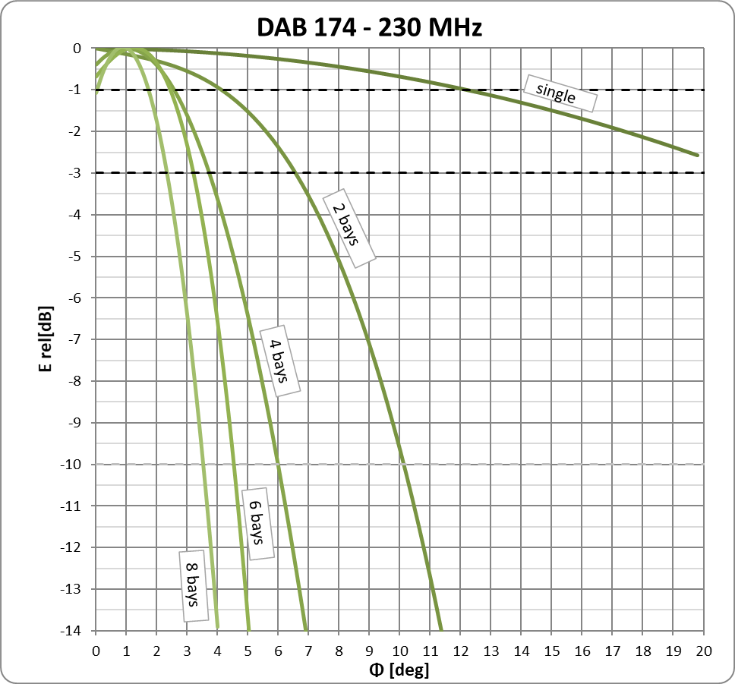
- Typical vertical patterns of VHF DAB antennas
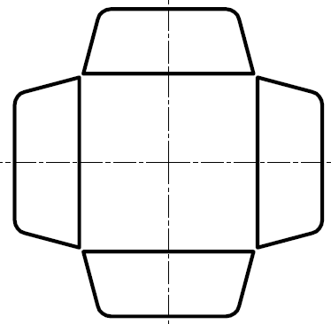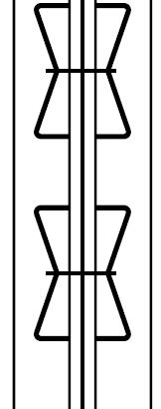
- Top and side view of a typical UHF DVB-T/-T2 antenna design on a rectangular mast
- Typical vertical radiation pattern parameters for UHF DVB-T/-T2 multi-bay antenna arrays with null fill and 0.5° down tilt
Number of bays in antenna array | 1 | 4 | 8 | 12 | 16
Elevation angle Φ(-1dB), deg | 12.3 | 2.6 | 1.3 | 1.2 | 0.8
Elevation angle Φ(-3dB), deg | 22 | 3.8 | 1.8 | 1.6 | 1.2
Elevation angle Φ(-10dB), deg | 40 | 5.9 | 2.9 | 2.1 | 1.6
Elevation angle Φ_{min} to obtain min. and max during height scan, deg | 1.5 (at 862 MHz) … 2.7 (at 470 MHz)

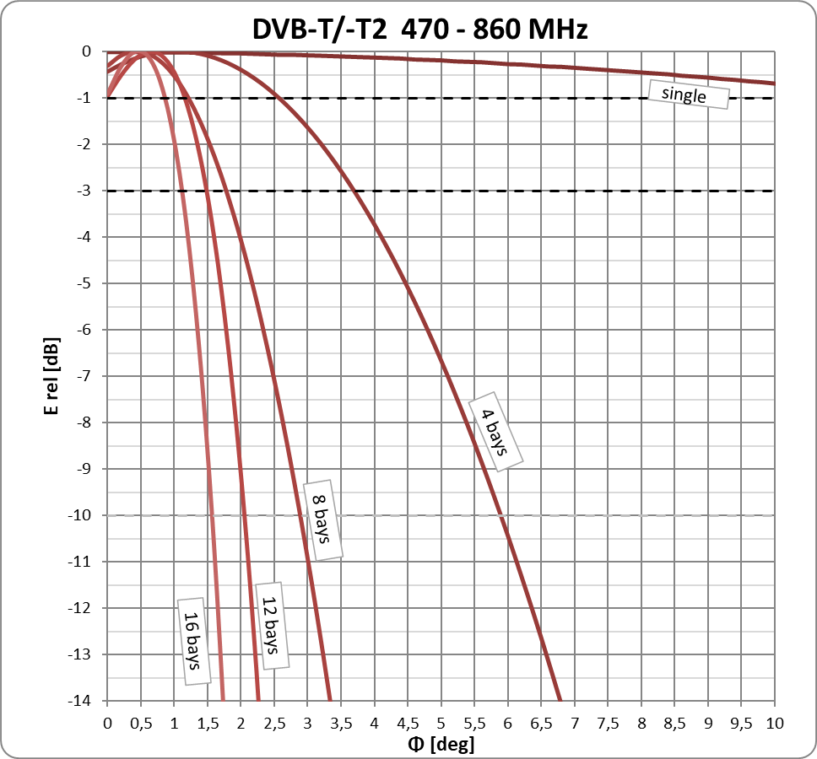
- Typical vertical patterns of UHF DVB-T/-T2 antennas
- Terms, definitions and abbreviations
- Terms, definitions and abbreviations
Abbreviation or symbol | Explanation
a_{c} | Cable loss
AV | Average
c | Velocity of light in free space
D | Largest dimension of the transmitting antenna
d | Horizontal distance from transmitting antenna position to the measuring antenna position
DAB | Digital Audio Broadcasting
d_{max} | Maximum distance from transmitting antenna position to the measurement antenna position at which still is possible to obtain one minimum and one maximum of field strength during a height scan
d_{min} | Minimum distance from transmitting antenna position to the measurement antenna position at which with sufficient accuracy can be achieved considering the directivity of the antenna in the vertical plane
d_{n} | Normalised distance (the distance derived from H·h·f/c)
DVB-T | Digital Video Broadcasting — Terrestrial
E | Field strength (RMS value)
$$E$$ | Resulting field strength
e.i.r.p. | Equivalent isotropically radiated power. This is the product of the antenna input power and the antenna gain, referenced to an isotropically radiating antenna. If not specified otherwise, it means the radiated power value in the direction of maximum radiation (main beam).
e.r.p. | Equivalent radiated power. This is the product of the antenna input power and the antenna gain, referenced to an dipole antenna. If not specified otherwise, it means the radiated power value in the direction of maximum radiation (main beam). e.r.p. = e.i.r.p. + 2.15 dB
E_{c} | Calculated field strength
$$\overline{E_{c}}$$ | Average of the calculated field strength values
E_{FS} | Field strength of the direct wave at the measurement point, possibly outside of the main vertical beam of the Tx antenna
E_{FS} | Free space field strength
E_{H} | Horizontal field strength component
E_{m} | Measured field strength
$$\overline{E_{m}}$$ | Average of the measured field strength values
E_{max} | Maximum field strength obtained during a height scan
E_{min} | Minimum field strength obtained during a height scan
E_{R,} $E_{R}$ | Field strength of ground-reflected wave
E_{V} | Vertical field strength component
f | Frequency
F(θ) | Vertical directivity of the transmitting antenna (function of angle)
FM | Frequency modulation
GNSS | Global Navigation Satellite System
G_{RX} | Receiving antenna gain
h | Height of the measuring antenna above the ground
H | Height of the transmitting antenna above the ground. In case of hilly terrain, this is the height of the transmitting antenna above the receiving ground plane
h_{max} | Maximal achievable height of the measuring antenna above the ground
h_{min} | Minimal achievable height of the measuring antenna above the ground
k | Antenna factor in dB/m
L_{D} | Length of the direct propagation path
LoS | Line-of-sight
L_{R} | Length of the indirect propagation path due to ground reflection
n_{k} | Correction coefficient
P_{RX} | Measured receiver input power
P_{a} | Authorised e.i.r.p. of the transmitter
R | Ground reflection coefficient
RLAN | Radio Local Area Networks
RMS (r.m.s.) | Root Mean Square
Rx | Receiver
t | Time
TDMA | Time Division Multiple Access
Tx | Transmitter
U_{max} | Maximal signal voltage level
U_{min} | Minimal signal voltage level
U_{RX} | Measured receiver input voltage
ΔE | Difference between the maximum and the adjacent minimum field strength
$$ΔΦ$$ | Phase difference between the direct and the ground-reflected wave
θ | Main beam elevation angle of the transmitter antenna (down tilt)
θ (-10 dB) | Elevation angle corresponding to transmitting antenna’s vertical pattern at  -10 dB
θ (-1dB) | Elevation angle corresponding to transmitting antenna’s vertical pattern at  -1 dB
θ_{D} | Transmitting antenna elevation angle corresponding to direct propagation path
θ_{max} | Transmitting antenna elevation angle corresponding to distance d_{min}
θ_{min} | Transmitting antenna elevation angle corresponding to distance d_{max}
θ_{R} | Transmitting antenna elevation angle corresponding to reflected propagation path
λ | Wavelength

- list of references
- ITU Handbook Spectrum Monitoring, Edition 2011
- JCGM 100:2008: “Evaluation of measurement data - Guide to the expression of uncertainty in measurement”
- ETSI TR 100 028-1 and TR 100 028-2: “Electromagnetic and Radio spectrum Matters (ERM); Uncertainties in the measurement of mobile radio equipment characteristics (Parts 1 and 2 - version 1.4.1)”
- G. E. Leontjev: “Height Scan Methods for Determining the Radiated Power at Microwaves Frequencies”. Proc. 2018 International Symposium on Electromagnetic Compatibility (EMC Europa 2018), August 27-30, Amsterdam, Netherlands
- Report ITU-R P.1008-1: “Reflection from surface of the Earth”
- G. Leontjev. Over-the-air methods for determining the radiated power of radio station. Proc. 2017 International Symposium on Electromagnetic Compatibility (EMC Europa 2017), September 4-8, Angers, France
- Recommendation ITU-R P.526-12: “Propagation by diffraction”
- Recommendation ITU-R P.525-2: “Calculation of Free-Space Attenuation”
- Recommendation ITU-R SM.1708-1: “Field strength measurements along a route with geographical coordinate registrations”

