 |  |  | FM22(22)46
Project Team FM22
58th Meeting of FM22
Copenhagen / Web Meeting, 04 – 07 October 2022
Date issued: | 15 September 2022
Source: | Lithuania
Subject: | Modification of ECC/REC/(12)03 on EIRP Measurements
Group membership required to read? (Y/N) |  | N
Summary:
The Annex contains a suggestion on a modification of Recommendation ECC/REC/(12)03 on EIRP determination through field strength measurements. Compared to the current version, a new formula has been introduced to calculate the maximum distance when the height scan method can be applied, and the allowable distance between field strength measurement points when applying the route scan method has been significantly increased.
Proposal:
FM22 is invited to consider this proposal in the development of an update of ECC/REC/(12)03.
Annex: Draft Revision of Recommendation ECC-REC(12)03.

Background:
- ECC/REC/(12)03 Determination of the radiated power through ground-based field strength measurements in the frequency range from 30 MHz to 6000 MHz.
- Results of the practical application of the recommendation ECC/REC/(12)03.

Annex: Draft Revision of Recommendation ERC-REC(12)03.

Introduction
The recommendation ECC/REC/(12)03 .describes two methods for measuring the radiated power of a transmitter: the height scan method and the route scan method. The use of the first method is limited by the maximum distance between transmitter and measurement location d_{max} that ensures to obtain at least one field strength maximum and one field strength minimum during a height scan. The recommendation provides expressions for calculating this distance. Practical measurements have shown that this expression gives somewhat underestimated values of the distances d_{max}. This document provides an expression that allows you to more accurately calculate the distance.
The route scan method is based on measuring the field strength of the measured transmitter along the selected route using a measuring vehicle. According to the recommendation the speed of measurement system must ensure that when the measurement vehicle moves, the measurement points must be taken at the highest possible speed, ideally not less than 0.8 wavelengths apart. This document shows that distances between measurement points can be much longer.

Distance from the transmitter at which the height scan method can be applied
The recommendation ECC/REC/(12)03 provides the following formula for calculating the distance d_{max} :
$d_{max}\left(m\right)=\frac{f\left(MHz\right)H\left(m\right)h_{max}\left(m\right)}{225}$ , (1)
where f is frequency, H is height of the transmitting antenna above the ground and h_{max} is maximal achievable height of the measuring antenna above the ground.
The detailed derivation of formula (1) is given in the above recommendation. Note that this formula was obtained under a rather strict condition
$ΔL_{max}−ΔL_{min}=λ$ , (2)
where ΔL_{max} is the difference between the length of the direct propagation path and the length of the indirect propagation path due to the ground reflection when the height of measuring antenna above the ground is maximal; ΔL_{min} is the path difference when the height of measuring antenna above the ground is minimal and λ is the wavelength of the transmitting signal.
The fulfilment of condition (1) ensures that at least one maximum and one minimum during a height scan is obtained when the phase of the reflection coefficient changes over a wide range. According to the data presented in [1] (see Figure 1), for vertically polarized waves, depending on grazing the angle, the phase of the reflection coefficient can vary from zero to 180 degrees.
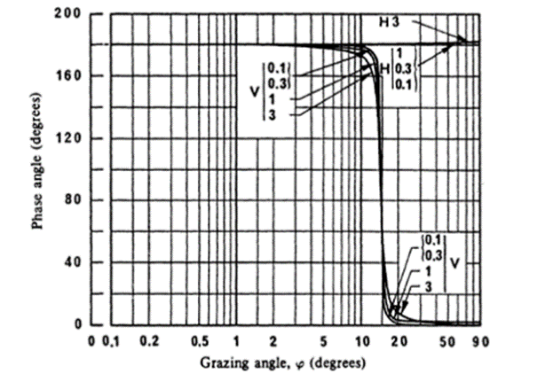
Figure 1: The phase of the reflection coefficient of a medium dry ground as a function of a grazing angle for vertical V and horizontal H polarizations [1] (the frequencies are given in GHz).
Figure 2 shows the results of calculating the dependence of the field strength of a vertically polarized wave on height for three phase of the reflection coefficient values: 0, 90 and 180 degrees. The calculation was carried out for the distance of 889 m, which was determined by formula (1). It can be seen from the Figure 2, that for any phase value in the height range from 3 to 10 meters (practically achieved heights when using retractable masts on monitoring vehicles), there is always one minimum and one maximum.
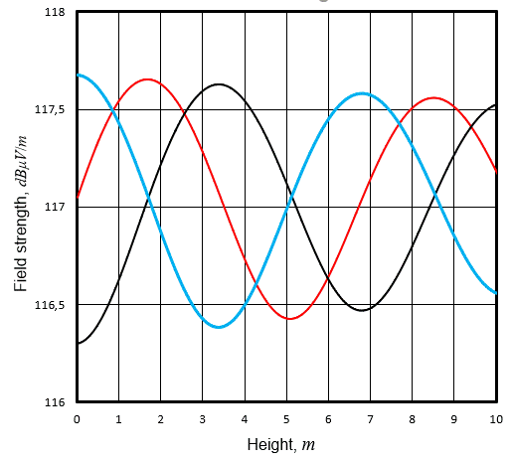
Figure 2: The height dependence of the field strength for different phase of the reflection coefficient (phase 0 degrees – blue line, phase 90 degrees – red line and phase 180 degrees – black line). The initial calculation data: the equivalent radiated power – 39,5 dBW; the frequency – 100 MHz; height of the transmitting antenna above the ground – 200 m; the distance from transmitter – 889 m.

On the other hand, the height scan method is usually applied at the maximum possible distance d_{max} when the grazing angle φ is quite small. From expression (1) it follows that
$tanφ=Η/{d_{max}}=\frac{225}{f\left(MHz\right)h_{max⁡\left(m\right)}}$ . (3)
Taking the values f=100 MHz and h_{nax} = 10 m, we get that tan(φ)=0.225. Consequently φ = 12.7 degrees. As can be seen from Figure 1, at angles of 12.7 degrees or less, the phase of the reflection coefficient of a vertically polarized wave is very close to unity. In the case of a horizontally polarized wave, the phase of the reflection coefficient is always equal to unity. Therefore, the strength of the resultant field of the direct and reflected waves near the surface is zero (the first field strength minimum). In such a case condition (2) can be replaced by a weaker condition:
$ΔL_{max}=λ≡\frac{c}{f}$ , (4)
where c is velocity of light in free space.
Under condition (4), the second minimum of the resultant field strength will be at a height of h_{max}, and the maximum - at a height of 0.5h_{max}. According recommendation ECC/REC/(12)03 the path difference ΔL_{max} is equal
$∆L_{max}=\frac{2Hh_{max}}{d}$ . (5)
It follows from (4) and (5) that the maximum separation distance d_{max} between the transmitter and measurement location is given by:
$d_{max}=\frac{2fHh_{max}}{c}$ . (6)
This equation can be expressed in more useful form:
$d_{max}=\frac{f\left(MHz\right)H\left(m\right)h_{max}\left(m\right)}{150}$ . (7)
Figure 3: The field strength dependence on the height at measurement location distance 1333 m.
The initial calculation data: the equivalent radiated power – 39,5 dBW; the frequency – 100 MHz; height of the transmitting antenna above the ground – 200 m.

Figure 3 shows the results of calculating the dependence of the field strength of a vertically and horizontally polarized wave on height for phase of the reflection coefficient 180 degrees. The calculation was carried out for the distance of 1333 m, which was determined by formula (7). It can be seen from the Figure 3 that in the height range from 3 to 10 meters, there is always one field strength minimum and one field strength maximum.
It is easy to see that the value of dmax calculated by formula (7) is 1.5 times higher than the value calculated by formula (1).

Maximum distances between field strength measurement points allowed when using the route scan method
As mentioned above, according to the recommendation ECC/REC/(12)03, the distance between the field strength measurement points along the route should not be less than 0.8 wavelength. This requirement seemed to us too strict, and therefore, to verify it, we conducted the following experiment.
The route scan method is based on the comparison of the field strength values measured along the route with calculated field strength values. According to this method, the transmitter’s radiated power P_{m} is determined by the formula
$P_{m}\left(dBW\right)=P_{s}\left(dBW\right)+\left(\overline{E_{m}}−\overline{E_{c}}\right)\left(dB\right)$ , (8)
where P_{s} is the authorised radiated power, $\overline{E_{m}}$ is measured average field strength for a route and $\overline{E_{c}}$ is calculated average field strength for a route at the radiated power P_{s}.
As can be seen from formula (8), the determined value of the radiation power is linearly related to the measured average value of the field strength $\overline{E_{m}}$ (of course, on a logarithmic scale). Therefore, it is necessary to determine how the average value $E_{m}$ changes with a change in the distance between the measurement points. For this purpose, data obtained from field strength measurements of FM transmitters along six different routes were used. Route data with the radiation power of transmitter’s measurement errors are shown in
Table 1.
Table 1: Main parameters of routes
Route number | Frequency, MHz | Polarization | Length,  m | Radiated power  measurement error, dB
1 | 97.6 | V | 2230 | 1
2 | 88.2 | H | 3250 | 0.2
3 | 90.3 | H | 1430 | 0.6
4 | 96.2 | H | 2160 | 2.2
5 | 104.1 | H | 2210 | 0.7
6 | 102.1 | H | 2260 | 0.8
As a result of measurements for each route, a series of field strength values was obtained. Moreover, field strength measurements were carried out at points evenly distributed along the route. For this initial series, the average value of the field strength was calculated and the distance between the measurement points was normalized relatively to the wavelength. Then, taking every second value from the initial series, the second series was constructed. For it, the mean value was also calculated. It is clear that the distance between the measurement points in the second series is twice as large as in the initial series. Similarly, taking every second value from the second series, the third series was constructed. For it, the mean value was also calculated. It is clear that the distance between the measurement points in the third series is four times greater than in the initial series. This process continues until two field strength values remain.
Figure 4: Change in the average value of the field strength along the route with an increase in the distance between the measurement points (the distance is normalized relative to the wavelength).
As a result of the procedure described above, for each route, a series of average field strength values was obtained with the corresponding normalized values of the distances between measurement points. Using these series, graphs were constructed (see Fig. 4), which show how the average value of the field strength changes with increasing distance between measurement points. From these graphs it is clearly seen that, without prejudice to the accuracy of determining the radiation power, the distances between the measurement points can be equal to ten wavelengths.
- LIST OF REFERENCES
- Report ITU-R P.1008-1 “Reflection from surface of the Earth”.

