 |  |  | FM22(22)49
Project Team FM22
58th Meeting of FM22
Copenhagen / Web Meeting, 04 – 07 October 2022
Date issued: | 15 September 2022
Source: | Lithuania
Subject: | Supervision of MFCN field strength in border areas
Group membership required to read? (Y/N) |  | N
Summary:
The paper briefly discusses the issues to be addressed in the preparation of a new ECC Recommendation on supervision of MFCN field strength in border areas.
Proposal:
FM22 is invited to study the material and conclude whether only a new Recommendation is to be developed, or additionally the existing Recommendations ERC/REC 74-02 could be updated to cover the technical part of the issue.
Background:
FM22 work programme

Introduction
Lithuania in document FM22(22)06 drew attention to several problems regarding the control of the MFCN field strength at the border. Technical problems relate to the method of measuring the field strength. Of course, as suggested in document FM22(22)44, they can be solved by updating the current Recommendation ERC/REC 74-02 “Method of measuring the field strength at fixed points in the frequency range 29.7 to 960 MHz”. The legal problems associated with evaluating the results of field strength measurements cannot be resolved in this way. In our opinion, they should be dealt with in a new ECC Recommendation.
The new ECC Recommendation, in addition to „standardizing” the methods of measurement, would make it possible to evaluate the results of measurements in the same way and would contribute to streamlining the practice of supervision the fields strength from MFCN stations at the border. Of course, the appearance of this recommendation would in no way require a revision of existing agreements with neighboring countries regarding the cross-border coordination for Mobile/Fixed Communications Networks.

Issues that are not resolved within the framework of the ERC/REC 74-02 recommendation
The first question that could be addressed in the new ECC Recommendation is what to do if the measured actual field strength exceeds the limit value given in the bilateral agreements between administrations (hereinafter will be referred to as Agreements), but there is no interference to the base station. If this field is created by a base station of a neighboring country, then whether it is necessary to consider this a violation of the terms of the contract and require the elimination of the violation. And maybe allow some kind of excess? On the other hand, even in the case where there is no interference to base stations, the field strength limit should not be allowed to be significantly exceeded, because otherwise mobile phones near the border will turn on roaming and the phones will connect to the mobile networks of the neighboring country.
The second question is the following: is it possible, as is often done, to estimate the field strength not directly from the measurement results, but by the expected field strength calculated from the measured value of the power of some reference signal? If exceeding the field is considered a violation, then it seems logical to use the actual field strength rather than calculated using reference signal.
The third question will arise if it is decided to allow the limit value of the field strength to be exceeded. In this case, it will be necessary to calculate the allowable excess. One of the possible options for calculating the allowable excess, obtained as a result of the analysis of propagation curves from the Recommendation ITU-R P.1546 (“Method for point-to-area predictions for terrestrial services in the frequency range 30 MHz to 4 000 MHz”), is given in document [1].

Technical issues to be resolved under the new ecc recommendation
Let us briefly formulate the main questions that need to be answered in the new ECC Recommendation.
The first question is related to the cross-polarization of radiation from base stations. For clarity, consider the typical antenna array of the active antenna system (AAS for short) used in new 5G base stations. As can be seen from figure 1, the antenna array (A) is made up of rows and columns of individual dual-polarized antenna elements (B). Usually antenna array is divided into subarrays (C). And each subarray (D) connected to two radio chains, one per polarization. By changing the phases of the subarray signals in a certain way, the array gain can be achieved in any direction.
Thus, it follows from the above that, in fact, the AAS consists of two subantennas, one of which emits radio waves with a polarization of +45°, and the other - -45°. And when the base station is characterized by the value of the EIRP, it means the sum (in linear scale) of the Partial EIRP +45 and the Partial EIRP -45. Similarly, the total radiation power of the base station is the sum of the partial radiation powers.
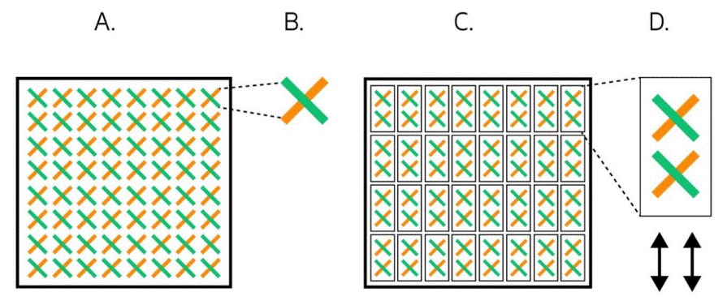
Figure 1: AAS typical antenna array [2]
In the case of the field strength generated by the base station, the situation is somewhat different, since there is no definition (concept) of the total field strength. There are partial field strengths E(+45) and E(-45), but their simple summation has no physical meaning, because the field strength in both the vertical and horizontal planes depends not only on the partial field strengths, but also on their cross-correlation. And usually this cross-correlation is constantly changing.
Unfortunately, neither the ECC Recommendations regarding coordination between MFCN nor the agreements with neighboring countries mention cross-polarized fields. They give the limit values of the field strengths and understand the polarization as you want. It would be logical, although this would significantly complicate the measurement procedure, to measure partial field strengths E(+45) and E(-45).
The second question concerns the measurement of the received power of the reference signals (RSRP in the case of LTE and SS-RSRP in the case of 5G). Consider the widely used LTE option in Europe, when 2 MIMO antennas are used (more precisely, two parts with polarization +45 and -45 of one cross-polarized antenna, as mentioned above). The reference signals (RS) for both antennas (polarizations) occupy different positions in the resource grid. This enables the code selective measuring instrument to determine whether the received RS element is coming from antenna 0 or antenna 1.
Note that many papers have been published that describe how, in the case of LTE, to calculate the maximum possible field strength or the maximum EIRP of a base station from the results of the measurement of the RSRP. However, none of the papers we have seen mention the need to use two values of the RSRP.
It seems that the draft new ECC Report 345 “In-band measurement methodologies for 5G AAS base stations in the field“ [3] does not clarify this issue. Section 5.1 of this report describes how the EIRP and TRP (total radiated power) of 5G base station are determined using ground-based measurement of the SSB. According to the procedure in this section, the value of one SS-RSRP is measured using R&S TSMA6 scanner and its value is used to calculate the total radiated power. But the total power is equal to the sum of the powers of radiation with a polarization of +45 and -45. No explanation for this inconsistency has been given. In our opinion, a possible explanation for this inconsistency can be as follows. A vertically polarized antenna was used to measure the RSRP. Then, if the SSB signals with polarizations +45 and -45 are fully correlated, then when using a vertically polarized antenna, the total power of these two SSB signals will be measured. But these are only assumptions, nothing more.
It is interesting to note that some measuring devices, for example Selective Radiation Meter SRM-3006, register separately RSRP-0 and RSRP-1. There are devices which register only one value of the RSRP. For example, the Lithuanian administration uses R&S TSME6 scanners to measure the RSRP, which register only one value of the RSRP. What is this value: RSRP-0, RSRP-1 or their RMS value is not mentioned in the specification of the scanner. Contacts with representatives of the manufacturer's company have not yet yielded any results.
In concluding this section, we note that on June 6 this year, changes were made to the Recommendation
ECC (15)01. Field strength limit values in this recommendation are mean values for non-AAS BS and median values for AAS BS. Recommendation provides field strength limit values in the 3400-3800 MHz frequency band for TDD MFCN operation with AAS and non-AAS systems across the border. It is important that for many operations modes not only the limit values of the field strength in the frequency band of 5 MHz are given, but also the corresponding SSB field strength values. These changes in the Recommendation ECC (15)01 should be taken into account when preparing a new ECC Recommendation.
- LIST OF REFERENCES
- FM22(22)06 Practical supervision of MFCN field strength in border areas.
- https://www.5gamericas.org/advanced-antenna-systems-for-5g/
- SE21(22)024A01_Draft ECC Report 345 as sent to PC

