 |  |  | CG4G(22)016
ECC PT1 CG 3.8-4.2 GHz local access connectivity
Web meeting, 28 November 2022
Date issued: | 24 November 2022
Source: | Lithuania
Subject: | 5G NR Base station classes
Group membership required to read? (Y/N) |  | N
Summary:
3GPP TS 38.104 (or ETSI TS 138 104) establishes single-RAT minimum RF characteristics and minimum performance requirements of NR (and NB-IoT operation in NR in-band) Base Station (BS).
This input contribution extracts information from relevant sections of 3GPP specification:
- Conducted and radiated core requirements for the BS architectures and BS types as defined in Section 4.3;
- BS classes as defined in Section 4.4;
- BS conducted output power requirements as defined in Section 6.2;
- OTA BS output power requirements as defined in Section 9.3.
This material is then compared to the information received from WG FM. Observations are provided on possible differences.
Proposal:
invites Group to
- take into account characteristics of base stations as defined in 3GPP technical specification when considering the starting point for the coexistence and sharing studies;
- identify the differences (compared to 3GPP) in the characteristics proposed by WG FM and seek for further clarification, if needed.
Background:
ECC PT1 work item PT1_47 on feasibility and sharing studies on the shared use of the 3.8-4.2 GHz frequency band by terrestrial wireless broadband systems providing local-area (i.e. low/medium power) network connectivity (Task 1 of the EC Mandate).
ECC PT1 meeting #71 agreed to establish a correspondence group (CG) to enhance the works.
Document from WG FM (ECC PT1(22)160) for ECC PT1 meeting #72 proposed elements for initial considerations.
ECC PT1 meeting #72 agreed to continue the CG and updated its ToR (document ECC PT1(22)151_Annex VIII-24r1).

3GPP/ETSI specification

Base station classes
3GPP/ETSI specification for 5G NR defines three classes for base station, namely:
- Wide Area Base Station
- Medium Range Base Station
- Local Area Base Station
These classes are corresponding to well-known cell type deployments, namely, Macro cell, Micro cell and Pico cell. Typical cell radius and power ranges for these types of cells (and corresponding BS class) are provided in Table 1.
Table 1: Deployment characteristics of BS classes
 | Wide Area BS | Medium Range BS | Local Area BS
Cell type | Macro Cell | Micro Cell | Pico Cell
Typical Cell Radius | 30 km to 2 km | 2 km to 200 m | 200 m to 4 m
Typical Power | 160 W to 20 W | 20 W to 2 W | 2 W to 0.25 W
3GPP has specified these classes to make sure that certain radio characteristics are in limits and suitable for specified deployment. These classes are based on minimum distance between base station (BS) and user equipment (UE) or minimum coupling loss support depending on base station type. The associated deployment scenarios for each class are exactly the same for BS with and without connectors.
The list of requirements that is defined for each base station type can be found in Section 4.6 of the 3GPP specification.

Base station types and reference points
In the 4G era, when it comes to base stations, the word is just base station, and the device that transmits the signal is simply called RRU (Remote Radio Unit), or RRH (Remote Radio Head). This is nothing but to say that the RF unit and the baseband unit are not together, simple and straightforward. And in the 5G era, when it comes to the type of base station, there is a string of codes as follows:
- BS type 1-C
- BS type 1-H
- BS type 1-O
- BS type 2-O
“BS” is short for Base Station, the "type" in the middle is a type, 1 indicates FR1, that is, sub-6 GHz frequency band, and 2 indicates FR2, that is, mmWave frequency band. The rest is the core code, where C stands for Conduct, meaning conduction, H stands for Hybrid, O indicates over-the-air or OTA.
Illustrative example is provided in Figure 1.
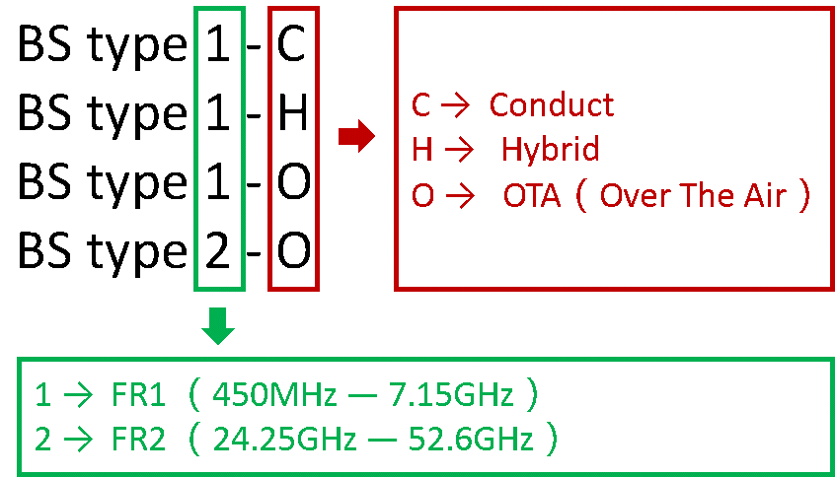
Figure 1: Base station types

Base station Type 1-C and 1-H
A diagram of BS Type 1-C is provided in Figure 2.
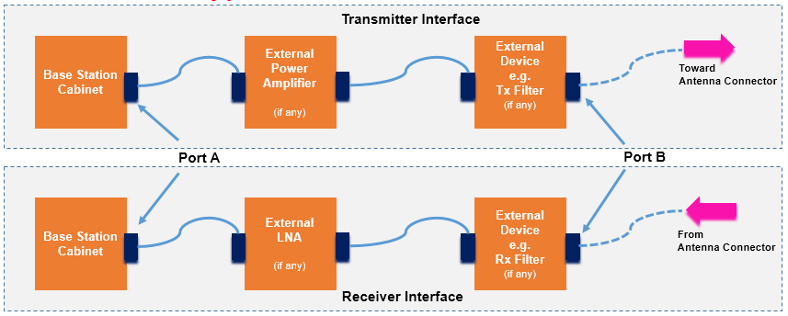
Figure 2: Base station Type 1-C
There is no built-in antenna in this type. To work properly, this device needs to be connected to an antenna, and the downlink transmits the RF signal to the antenna and the uplink receives the signal through the antenna.
A diagram of BS Type 1-H is provided in Figure 3.
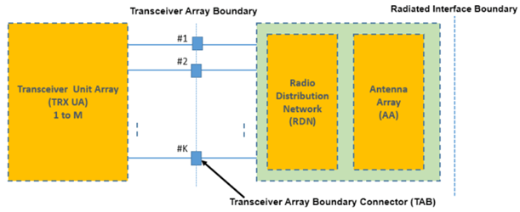
Figure 3: Base station Type 1-H
TAB interface indicates that its internal modules, the transceiver unit array (TRX UA) and the RF distribution network (RDN), are connected by a wire, and its signal conduction (Conduct) index is standardized and must meet the protocol requirements. On the other hand, since the AAU has integrated antennas, it must define its over-the-air signal radiation metrics, also called OTA (Over The Air). In this way, devices of this architecture define both, the Conduct (Conduct) and the signal radiation (OTA), metrics and are summarized by the term Hybrid.
These types of base stations are classified into Wide Area, Medium Range and Local Area classes considering their minimum coupling loss requirements for each class. The minimum coupling loss is defined as the minimum path loss measurement between the BS antenna connector and UE antenna connector in dB, it is denoted by MCL.
In case of Type 1-C base station the MCL is measured at reference port A or B and in case of Type 1-H base station the MCL is measured at TAB connector.
The MCL requirement for each class:
- Wide Area Base Station : MCL of 70 dB
- Medium Range Base Station : MCL of 53 dB
- Local Area Base Station: MCL of 45 dB

Base station Type 1-O and 2-O
Base station Type 1-O and 2-O contain three modules – Transceiver Unit Array (TRX UA), Radio Distribution Network (RDN) and Antenna Array (AA), but they have been tightly integrated into an inseparable box and does not have any RF connector or reference point to perform the measurements. Therefore, this type of device can only be defined by the OTA indicator.
A diagram of BS Type 1-O or 2-O is provided in Figure 4.
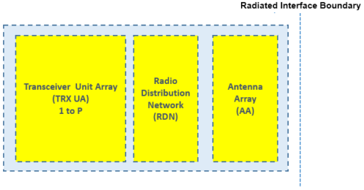
Figure 4: Base station Type 1-O or Type 2-O
These types of base stations are also classified as Wide Area, Medium Range and Local Area classes considering the minimum distance in meters between BS and UE for each class. The distance is measured from Radiated Interface Boundary (RIB).
The minimum distance requirement between BS and UE for each class:
- Wide Area Base Station : 35 m
- Medium Range Base Station : 5 m
- Local Area Base Station: 2 m

Sumarry of requirements for NR BS types
Table 2: Characteristics of BS types
 | Wide Area BS | Medium Range BS | Local Area BS
Cell type | Macro Cell | Micro Cell | Pico Cell
BS to UE Minimum Coupling Loss  (BS Type 1-C and 1-H) | 70 dB | 53 dB | 45 dB
BS to UE Minimum Distance  (BS Type 1-O and 2-O) | 35 m | 5 m | 2 m
Table 3: Conducted and radiated requirement refence points for BS types
Type 1-C | Type 1-H | Type 1-O | Type 2-O
FR1  Only conducted  requirements defined at individual antenna connectors | FR1  Conducted  requirements defined at individual TAB connectors  or  OTA  requirements defined at the RIB | FR1  Only OTA  requirements defined at the RIB | FR2  Only OTA  requirements defined at the RIB

output power requirements
Depending on BS type 3GPP provides the following output power requirements for BS Types 1-C, 1-H, 1-O and 2-O.
Table 4: Conducted output power requirements
 | Wide Area BS | Medium Range BS | Local Area BS
BS Type 1-C  Rated carrier output power  at individual antenna connector | No upper limit | ≤ 38 dBm (or 6.3 W) | ≤ 24 dBm (or 0.25 W)
BS Type 1-H  Rated carrier output power  at individual TAB connector | No upper limit | ≤ 38 dBm | ≤ 24 dBm
Table 5: Radiated output power requirements
 | Wide Area BS | Medium Range BS | Local Area BS
BS Type 1-H  Rated carrier output power  at the RIB | No upper limit | ≤ 38 dBm + 10log(N_{TXU,counted}) | ≤ 24 dBm + 10log(N_{TXU,counted})
BS Type 1-O  Rated carrier TRP output power  at the RIB | No upper limit | ≤ 47 dBm (or 50.1 W) | ≤ 33 dBm (or 2 W)
BS Type 2-O  Rated carrier TRP output power  at the RIB | No upper limit | No upper limit | No upper limit
N_{TXU,counted} is the number of active transmitter units calculated as in Section 6.1 of 3GPP specification

initial considerations by WG FM
ECC PT1 meeting #72 received LS from WG FM (ECC PT1(22)160) which indicated that:
“As a basis for the scenarios used for the studies on in-band coexistence, WG FM proposes to define two categories of base stations:
- low power ones using non-AAS
- medium power ones using either non-AAS or AAS
For low power, “local area BS” as per 3GPP with an output power ≤ 24 dBm may be a good starting point and initial discussions within WG FM considered an EIRP limit to ease interference calculations for administrations. For medium power, “medium range BS” as per 3GPP with an output power ≤ 38 dBm may be a good starting point.”

Observations
From 3GPP specifications we can see that for the work on feasibility and sharing studies on the shared use of the 3.8-4.2 GHz frequency band by terrestrial wireless broadband systems providing local-area (i.e. low/medium power) network connectivity (Task 1 of the EC Mandate) two classes and three types of base stations would be relevant:
Classes of base stations:
- Medium Range Base Station (Micro cell deployment)
- Local Area Base Station (Pico cell deployment)
Types of base stations:
- BS type 1-C (non-AAS base station)
- BS type 1-H (non-AAS/AAS base station)
- BS type 1-O (AAS base station)
Therefore the relevant 3GPP output power requirements would be as provided in Table 6.
Table 6: 3GPP output power requirements
 | Medium Range BS | Local Area BS
BS Type 1-C  Rated carrier output power  at individual antenna connector | ≤ 38 dBm (or 6.3 W) | ≤ 24 dBm (or 0.25 W)
BS Type 1-H  Rated carrier output power  at individual TAB connector | ≤ 38 dBm | ≤ 24 dBm
BS Type 1-H  Rated carrier output power  at the RIB | ≤ 38 dBm + 10log(N_{TXU,counted}) | ≤ 24 dBm + 10log(N_{TXU,counted})
BS Type 1-O  Rated carrier TRP output power  at the RIB | ≤ 47 dBm (or 50.1 W) | ≤ 33 dBm (or 2 W)
From WG FM document we can see that WG FM proposes to:
- use 3GPP Medium Range BS with connector output power value for medium power non-AAS BS and Local Area BS with connector output power value for low power non-AAS BS, as a starting point;
- apply medium power BS non-AAS output power value for medium power BS AAS;
- do not apply TRP metric for BS using AAS;
- apply EIRP metric for BS using both non-AAS and AAS;
- apply antenna gain of 0 dBi for BS using both non-AAS and AAS.
This would result in the following characteristics:
- Low power BS (Local Area BS) using non-AAS with EIRP of ≤ 24 dBm;
- Medium power BS (Medium Range BS) using non-AAS or AAS with EIRP of ≤ 38 dBm.
Consequently these can be summarised in Table 7 for better comparison with 3GPP requirements.
Table 7: WG FM proposed assumptions
 | Medium Range BS | Local Area BS
BS Type 1-C  Equivalent isotropic radiated power (EIRP) | ≤ 38 dBm (or 6.3 W) | ≤ 24 dBm (or 0.25 W)
BS Type 1-H  Equivalent isotropic radiated power (EIRP) | ≤ 38 dBm as non-AAS  ≤ 38 dBm as AAS | ≤ 24 dBm as non-AAS  N/A as AAS
BS Type 1-O  Equivalent isotropic radiated power (EIRP) | ≤ 38 dBm | N/A
N/A – not applicable

Proposal
Taking into account that 3GPP defined requirements for BS types with and without connectors, i.e. non-AAS and AAS, differently (conducted and radiated) further considerations should be given to the assumptions suggested by WG FM whether these are a good starting point to initiate the studies and do not dismiss some requirements from 3GPP.
- Extract from ETSI TS 138 104 relevant sections
