 |  |  | FM22(23)04
Project Team FM22
58th Meeting of FM22
Copenhagen / Web Meeting, 04 – 07 October 2022
Date issued: | 28 February 2023
Source: | Lithuania
Subject: | Modification of ECC/REC/(12)03 on EIRP Measurements
Group membership required to read? (Y/N) |  | N
Summary:
At the autumn 2022 meeting, Lithuania presented a document FM22(22)46 in which it proposed to make two changes to recommendation ECC/REC/(12)03 on EIRP determination through field strength measurements: a new formula has been introduced to calculate the maximum distance when the height scan method can be applied, and the allowable distance between field strength measurement points when applying the route scan method has been significantly increased. During the discussion of the document, the first change was approved, and an additional discussion of the second change was decided to be postponed to the spring 2023 meeting.
This document, in comparison with the previous document, provides additional data confirming the possibility of a significant increase in the distance between the points of measurement of the field strength when applying the route scan method. The updated Annex to this document (it contains a proposal for a modified Recommendation ECC/REC/(12)03) clarified the wording regarding the distance between measurement points.
Proposal:
FM22 is invited to consider this proposal in the development of an update of ECC/REC/(12)03.
Annex: Draft Revision of Recommendation ECC-REC(12)03.

Background:
- ECC/REC/(12)03 Determination of the radiated power through ground-based field strength measurements in the frequency range from 30 MHz to 6000 MHz.
- Results of the practical application of the recommendation ECC/REC/(12)03.
Annex: Draft Revision of Recommendation ERC-REC(12)03.

Introduction
The recommendation ECC/REC/(12)03 .describes two methods for measuring the radiated power of a transmitter: the height scan method and the route scan method. The route scan method is based on measuring the field strength of the measured transmitter along the selected route using a measuring vehicle. According to the recommendation the speed of measurement system must ensure that when the measurement vehicle moves, the measurement points must be taken at the highest possible speed, ideally not less than 0.8 wavelengths apart. This document shows that distances between measurement points can be much longer.

Maximum distances between field strength measurement points allowed when using the route scan method
The route scan method is based on the comparison of the field strength values measured along the route with calculated field strength values. According to this method, the transmitter’s radiated power P_{m} is determined by the formula
$P_{m}\left(dBW\right)=P_{s}\left(dBW\right)+\left(\overline{E_{m}}−\overline{E_{c}}\right)\left(dB\right)$ , (1)
where P_{s} is the authorised radiated power, $\overline{E_{m}}$ is average field strength for a route and $\overline{E_{c}}$ is calculated average field strength for a route at the radiated power P_{s}.
As can be seen from formula (1), the determined value of the radiation power is linearly related to the measured average value of the field strength $\overline{E_{m}}$ (of course, on a logarithmic scale). The value of $\overline{E_{m}}$ is calculated from the results of measurements of the field strength, and for the error in its determination to be small, the distances between the measurement points cannot be large. As mentioned above, according to the recommendation ECC/REC/(12)03, the distance between the field strength measurement points along the route d should not be less than 0.8 wavelength. In our case, this condition is too strict, since it was obtained for the Rayleigh channel, when there is no dominant propagation along a line of sight between the transmitter and receiver [1]. Route scan method is applicable only for Gaussian and for the Rican channel. Therefore, it is necessary to determine how for real routes the average value $\overline{E_{m}}$ changes with a change in the distance between the measurement points.
The distance between the measurement points of the field strength can be determined using the methods of mathematical statistics. The field strength along the route can be considered as a continuous random variable that has a mean µ and a variance σ² with an unknown distribution. Let N independent field strength measurements be made along the route and the sample mean $\overline{E_{N}}$ calculated. As shown in work [1], the following probabilistic statement can be made about the sample mean $\overline{E_{N}}$ :
$P\left\{\overline{E_{N}}−\frac{σZ_{α/2}}{\sqrt{N}}≤μ<\overline{E_{N}}+\frac{σZ_{α/2}}{\sqrt{N}}\right\}=1−α$ , (2)
where $Z_{α/2}$ is the number that the standard normal random value Z exceeds with probability α/2, and σ is square root of the variance.
This expression can be rewritten in the following form:
$P\left\{\left|\overline{E_{N}}−μ\right|≤\frac{σZ_{α/2}}{\sqrt{N}}\right\}=1−α$ . (3)
This expression shows that with a probability of 1-α, the maximum error in determining µ from N measurements of the field strength is
$δ=\left|\overline{E_{N}}−μ\right|=±\frac{σZ_{α/2}}{\sqrt{N}}$ . (4)
It follows from the last expression that the minimum required number of field strength measurement points along the route N is equal to
$N={\left(\frac{σZ_{α/2}}{δ}\right)}^{2}$ . (5)
To test expressions (4) and (5), we used data obtained from field strength measurements along 6 routes in Lithuania and 20 routes in Germany. The measurements in Germany were carried out by the Federal Network Agency staff and their results were presented in the FM22(17)13rev1 document. The main parameters of the measurement routes are given in Tables 1 and 2. In Table 1, the numbering of routes corresponds to their numbering in document FM22(17)13rev1.
Table 1: Main parameters of measurement routes in Germany
Route number | Frequency MHz | Polarization | Length  m | Sample Standard Deviation of field strength, dBµV/m
Routes for transmitter Ismaining
1 | 90.0 | H | 1862 | 3,51
2 | 103.2 | H | 1872 | 2,15
3 | 90.0 | H | 2220 | 4,83
4 | 103.2 | H | 2345 | 4,72
5 | 88.4 | H | 3990 | 6
6 | 90.0 | H | 3922 | 6,3
7 | 90.0 | H | 2199 | 3,79
8 | 103.2 | H | 2173 | 2,77
Routes for transmitter Munich Olympiaturm
1 | 89.0 | H | 3422 | 3,86
2 | 89.0 | H | 3928 | 4,12
3 | 107.2 | H | 3478 | 4,2
4 | 107.2 | H | 3948 | 4,52
5 | 89.0 | H | 2065 | 3,59
6 | 107.2 | H | 3183 | 3,27
7 | 89.0 | H | 5837 | 5,89
8 | 107.2 | H | 4878 | 3,79
9 | 89.0 | H | 4989 | 5,34
Rotes for transmitter Wandelstein
1 | 98.5 | H | 15552 | 5,4
2b | 98.5 | H | 6598 | 5,72
2y | 98.5 | H | 12172 | 6,07

As a result of measurements, for each route a series of field strength values was obtained. For five routes in Lithuania, the number of measurement points was 8001, and for one 4001. For routes in Germany, their number ranged from 9311 to 50444. Moreover, field strength measurements were carried out at points evenly distributed along the route. This circumstance is important in the processing of measurement data.

Table 2: Main parameters of measurement routes in Lithuania
Route number | Frequency MHz | Polarization | Length  m | Sample Standard Deviation of field strength dBµV/m
1 | 97.6 | V | 2230 | 1.82
2 | 88.2 | H | 3250 | 6.38
3 | 90.3 | H | 1430 | 1.8
4 | 96.2 | H | 2160 | 2.36
5 | 104.1 | H | 2210 | 2.45
6 | 102.1 | H | 2260 | 3.01
The measurement data were processed in the following way. First, for measured initial series, the sample mean $\overline{E_{N}}$ and sample standard deviation S of the field strength was calculated and the distance between the measurement points d was normalized relatively to the wavelength. Since there were a very large number of measurement points and distance between the measurement points was about 0.1 wavelength or less, it can be assumed with great accuracy that the sample mean $\overline{E_{N}}$ is equal to the mean μ, and the sample standard deviation S is equal to the square root of the variance σ. Values of sample standard deviation of field strength are given in Tables 1 and 2.
After processing the initial series of data, taking every second value from it, the second series was constructed. For it, the sampler mean value was calculated. The distance between the measurement points d in the second series is twice as large as in the initial series. Similarly, taking every second value from the second series, the third series was constructed. For it, the sampler mean value was also calculated. The distance between the measurement points d in the third series is four times greater than in the initial series. This process continues until two field strength values remain. Note that the series of field strength values obtained by the described method correspond to the results of real measurements.
As mentioned above, using the initial measurement data, the values µ and σ were calculated for each route. Using them by formula (4) for each route, the dependences of the maximum error in determining the mean value of the field strength δ on the number of measurement points N were calculated. The calculation was carried out for a probability of 90%, for which the value of $Z_{α/2}$ is equal to 1.645.
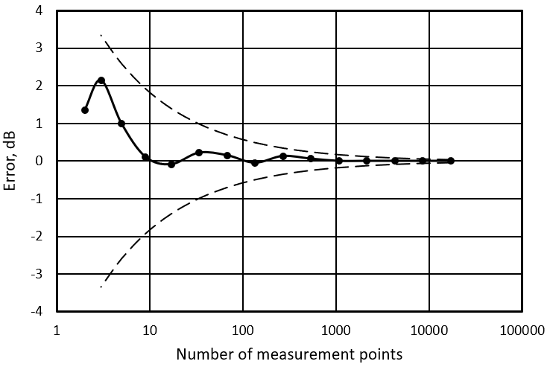
Figure 1: The measurement error of mean field strength along the route 5 (in location of transmitter Munich Olympiaturm) as the function on number of measurement points (dotted curves represent the calculated maximum error values, and the dots represent the measured values).

As a result of the procedure described above, for each route, a series of sample mean $\overline{E_{N}}$ and the error in its determining with the corresponding number of measurement points and normalized (relative to the wavelength) values of the distances d_{n} between this point was obtained. Using these data, the measured dependences of the measurement error of the mean field strength μ on the number of measurement points N were compared with the theoretical dependences calculated by formula (4). A typical result of such a comparison is shown in Figure 1. It can be seen from it that the measurement error is noticeably less than the calculated maximum value. Moreover, such a result was obtained for all 20 routes.
Since the measured error values are always noticeably less than calculated with a probability of 90 %, then by formula (5) you can only with a large margin determine the required number of measurement points. Since the value σ is unknown before measurement, the maximum possible value must be used in expression (5). From us measured routes, the maximum value σ=6.38 had route 2, the parameters of which are given in
Table 1. Assuming the maximum measurement error of 0.5 dB, the number of points is equal to
$N={\left(\frac{6.38∗1.645}{0.5}\right)}^{2}=440$. (6)
With a route length L of 3000 m and a frequency f of 100 MHz, the normalized distance between measurement points d_{n} will be equal to
$d_{n}=\frac{d}{λ}=\frac{L∗f}{N∗300}=\frac{3000∗100}{440∗300}=2.27$. (7)
The obtained value of the normalized distance between the measurement points of the field strength is about 3 times higher than the value recommended by the ECC/REC/(12)03. As mentioned above, in this way the distance is calculated with a large margin. More realistic maximum distances between measurement points can be obtained from experimental measurement results.
The experimental dependences of the measurement error of mean field strength along the routes in Lithuania on the distance between the field strength measurement points are shown in Figure 2. It can be seen from this figure that when the value of the normalized distance is from 0.1 to 3, the measurement error is close to zero. It begins to increase sharply at values of the normalized distance greater than 30.

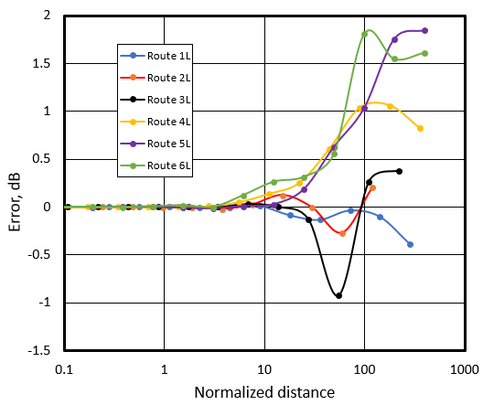
Figure 2: Change in the measurement error of mean field strength along the routes in Lithuania with an increase in the distance between the field strength measurement points.
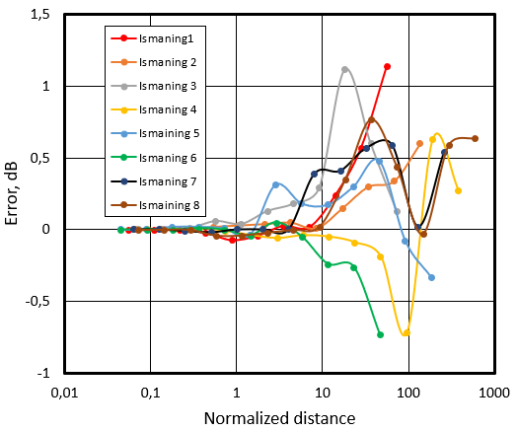
Figure 3: Change in the measurement error of mean field strength along the routes for transmitter Ismaning with an increase in the distance between the field strength measurement points.
The experimental dependences of the measurement error of mean field strength along the routes in Germany on the distance between the field strength measurement points are shown in Figures 3-5. It can be seen from the Figure 3 that when the value of the normalized distance is from 0.1 to 3, same as for routes in Lithuania, for 6 routes out of 8 for transmitter Ismaning the measurement error is close to zero. The same result is observed for 6 out of 9 routes for the transmitter Olympiturm. It can be seen from this Figure 5 that for routes for transmitter Wendelstein the measurement error is close to zero when the value of the normalized distance is from 0.1 to 10. But as you can see from the data in Figures 2-5, if the distance between the measurement points is 10 or less, then for all twenty-seven routes the measurement error of mean field strength does not exceed 0.4 dB.
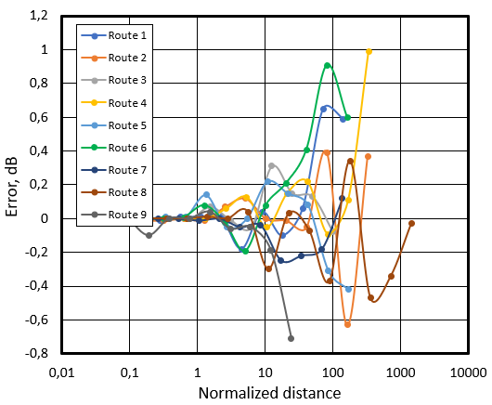
Figure 4: Change in the measurement error of mean field strength along the routes for transmitter Olympiturm with an increase in the distance between the field strength measurement points.
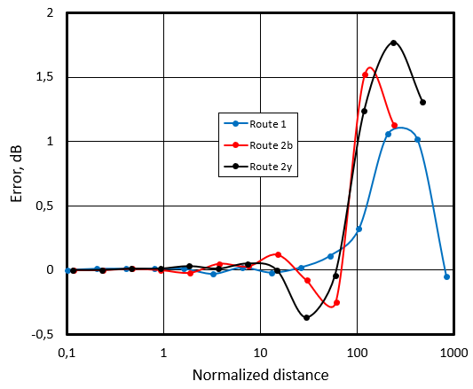
Figure 5: Change in the measurement error of mean field strength along the routes for transmitter Wendelstein with an increase in the distance between the field strength measurement points.
In this way we see that If the allowable measurement error of the average field strength along the route can be approximately 0.4 dB, then the distance between points can be taken equal to 10 wavelengths. Tables 3 and 4 shows the measurement error of equivalent isotropic radiation power (EIRP) when the distance between the field strength measurement points was about 0.1 wavelength and when this distance was taken to be 10 wavelengths. From the data given in these tables, it can be seen that as the distance between the measurement points of the field strength increases from about 0.1 wavelengths to 10 wavelengths, the error in determining the EIRP changes slightly (as mentioned above, the change in this error with a change in the distance between the measurement points is due to a change in the measured average value of the field strength along the route). Of course, the change in the error is random, and as the distance between measurement points increases to 10 wavelengths, it can either increase or decrease. The standard deviation of the change in the measurement error of the EIRP for routes in Germany was 0.2 dB, and for routes in Lithuania it was 0.16 dB.
Table 3: The measurement error of EIRP in Germany
 | The distance between the measurement points is about 0. 1 wavelength. |  | The distance between the measurement points is equal to 10 wavelengths
Route number | Number of measurement points | Radiated power measurement error, dB | Number of measurement points. | Radiated power  measurement error, dB | Difference of measurement error٭, dB
Routes for transmitter Ismaining
1 | 10233 | 3.3 | 59 | 2.9 | 0.4
2 | 9655 | 1.1 | 68 | 1.1 | 0
3 | 9311 | -1.12 | 70 | -1.18 | -0.06
4 | 8688 | -0.43 | 84 | -0.28 | 0.15
5 | 26199 | 0.9 | 121 | 0.48 | 0.42
6 | 26199 | -1.15 | 121 | -1.18 | -0.03
7 | 10426 | -2.07 | 69 | -2.2 | -0.13
8 | 10426 | 2.12 | 79 | 1.98 | 0.14
Routes for transmitter Munich Olympiaturm
1 | 14593 | -0.48 | 105 | -0.48 | 0
2 | 16028 | -1.67 | 132 | -1.98 | -0.31
3 | 12740 | 0.2 | 127 | 0.1 | 0.1
4 | 17157 | -1.31 | 144 | -0.91 | 0.4
5 | 14593 | 3.64 | 65 | 3.82 | -0.18
6 | 14593 | 2.19 | 118 | 2.27 | -0.08
7 | 13028 | 0.42 | 177 | 0.48 | -0.06
8 | 9987 | 0.45 | 178 | 0.25 | 0.2
9 | 15581 | 1.03 | 152 | 1.01 | 0.02
Rotes for transmitter Wandelstein
1 | 50444 | -1.03 | 513 | -1.01 | -0.02
2b | 18453 | -3.89 | 513 | -4.03 | -0.14
2y | 34700 | -1.29 | 393 | -1.42 | -0.13
٭ The difference between the absolute values of the EIRP errors, determined when the distance between the measurement points is about 0.1 wavelength and equal to 10 wavelengths, respectively.

Table 4: The measurement error of EIRP in Lithuania
 | The distance between the measurement points is about 0. 1 wavelength. |  | The distance between the measurement points is equal to 10 wavelengths
Route number | Number of measurement points | Radiated power measurement error, dB | Number of measurement points. | Radiated power  measurement error, dB | Difference of measurement error٭, dB
1L | 8001 | 1.0 | 110 | 1.04 | -0.4
2L | 4001 | 0.2 | 96 | -0.5 | -0.3
3L | 8001 | 0.6 | 44 | 0.61 | -0.01
4L | 8001 | 2.2 | 70 | 2.27 | -0.07
5L | 8001 | 0.7 | 77 | 0.8 | -0.1
6L | 8001 | 0.8 | 77 | 0.84 | -0.04
٭ The difference between the absolute values of the EIRP errors, determined when the distance between the measurement points is about 0.1 wavelength and equal to 10 wavelengths, respectively.
Note that for most routes (apart from atypically long routes for transmitter Wandelstein) with a distance between measurement points of 10 wavelengths, the number of these points is in the range from 44 to 178, which is noticeably less than 440. To illustrate the situation with the number of measurement points, Figure 6 shows the original dependence curve of the field strength along route 6L, consisting of the values measured at all 8001 points spaced from each other at a distance 0.1 wavelength. The same figure shows the values of the field strength at 77 points spaced from each other at a distance 10 wavelengths. In this case 77 points quite accurately repeat the original curve. Consequently, the average value of the field strength calculated from 77 points is only 0.04 dB different from the average value calculated from 8001 points.
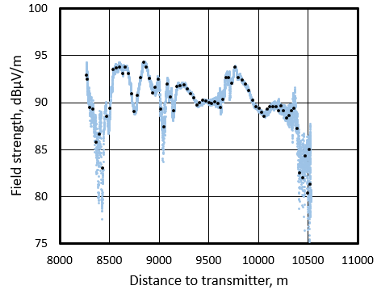
Figure 9: Field strength measurement result along the route 6L (the distance between the blue dots is 0.1 wavelength, between the black dots - 10 wavelengths).
Thus, when choosing the distance between the measurement points of the field strength, two criteria can be used. If the allowable maximum measurement error of the average field strength along the route can be approximately 0.4 dB, then the distance between points can be taken equal to 10 wavelengths. The second, more stringent criterion requires a minimum number of measurement points of 440. For several reasons, the first criterion is more convenient and practical. First, in the case of the first criterion, the number of measurement points is noticeably smaller, which imposes lower requirements on the speed of the measuring system and allows the measuring vehicle to travel at a higher speed. Secondly, in this case, the maximum speed of the measuring vehicle is simply calculated, since it is only necessary to know how many values the measuring system fixes per second. In the case of the second criterion, it is additionally necessary to know the length of the route in advance, which is not always possible before taking measurements.
LIST OF REFERENCES
- William C. Y. Lee. Mobile Cellular Telecommunications System, McCraw-Hill Book Company, 1989, p.371.
- Julius S. Bendat and Allan G. Persol. Random data. Analysis and Measurement Procedures, John Wiley & Sons, Inc, 1986.

