​​
FM22(23)10Annex

ECC Recommendation (YY)XX

Field strength measurements of Mobile/Fixed Communications Networks (MFCN) in border areas in the frequency range 790-3800 MHz
approved xx 2024

introduction
This Recommendation contains methods to measure the field strength of base stations of Mobile/Fixed Communications Networks (MFCN) in border areas in the frequency range 790-3800 MHz.
This Recommendation complements ERC Recommendation 74-02 [1] in order to cover MFCN systems operating in frequency bands harmonised for MFCN usage.

ECC recommendation of YY(XX) on Field strength measurements of Mobile/Fixed Communications Networks (MFCN) in Border areas in the frequency Range 790-3800 MHz
“The European Conference of Postal and Telecommunications Administrations,
considering
- that mobile/fixed communications networks (MFCN) includes IMT and other communications networks in the mobile and fixed services which would include fixed wireless access but not point-to-point links;
- that administrations may diverge from the technical parameters and procedures described in this Recommendation subject to bilateral / multilateral agreements;
- that commonly agreed measurement methods to assess compliance with cross-border coordination conditions are necessary.
noting
- that ERC Recommendation 74-02 describes general methods of field strength measurements at fixed points in the frequency range 29.7-960 MHz
recommends
- that measurements of the field strength and other RF parameters relevant for the cross-border coordination of Mobile/Fixed Communication Networks are carried out according to the methods described in ANNEX 1:.
Note:
Please check the Office documentation database https://docdb.cept.org for the up to date position on the implementation of this and other ECC Recommendations.
- Measurements of FIELD STRENGTH and other relevant parameters in border areas
  - Introduction
Cross-border conditions are generally based on methods that provide theoretical predictions of field strength using radiowave propagation models. It is practically impossible to recreate these methods with measurement procedures in the field. Therefore, only some approximation of measurements could be used to check compliance with those methods. Measurements to assess compliance with the conditions derived from theoretical predictions should therefore aim to apply the conditions that were used for the calculations (e.g. detector, bandwidth, location and time probability, etc.) as much as possible.
The field strength produced by base stations at the border is usually determined by the following parameters:
- the type of duplex mode, i.e. TDD or FDD;
- the operation mode, i.e. synchronised, semi-synchronised or non-synchronised operation of the systems;
- the alignment of centre frequencies;
- the use of preferential or non-preferential frequencies;
- the use of preferential or non-preferential Physical Cell Identities.

These parameters have to be agreed by the administrations or operators in their bilateral/multilateral agreements/arrangements. CEPT has developed a number of recommendations for cross-border operations for mobile systems. These recommendations could be considered by the administrations or operators when developing their bilateral/multilateral agreements/arrangements. Some CEPT members are also signatories of “HCM Agreement” which defines conditions for coordination of frequencies between 29.7 MHz and 43.5 GHz for fixed service and land mobile service. It should be noted that field strength in those deliverables may be defined differently (i.e. mean, medium, maximum permissible or predicted field strength) therefore this also impacts the measurement procedure.

  - Determination of relevant system parameters
Most of the parameters that relevant for the measurements of field strength level have to be requested by the administration or operators. It is also possible to determine some of them by a measurement with a directional antenna directly at the borderline. The antenna should be pointed either in the direction of the nearest domestic or nearest foreign base station.
Determination of the technology and frequency alignment can be done with a spectrum analyser in the frequency domain, with the following settings.
Table 1: Spectrum analyser settings for frequency domain measurements
Centre frequency: | Centre frequency of the downlink channel under investigation
Span: | ≥100 MHz (5G/NR), ≥20 MHz (4G/LTE), ≥5 MHz (3G/UMTS)
RBw/capture Bw: | 300 kHz (5G/NR), 30 kHz (4G/LTE), 10 kHz (3G/UMTS)
Sweep/Capture time: | (auto)
Trace: | MaxHold

Determination of the duplex mode can be done with a spectrum analyser in the time domain, with the following settings:
Table 2: Spectrum analyser settings for time domain measurements
Centre frequency: | Centre frequency of the downlink signal measured in the frequency domain
Span: | Zero
RBw/capture Bw: | Nearest available RBw/capture Bw to the signal Bw measured in the frequency domain
Sweep/Capture time: | 20 ms (5G/NR) or 10 ms (4G/LTE and 3G/UMTS)
Trace: | ClearWrite
Trigger: | Fixed every 20 ms (5G/NR), every 10 ms (4G/LTE and 3G/UMTS), or Video (Note)
Note: For a fixed trigger setting, an analyser which is frequency-locked to a GNSS signal is necessary. Video triggering may only work for UMTS TDD systems

The aim is to achieve a trace display, which is time synchronized with a frame of the MFCN system. In FDD systems, the whole frame is (temporarily) filled with data signals, while in TDD systems a certain fraction of the frame time is always left empty.
Alternatively, the system parameters above may also be determined by a specialized measurement system capable of decoding the signal. Apart from being simple in handling, one advantage of this method is the capability to decode parameters for multiple signals, and not only the strongest. If the same system technology and centre frequency is used on both sides of the border, the parameters of both can be measured on one location, even with omnidirectional antennas.

  - Relevant signals to be measured
    - General
Field strength level at the same location depends on many networks parameters, like modulation techniques, bandwidths, transmitter power, etc. Because it cannot be assumed that the network is fully loaded with traffic during the time of measurement, only certain parts of the signal are actually measured, and the result is then extrapolated to simulate a situation with full traffic load. Selection of signals to be measured and extrapolation method depends on the system technology and is described in the following sections.
The received field strength can be calculated by :
 | $$E\left({dBμV}/m\right)=P_{tot}\left(dBm\right)−K_{ant}\left({dB}/m\right)−a_{c}\left(dB\right)+107$$ | (1)
Where
- E is the maximum field strength produced by the MFCN station in dBµV/m;
- P_{tot} is the maximum (extrapolated) receive level in dBm;
- K_{ant} is the antenna factor of the measurement antenna in dB/m;
- a_{c} is the attenuation of the RF cable between measurement antenna and receiver in dB.
    - 2G / GSM
One of the RF channels used by a GSM base station is carrying the broadcast control channel (BCCH) and is transmitted with full power on all 8 time slots. Measurements should therefore be done on this channel frequency (C0) and are possible with a spectrum analyser using the following settings.
Table 3: Spectrum analyser settings for measurements of the GSM system
Centre frequency: | Centre frequency of the C0 channel
Span / capture Bw: | 500 kHz
RBw: | 1 kHz
Detctor: | RMS
Sweep / capture time: | Auto
Trace: | ClearWrite
Measurement function: | Channel power measurement with a channel Bw of 200 kHz

Although the occupied bandwidth of a GSM signal is slightly higher than 200 kHz, the smaller setting of the channel width is recommended to avoid influences of neighbouring channels.
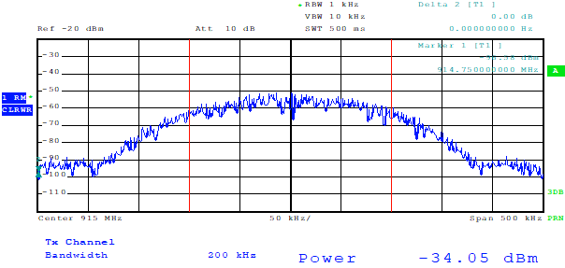
- Measurement of a GSM signal with a spectrum analyser
No extrapolation is necessary because the measured level is independent of the traffic.
    - 3G / UMTS
The traffic-independent signal in UMTS is the common pilot channel (CPICH). It is transmitted at the same frequency and with the same bandwidth as the logical traffic channels, only with a different spreading code. Measurement of the maximum signal level from a UMTS station is therefore only possible with dedicated equipment after decoding in the code domain.
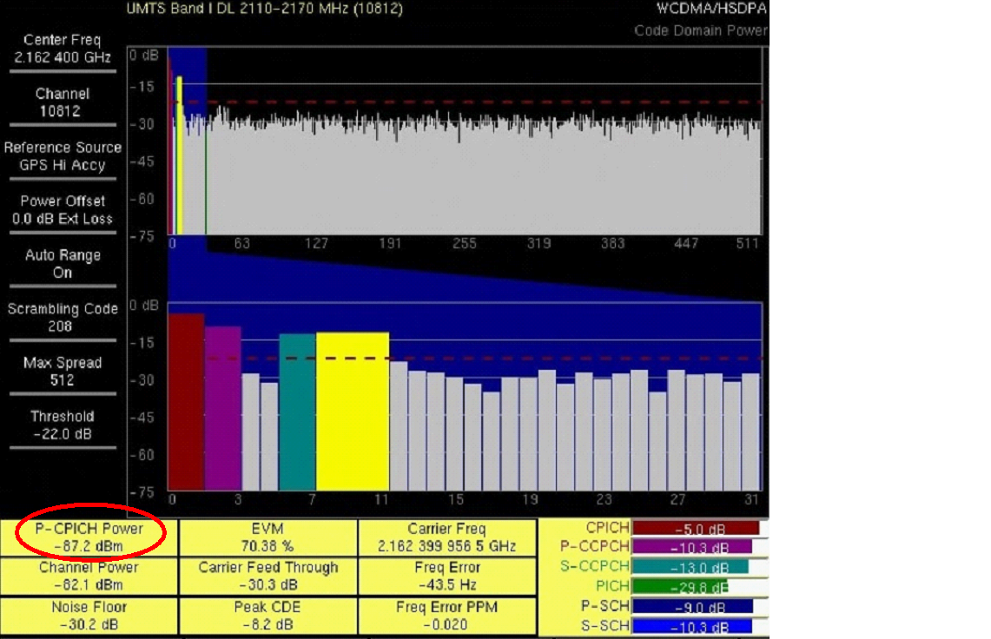
- Sample screen for UMTS level measurements with dedicated equipment
Extrapolation to a full traffic situation is done by adding a correction factor to the measurement result (red circle in Figure 2:). Unless other information from the provider is available, the correction factor is 10 dB.
    - 4G / LTE
In LTE, the traffic-independent signals used for the measurement is the physical broadcast channel (PBCH), which is transmitted every 10 ms over the inner 1.05 MHz of bandwidth. Its length is 4 symbols or about 266 µs. However, during the first two symbols, reference signals are also transmitted. The „pure” PBCH is transmitted during the last two symbols for a length of about 133 µs.
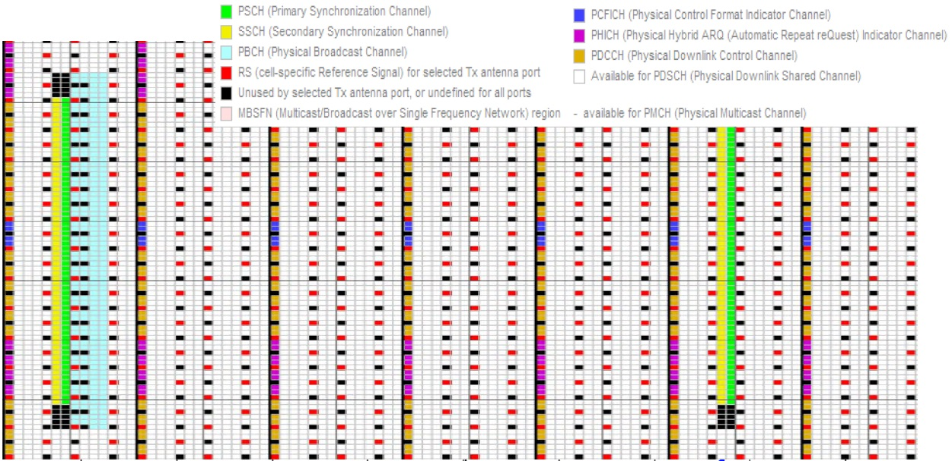
- LTE resource grid of the inner 1.2 MHz
The measurement has to be time-synchronized and limited in time and bandwidth. Although challenging, it is in principle possible with a spectrum analyser that is synchronized by GNSS.
Table 4: Spectrum analyser settings for measurements of the LTE system
Centre frequency: | Centre frequency of the LTE channel
Span: | Zero span
RBw/capture Bw: | 1 MHz
Detctor: | RMS
Sweep / capture time: | 2 ms
Trace: | ClearWrite
Trigger: | Fixed every 10 ms. Offset adjusted so that PBCH is in display window
Measurement function: | Time domain power with limits set to the PBCH

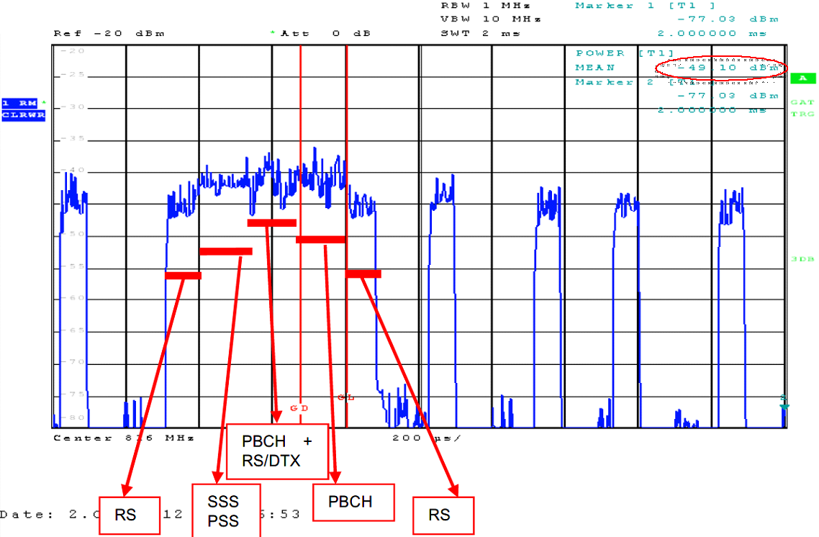
- Sample screen for a measurement of the LTE PBCH with spectrum analyser
The actual measurement has to be limited to the last two symbols of the PBCH block (gate length about 133 µs), because the reference symbols transmitted during the first two symbols may be boosted in power.
In Figure 4: the resulting level of the PBCH is circled in red (-49.1 dBm). This is the level of all subcarriers in 1 MHz bandwidth. In a full traffic situation it is assumed that all traffic carriers could be transmitted with the same power as the PBCH. The total LTE level with full traffic would then be:
 | $$P_{tot}\left(dBm\right)=P_{meas}\left(dBm\right)+10×log\left(\frac{B_{LTE}\left(MHz\right)}{1MHz}\right)$$ | (2)
Where
- P_{tot} is the total LTE level in a full traffic load situation in dBm;
- P_{meas} is the measured PBCH-level in dBm;
- B_{LTE} is the bandwidth of the LTE channel in MHz.

A more convenient way of measurement is the use of dedicated equipment that is able to decode the LTE signal and display the level of the different components separately, like in the following example.
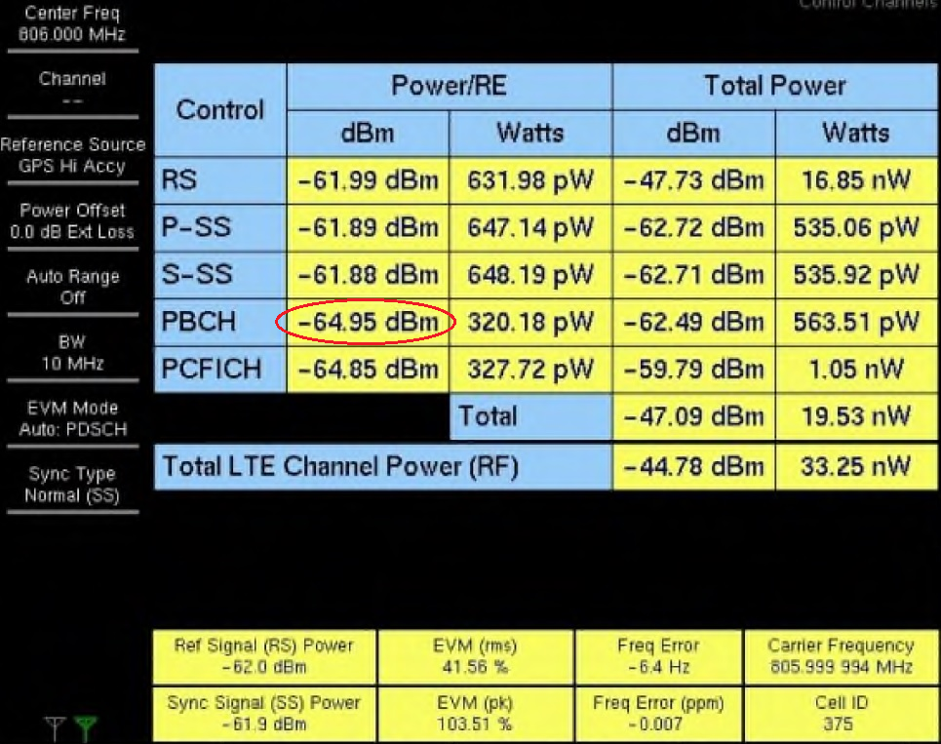
- LTE measurement with dedicated equipment
Most decoding equipment displays the power per resource element. In Figure 5:, the power of one resource element in the PBCH is circled in red (-64.95 dBm). Extrapolation to a full traffic situation can be done with the following formula:
 | $$P_{tot}\left(dBm\right)=P_{ℜ}\left(dBm\right)+10×log\left(ℜ_{tot}\right)$$ | (3)
Where
- P_{tot} is the total LTE level in a full traffic load situation in dBm;
- P_{RE} is the measured level of one resource element in the PBCH in dBm;
- RE_{tot} is the total number of resource elements in the LTE channel.

This assumes that the traffic resource elements can be transmitted with the same power as the PBCH.
    - 5G /NR
The 5G NR signal is also composed of some traffic-independent signals and resource elements that are activated during traffic only. The traffic-independent signal used for the measurement is called synchronisation signal block (SSB). This block also contains the broadcast information.
One of the specifics about the NR system is, however, that it may use active antenna arrays (AAS) that are able to form the antenna beam and point it in specific directions. In case of an AAS, the SSB is transmitted with different antenna characteristics and sometimes with different gain from traffic beams. The 5G NR Standard allows between one and 8 SSBs. Typical configurations in Europe are one beam with 120° horizontal main lobe, and 7 or 8 beams transmitted in sequence.
Tx
Tx
1
2
3
4
5
6
7
- Configurations with 1 SSB (left) and 7 SSBs (right)
The SSB is not necessarily transmitted on the centre frequency of the 5G channel. Common configurations are either the centre frequency, or at the lower or upper end of the 5G channel. The bandwidth of the SSB is 7.2 MHz for systems with 30 kHz subcarrier spacing and 3.6 MHz for systems with 15 kHz subcarrier spacing.
Measurements of 5G NR signals can principally be made with spectrum analysers, provided they are synchronized by GNSS. Preferably, real-time analysers should be used. As a first step, frequency and number of the SSB has to be determined. With a real-time spectrum analyser, this is preferably done with a spectrogram display with the following settings:
Table 5: Realtime analyser settings for determination of the SSB configuration
Centre frequency: | Centre frequency of the 5G channel
Span / capture Bw: | Equal to the bandwidth of the 5G channel, e.g.100 MHz
RBw: | Auto
Detector: | Peak or sample
Sweep / capture time: | 20 ms
Trace: | ClearWrite

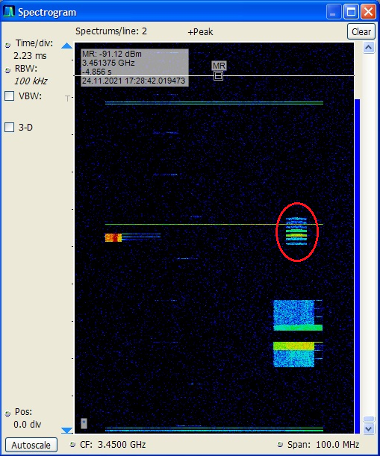
- Sample spectrogram of a 5G NR frame with 7 SSBs
The station in Error: Reference source not found is configured for 7 SSBs transmitted at the upper end of the channel (red circle).
Once the frequency of the SSB is determined, its level can be measured with a standard or real-time spectrum analyser with the following settings:
Table 6: Spectrum analyser settings for measurement of the SSB level in 5G NR signals
Centre frequency: | Centre frequency of the SSB
Span: | Zero span
RBw / Capture Bw: | 1 MHz
Detector: | RMS
Sweep / capture time: | 20 ms
Trace: | ClearWrite
Trigger: | Fixed every 20 ms. Offset adjusted so that SSBs are in display window
Measurement function: | Time domain power with limits set to the strongest SSB (gate length

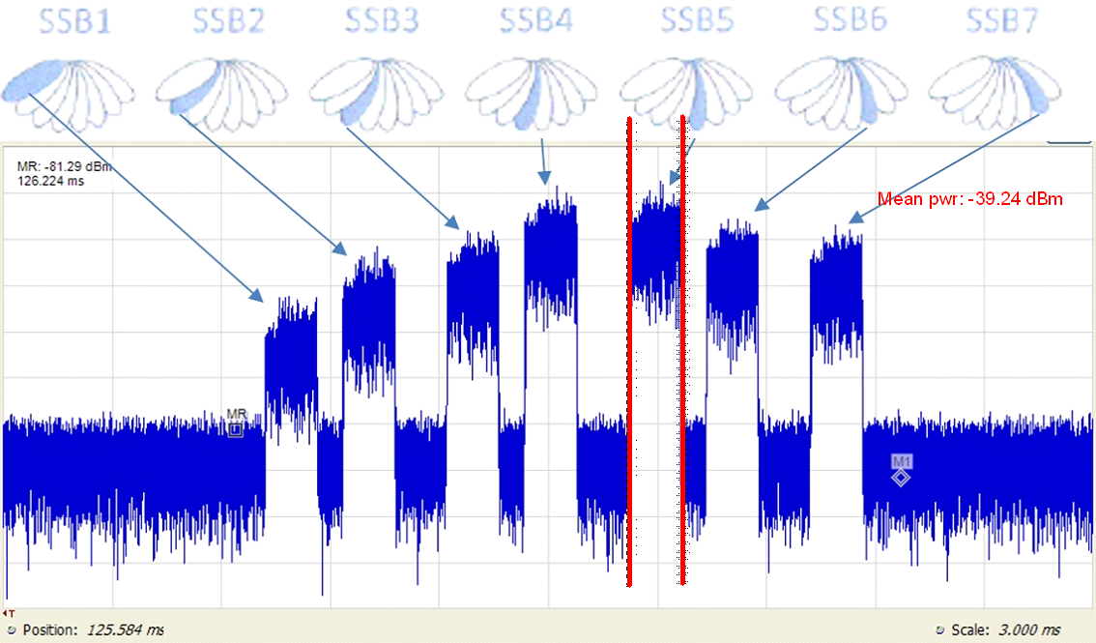
- Sample measurement of a 5G NR station with 7 SSBs
The displayed result represents only the fraction of the strongest SSB in the selected measurement bandwidth.
The total level of the SSB could be calculated as:

 | $$P_{SSB}\left(dBm\right)=P_{meas}\left(dBm\right)+10×log\left(\frac{{Bw}_{SSB}\left(MHz\right)}{RBw\left(MHz\right)}\right)$$ | (4)
Where
- P_{SSB} is the total received level of the strongest SSB in dBm;
- P_{meas} is the measured level of the strongest SSB in selected RBw in dBm;
- Bw_{SSB} is the bandwidth occupied by the SSB in MHz (equals to 240 × subcarriers spacing (kHz));
- RBw is the measurement bandwidth in MHz.

A more convenient method of measuring the 5G NR levels is using dedicated equipment that is able to decode the 5G signal and measure the levels of the different resource elements separately.
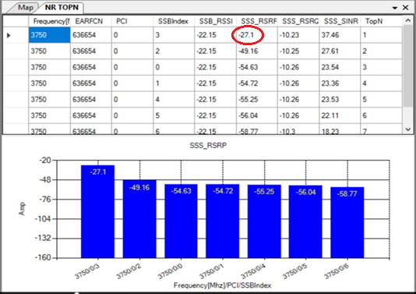
- SSB measurement with decoding equipment
The base station in Error: Reference source not found is transmitting 7 SSBs. The level of the strongest SSB 3 is circled in red (-27.1 dBm).
One assumption that has to be made when measuring 5G signals from neighbouring countries is that the measurement location is in the main lobe range of both SSB and traffic beams.
Correct extrapolation to a full traffic situation which would produce the maximum field strength is only possible with knowledge of the antenna gain difference between SSB and traffic beams. This information may be obtained from the operator, but in practice it is seldom available for foreign stations.
In the absence of the antenna data, the following gain differences should be applied:
- For AAS stations with 1 SSB: ∆G = 6 dB;
- For AAS stations with 7 SSB: ∆G = 0 dB;
- For stations with passive antenna systems: ∆G = 0 dB.

The above mentioned gain differences present a conservative approach with the aim not to overestimate the resulting maximum field strength. In some AAS stations, the gain difference is higher. In this case, the measurement would underestimate the maximum possible field strength. If the antenna types are known, it is recommended to use that actual gain differences instead of the generic ones above.
The total level of the LTE signal under a full traffic situation could then be calculated as:
 | $$P_{tot}\left(dBm\right)=P_{SSB}\left(dBm\right)+∆G\left(dB\right)+10×log\left(\frac{{Bw}_{5G}\left(MHz\right)}{{Bw}_{SSB}\left(MHz\right)}\right)$$ | (5)
Where
- P_{tot} is the total received level of the LTE signal under simulated full traffic situation in dBm;
- P_{SSB} is the SSB level in dBm;
- ∆G is the gain difference between SSB and traffic beam in dB;
- Bw_{SSB} is the bandwidth occupied by the SSB in MHz (equals to 240 × subcarriers spacing (kHz));
- Bw_{5G} is the bandwidth of the 5G channel in MHz.
  - Measurement at fixed locations
    - Application and principle
This method is applicable in cases of reported or assumed interference to a receiver at a specific location, e.g. a base station, or if an administration wants to determine whether the predicted field strength from foreign MFCN exceeds the values in a cross-border agreement at a specific location.
The propagation models used for field strength calculations can only predict the average field strength at a certain distance from the transmitter. Specific terrain conditions and clutter cannot be considered. Excess of the agreed limits at one particular location does not automatically prove a violation of the agreement. It is therefore necessary to perform a cluster measurement of the field strength around the location of interest.
    - Required equipment
The following equipment is recommended for these measurements:
- Measurement car with retractable mast of at least 10 m maximum height;
- Directional antenna suitable for the frequency range of the MFCN band;
- Spectrum analyser or decoding equipment according to section A1.3.
    - Measurement procedure

The required number of measurement locations depends on the required reliability and the difference between the measured values at the best reception point and at the worst reception point, where:
 | $$∆E\left({μV}/m\right)=E_{max}\left({μV}/m\right)+E_{min}\left({μV}/m\right)$$ | (6)
Where
- ∆E is the difference between field strength at the best reception point an worst reception point in µV/m;
- E_{max} is the field strength at the best reception point in µV/m;
- E_{min} is the field strength at the worst reception point in µV/m.

For a given confidence level of 90% that the real field strength lies within 1 or 1.5 dB of the average measured level, the following table provides guidance on the required number of measurement locations.
Table 8: Required measurement locations for cluster measurements
Confidence |  | ∆E = E_{max} – E_{min}
level | interval | 0 – 5 dB | 5 – 10 dB | 10 – 15 dB | 15 – 20 dB
90% | 1 dB | 3 | 11 | 24 | 43
90% | 1.5 dB | 2 | 5 | 11 | 19

According to ERC Recommendation 74-02, the minimum number of test points is 5, regardless of the entry in the table above.
Measurement locations should be selected so that there are no reflecting objects and as few overhead conductors (power and telephone lines, antennas, buildings with metal roofs or gutters) as possible within ten times the wavelength.
The directional antenna is pointed to the applicable height and pointed in the direction of maximum received level.
If the antenna allows flexible polarisation, then for 4G and 5G measurements are carried out at two polarization values: +45° and -45°. Otherwise, vertical polarisation is used.
The spectrum analyser or decoding receiver is adjusted to the settings applicable to the MFCN technology used (see section A1.3).
To cancel out the effect of ground reflection, the antenna height is varied around the nominal height (3 m or 10 m) until a maximum and an adjacent local minimum of the received level is detected. When a spectrum analyser is used, a standard height scan can be performed where the received level is constantly measured and recorded while raising/lowering the antenna height. If a decoding receiver is used, the maximum and minimum values have to be determined manually by changing the antenna height in small steps.
The field strength of the direct wave can be calculated as:

 | $$E_{D}\left({μV}/m\right)=E_{max}\left({μV}/m\right)−\frac{1}{2}∆E\left({μV}/m\right)$$ | (7)
Where
- E_{D} is the field strength of the direct wave (without reflection) in µV/m;
- E_{max} is the maximum measured field strength during the height scan in µV/m;
- ∆E is the difference between maximum and next minimum of the field strength during the height scan in µV/m.

If measured in logarithmic units (dBµV/m), the field strength of the direct wave can be calculated as:

 | $$E_{D}\left({dBμV}/m\right)=E_{max}\left({dBμV}/m\right)−η_{k}$$ | (8)
Where
- E_{D} is the field strength of the direct wave (without reflection) in dBµV/m;
- E_{max} is the maximum measured field strength during the height scan in dBµV/m;
- N_{k} is the correction coefficient to be applied (see Figure 10:) in dB.
- Correction coefficient to eliminate ground reflection
The final result is the linear average value of the field strengths measured at all measurement locations.
  - Measurements over longer time periods
    - Application and principle
In cases of interference to a specific receiver, the ERC Recommendation 74-02 foresees measurement over longer time periods. The aim is to evaluate time-fluctuations of the interfering signal, e.g. caused by varying propagation conditions.
The measurements are taken either at the antenna of the interfered station, or with a calibrated directional measurement antenna close to the interfered station. Field strength samples taken at regular intervals are evaluated statistically, and the values for 10%, 50% and 90% of the time are determined.
    - Required equipment
If the measurements are taken at the interfered antenna, the following equipment is recommended:
- Spectrum analyser or decoding equipment according to section A1.3;
- Computer to retrieve and store measurement results from the analyser or decoding equipment.

If the measurements are taken at a measurement antenna, the following equipment is necessary in addition:
- Measurement car with retractable mast of at least 10 m maximum height;
- Directional antenna suitable for the frequency range of the MFCN band.

If the spectrum analyser or decoding receiver has built-in facilities to store multiple measurement results, a separate computer is not necessary.
    - Measurement procedure
The spectrum analyser or decoding receiver is connected to the antenna of the interfered station (possibly via a directional coupler), or mounted on the measurement car positioned near the interfered station, in 10 m height.
Depending on the service to be monitored, the equipment settings according to section A1.3 are applied.
It is recommended to take at least one measurement sample per hour. The resulting field strength is recorded.
According to ERC Recommendation 74-02, the measurement should run at least for a period of 24 hours. If weather or seasonal influences of the propagation should be considered, the duration has to be prolonged accordingly. Longer measurement times also increase the confidence level.
After the measurement period is finished, all measurement samples are sorted by level and evaluated to state:
- the field strength that is exceeded by 10% of the samples;
- the median field strength (50%);
- the field strength that is exceeded by 90% of the samples.

These results represent the time probability.
  - Mobile measurements along the border
    - Application and principle
This method is applicable in case of (routine) measurements to assess the overspill of MFCN signals from neighbouring countries in border regions. Although there may not be a case of harmful interference, excess signals strengths may result in mobiles unintentionally logging into the foreign network, thereby introducing roaming charges for the users in border regions.
    - Required equipment
...
    - Measurement procedure
...
  - Result evaluation
The final result of the field strength is the level measured according to the sections above plus measurement uncertainty defined in the section A1.8.
  - Measurement uncertainty
…
- list of references and relevant documentation
- ERC Recommendation 74-02: „Method of measuring the field strength at fixed points in the frequency range 29.7-960 MHz”

