 |  |  | FM22(23)12
Project Team FM22
59rd Meeting of FM22
Copenhagen / Web Meeting, 28 – 31 March 2023
Date issued: | 23 March 2023
Source: | Lithuania
Subject: | MFCN field strength control in border areas
Group membership required to read? (Y/N) |  | N
Summary:
When monitoring MFCN fields strength levels for non-AAS BS in the border areas, it is proposed to measure average/mean field strength in logarithmic scale in order to be able to compare that with the levels defined in ECC Recommendation (15)01. Some additional elements, i.e. averaging time of measurements and how to account for network loading (traffic) also needs to be taken into account.
Proposal:
FM22 is invited based on the material to discuss the following:
- To measure average/mean field strength in logarithmic scale;
- To use at least 360 s averaging time when measuring the average value of the field strength;
- In case received signal power is measured instead of field strength the correction of 10 dB should be applied in order to account for network loading.
Participants are also invited to share their monitoring practice for measuring the field strength levels created by MFCN in the border areas.
Background:
- ERC/ECC recommendations regarding cross-border coordination for MFCN.
- At the 58th meeting of FM22 it was decided that in cooperation with Latvia and Lithuania, Germany will start to develop a first draft of a new ECC Recommendation on MFCN field strength measurements at the border areas.

Introduction
The FM22 group is currently drafting a new ECC recommendation “Field strength measurements of Mobile/Fixed Communications Networks (MFCN) in border areas in the frequency range 790-3800 MHz”. The main purpose of this recommendation is to unify the methods for measuring field strength in border areas between neighbouring countries. These measurements themselves are usually used to check compliance with the field strength limits given in cross-border recommendations as well as in bilateral/multilateral agreements between the administrations or operators of neighbouring countries. Moreover, the field strength limits in the agreements are usually rewritten from the relevant recommendations.
As for the field strength measurements, the situation with the definition of field strength seems somewhat ambiguous to us. For example, the ECC Recommendation (15)01 defines mean values for non-AAS BS and median values for AAS BS. But on the other hand, the limits are usually interpreted as the maximum values of the field strength.

Derivation of the field strength limits for cross-border
The field strength limits are obtained as a result of computer simulation. Here, the interference from one network to another network is simulated. The field strength limit is obtained for the acceptable throughput loss.
For simulation, usually the software tool SEAMCAT is used. SEAMCAT is based on the Monte-Carlo simulation method, which is developed within the frame of CEPT. As a result of simulations using this software tool, the average and median value of the field strength is calculated. According to the program description [1] the mean is computed using the simulated results in dB and the median is computed using the simulated results converted to linear values and then converted again to dB. From this, for example for ECC Recommendation (15)01 we understand that mean level refers to the field strength averaged on a logarithmic scale. As for the median, median is the same whether it is calculated in logarithmic or in linear scale, so the end result is the same.

Difficulties in monitoring the field strength limits
The averaged field measurements noticeably depend on the averaging time. It seems reasonable to take the averaging time long enough to obtain reproducible results of the measured average value. In the case of LTE, this averaging time will be in the order of 360 s [2]. It should be noted that this average value will be noticeably less than the maximum values of the field strength.
Averaged field strength also depends on the traffic. Usually the measurements are carried out for the power of one resource element in the PBCH and then extrapolated to a full traffic situation (further, for brevity, this field strength will be called the extrapolated field strength). It is usually assumed in this calculation that the traffic resource elements can be transmitted with the same power as this resource element. In reality, this situation rarely happens. Figure 1 shows the results of field strength measurements at 1470 m from the non-AAS LTE base station. The field strength calculated from the measured RSRP was 103.4 dBµ/m. It can be seen from the figure that only 2 measured values are close to this calculated value (there were 8000 measured values in total). Note that the average value of the field strength for all 300 seconds of measurement is 92.7 dBµV/m. Thus, the maximum value is approximately 10 dB higher than the average value.
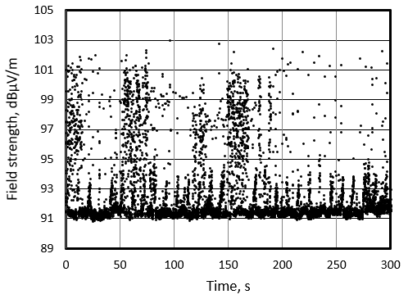
Figure 1: The dependence of the field strength of the LTE base station from time (measured using the RMS detector; the time of one measurement was 37 ms)
Figure 1 shows that periodic bursts of traffic are observed. One such burst which was observed in the interval of 50-100 s is shown in more detail in Figure 2. It can be seen from this figure that during the burst, the average values of the field strength for short averaging times increase noticeably.
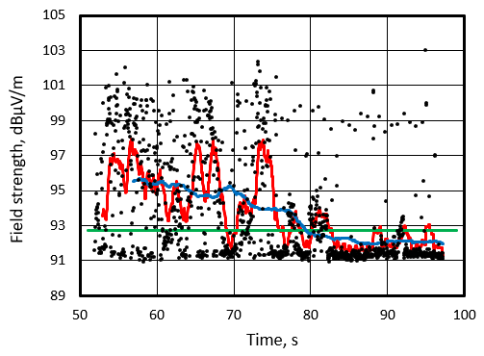
Figure 2: The dependence of the average value of the LTE base station field strength during the burst of traffic from time for different averaging intervals (averaging interval 1 s – red, 10 s – blue). The green line represents the average value for all 300 seconds of measurement
It follows from the above that for LTE the average value of the field strength is about 10 dB less than the maximum value. Therefore, the extrapolated value of the field strength reduced by about 10 dB in order to get averaged field strength. Of course, 10 dB is a preliminary result and by collecting more statistics this value can be refined.

Proposal
To add the following information to the new ECC recommendation on field strength measurements of Mobile/Fixed Communications Networks (MFCN) in border areas to the relevant sections:
- To measure average/mean field strength in logarithmic scale;
- To use at least 360 s averaging time when measuring the average value of the field strength;
- In case received signal power (e.g. RSRP for LTE) is measured instead of field strength the correction of 10 dB should be applied in order to account for network loading.

list of references and relevant documentation
- https://ecowiki.atlassian.net/wiki/spaces/SH/pages/492452/A1.5.2+Visualisation
- FM22(22)06 - Practical supervision of MFCN field strength in border areas

